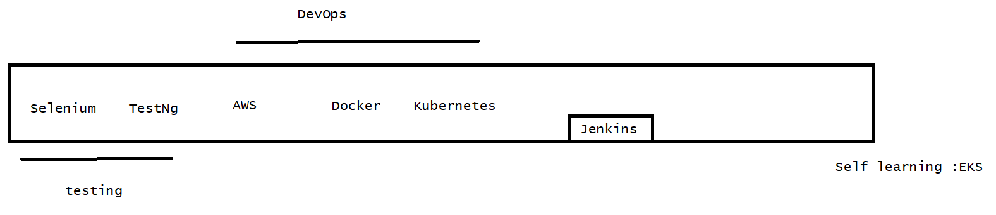

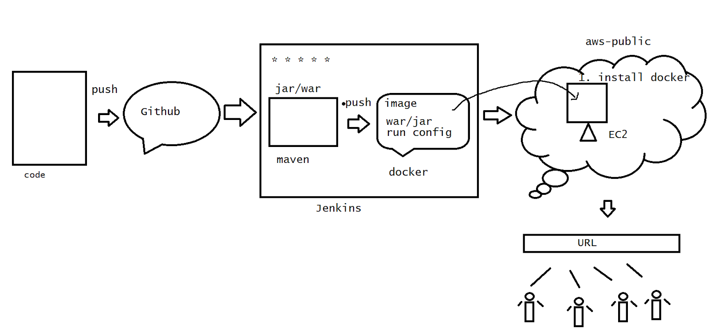

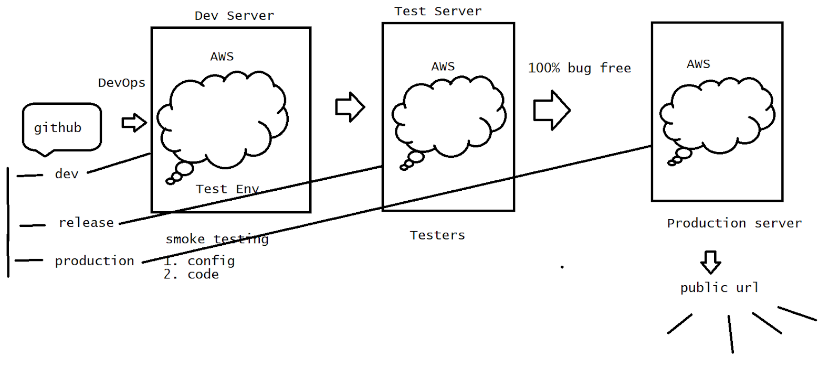

>Selenium

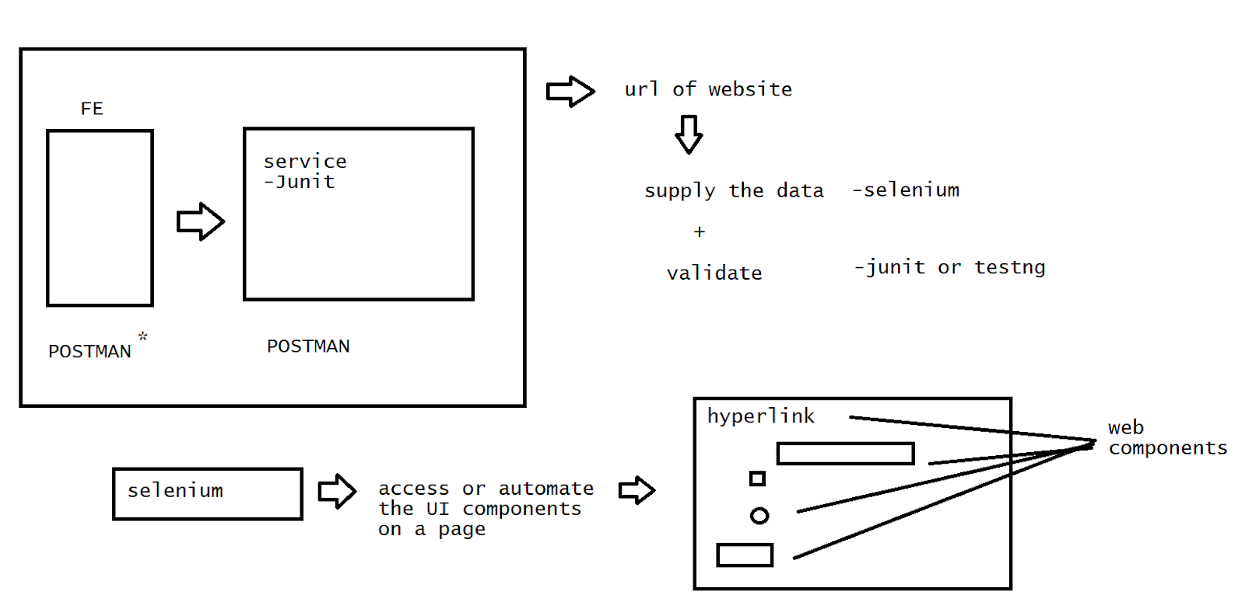

1. It is an open source java platform to access the UI components over the webpage
2. We can pass the data what ever we require to test from the FE ->BE at the Ui level in an automated way .
3. Support all OS
4. Support all the browsers
5. functional/performance

* Selenium  is used for functional testing and it is integrated with maven / jenkins for continuous testing and also it can be tested with the support of Junit / TestNG

Limitation

Browser-level components only.

It doesn't support the UI components at the OS level.

[selenium + AUTOIT/SKULI]

<https://github.com/kkarthik46/selinium-test/blob/main/95.zip>

Delete the Chrome driver after the extract

Step -1

Verify the chrome version

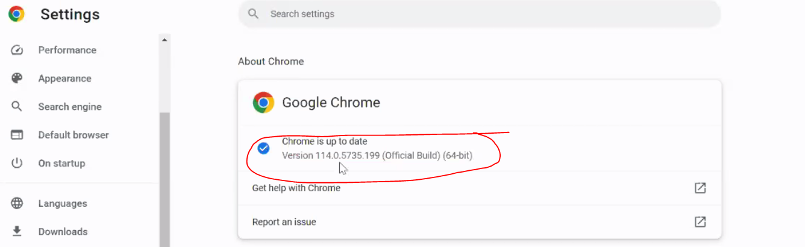

Step -2

In Google type chrome driver

<https://chromedriver.chromium.org/downloads>

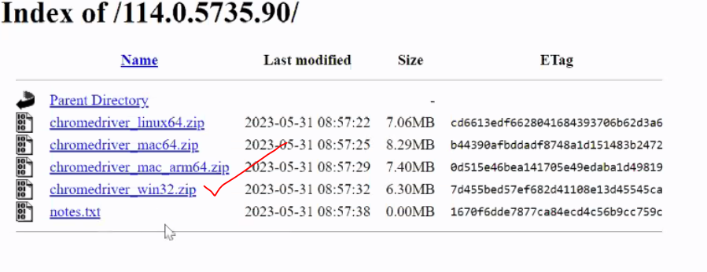

Extract it and keep it on to the jar folder

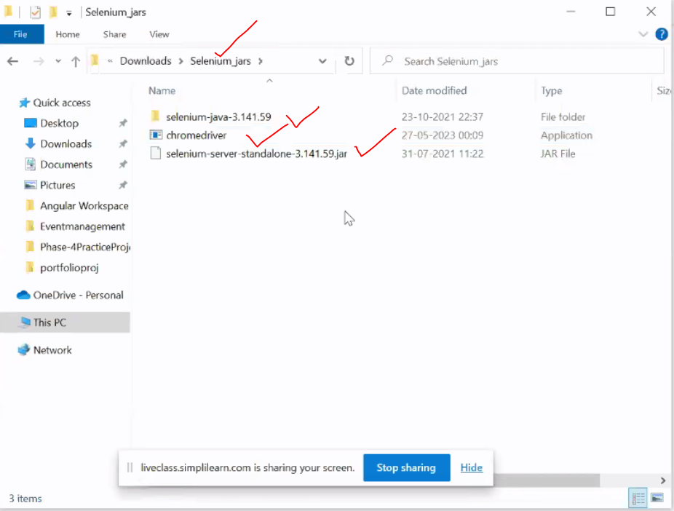

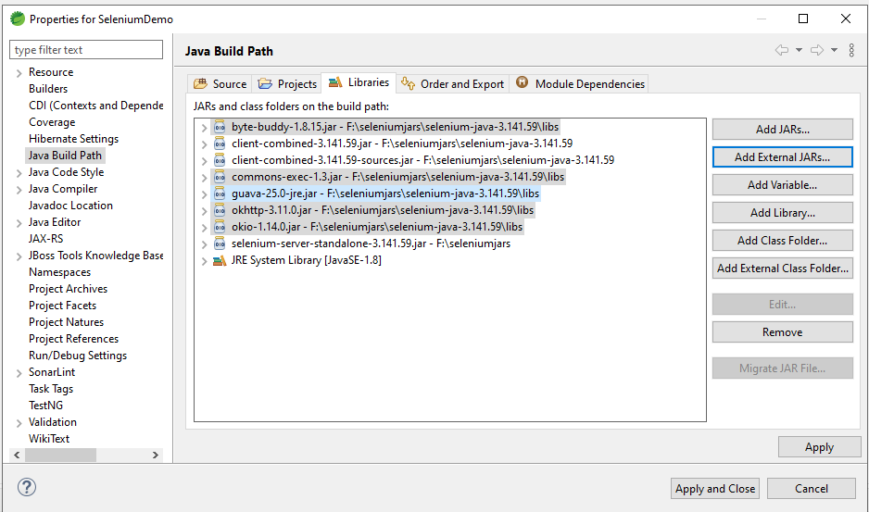

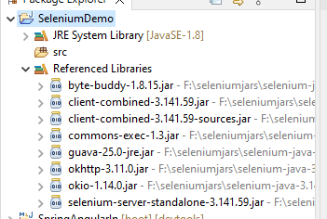

Steps for selenium code:

1. Manual build path

2. define the path of the web driver on the machine (.exe)

3. Define the object for the driver

4. Maximize the browser screen

5. open the URL which is required for the automation.

6. Do the operations

7. Close the browser

//Basic sele operations :

//loaded a website

import org.openqa.selenium.WebDriver;

import org.openqa.selenium.chrome.ChromeDriver;

public class SelAuto {

public static void main(String[] args) {

//register the Chrome driver

System.setProperty("webdriver.chrome.driver","F:\\seleniumjars\\chromedriver.exe");

//create an obj to the driver -obj to the browser

WebDriver wd=new ChromeDriver();//wd is the controller obj to web browser

//maximize the screen

wd.manage().window().maximize();

//web URL

wd.get("https://www.amazon.in/");

//close the browser

wd.close();

}

}

//we have loaded a page on a server

import org.openqa.selenium.WebDriver;

import org.openqa.selenium.chrome.ChromeDriver;

public class SelAuto {

public static void main(String[] args) throws InterruptedException {

//register the chrome driver

System.setProperty("webdriver.chrome.driver","F:\\seleniumjars\\chromedriver.exe");

//create an obj to the driver -obj to the browser

WebDriver wd=new ChromeDriver();//wd is the controller obj to web browser

//maxmize the screen

wd.manage().window().maximize();

//web url

wd.get("http://127.0.0.1:5500/register.html");

//close the browser

Thread.sleep(20000);

wd.close();

}

}

//WebElements

Unique identification of a tag

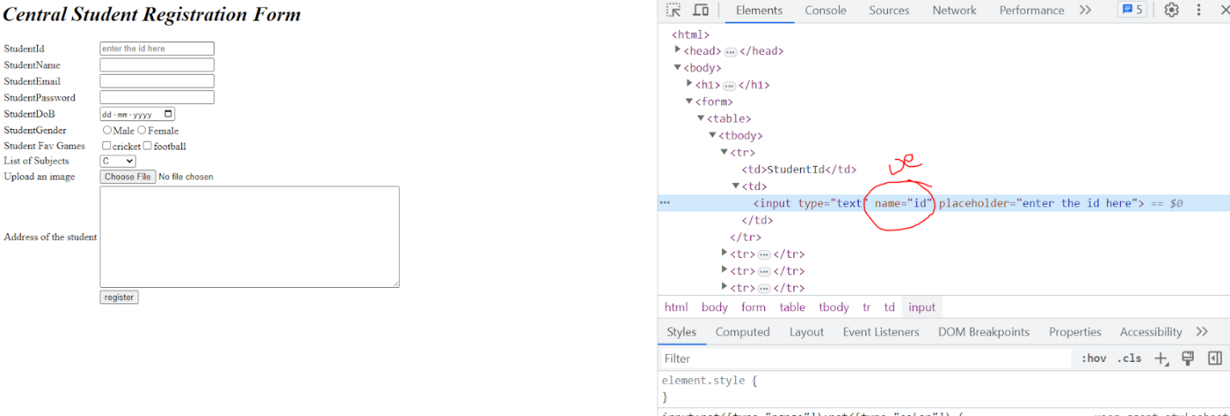

*wd.findElement(By.****webelement****(“identifier”));*

id,name,cssselector,tagName,className,Xpath,linkText,partialLinkText.

Field Level

id,name,cssselector,tagName,className,Xpath

Best :

id,name,Xpath

Hyperlink :

linkText,partialLinkText

Best :linkText

import org.openqa.selenium.By;

import org.openqa.selenium.WebDriver;

import org.openqa.selenium.chrome.ChromeDriver;

public class SelAuto {

public static void main(String[] args) throws InterruptedException {

//register the chrome driver

System.setProperty("webdriver.chrome.driver","F:\\seleniumjars\\chromedriver.exe");

//create an obj to the driver -obj to the browser

WebDriver wd=new ChromeDriver();//wd is the controller obj to web browser

//maxmize the screen

wd.manage().window().maximize();

//web url

wd.get("http://127.0.0.1:5500/register.html");

wd.findElement(By.name("id")).sendKeys("1");

//close the browser

Thread.sleep(20000);

wd.close();

}

}

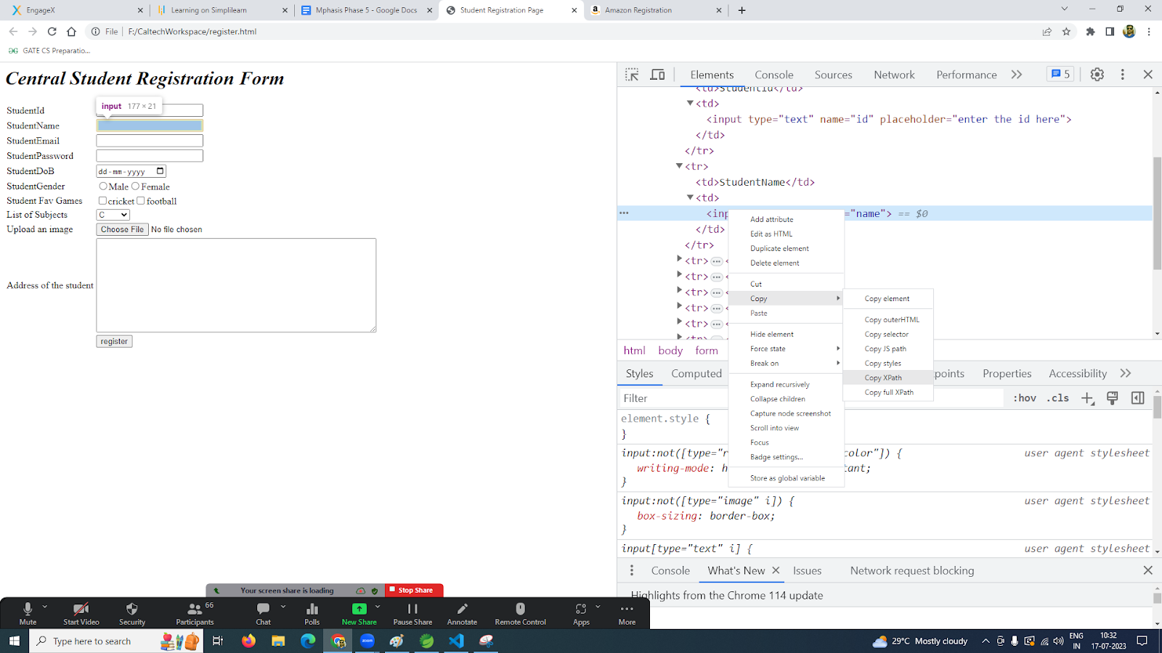

When we don't have an identifier use xpath.

import org.openqa.selenium.By;

import org.openqa.selenium.WebDriver;

import org.openqa.selenium.chrome.ChromeDriver;

public class SelAuto {

public static void main(String[] args) throws InterruptedException {

//register the chrome driver

System.setProperty("webdriver.chrome.driver","F:\\seleniumjars\\chromedriver.exe");

//create an obj to the driver -obj to the browser

WebDriver wd=new ChromeDriver();//wd is the controller obj to web browser

//maxmize the screen

wd.manage().window().maximize();

//web url

wd.get("https://www.amazon.in/");

wd.findElement(By.linkText("Start here.")).click();

wd.findElement(By.id("ap_customer_name")).sendKeys("karthik");

wd.findElement(By.id("ap_phone_number")).sendKeys("134567891");

wd.findElement(By.id("ap_email")).sendKeys("ka@gmail.com");

wd.findElement(By.id("ap_password")).sendKeys("123456789");//continue

wd.findElement(By.id("continue")).click();

//close the browser

Thread.sleep(20000);

wd.close();

}

}

//wd.findElement(By.partialLinkText("Start")).click();-not a goot practice

Task:

Open the amazon page log into it .select the search bar and provide the phone search as Samsung

>How is the chrome browser auto invoked by the server?

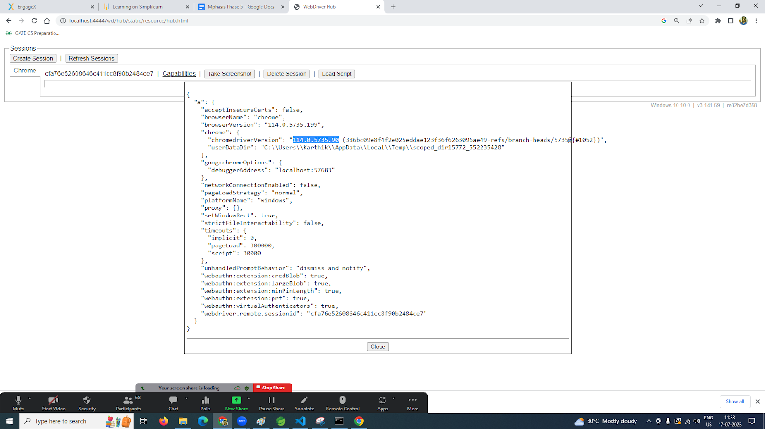

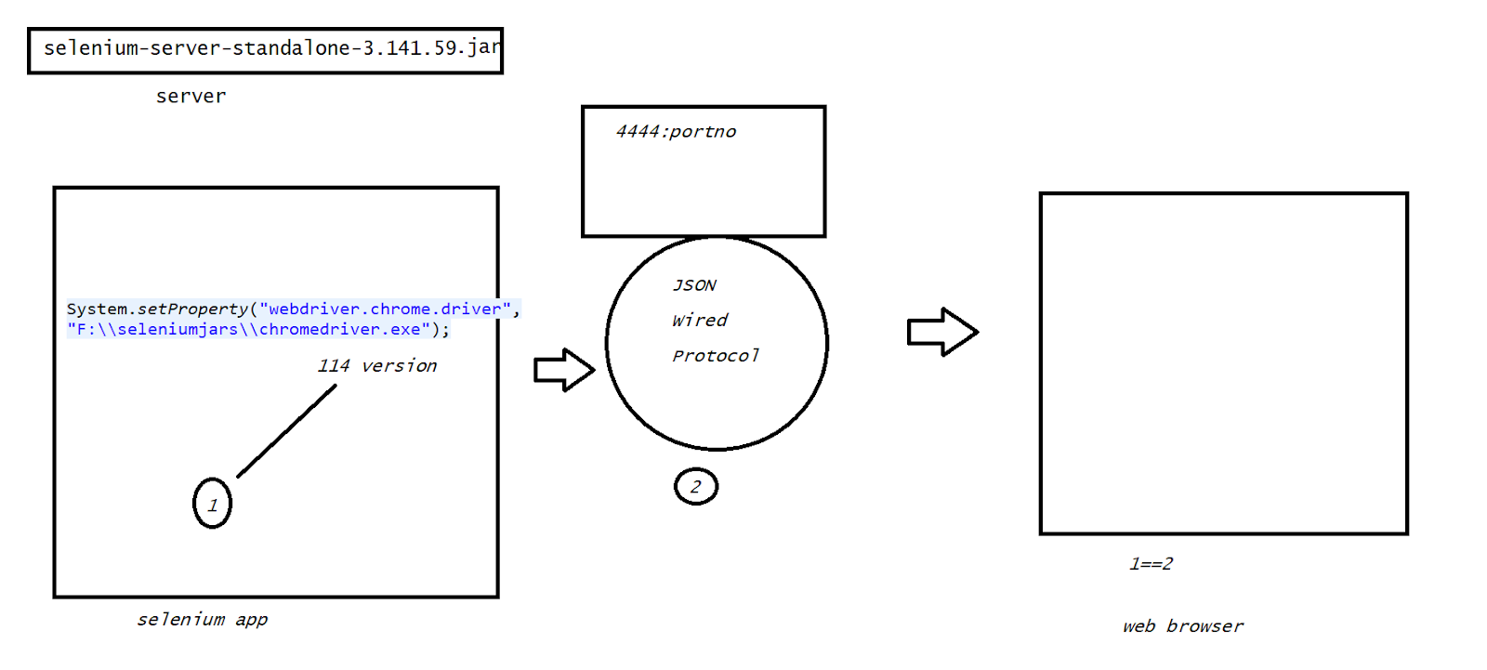

field - sendKeys()

Button , hyperlink - click(),submit(),sendKeys(Keys.ENTER)

Selenium into testing

1. Conditional
2. Junit
3. TestNG

Selenium JDBC

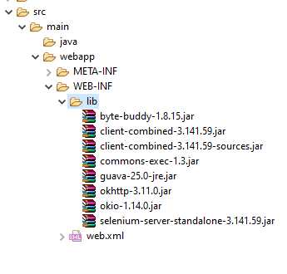+ mysql connector

<%@ page language="java" contentType="text/html; charset=ISO-8859-1"

    pageEncoding="ISO-8859-1"%>

<!DOCTYPE html>

<html>

<head>

<meta charset="ISO-8859-1">

<title>Insert title here</title>

</head>

<body>

<form action="insert.jsp">

User<input type="text" name="user"><br>

<input type="submit" name="submit">

</form>

</body>

</html>

package webselenium;

public class User {

private String username;

public String getUsername() {

return username;

}

public void setUsername(String username) {

this.username = username;

}

}

package webselenium;

import java.sql.Connection;

import java.sql.PreparedStatement;

import java.sql.SQLException;

public class UserDAO {

public int insert(User user) throws ClassNotFoundException, SQLException {

Connection con=dBUtil.dbConn();

String sql="insert into userdetail values(?)";

PreparedStatement ps=con.prepareStatement(sql);

ps.setString(1,user.getUsername());

return ps.executeUpdate();

}

}

package webselenium;

import java.sql.Connection;

import java.sql.DriverManager;

import java.sql.SQLException;

public class dBUtil {

public static Connection dbConn() throws SQLException, ClassNotFoundException {

Class.forName("com.mysql.jdbc.Driver");

Connection con=DriverManager.getConnection("jdbc:mysql://localhost:3306/db1","root","123456");

return con;

}

}

//insert.jsp

<%@ page language="java" contentType="text/html; charset=ISO-8859-1"

    pageEncoding="ISO-8859-1"%>

    <%@page import="webselenium.*" %>

<!DOCTYPE html>

<html>

<head>

<meta charset="ISO-8859-1">

<title>Insert title here</title>

</head>

<body>

<%

String name=request.getParameter("user");

User user=new User();

user.setUsername(name);

UserDAO dao=new UserDAO();

int i=dao.insert(user);

if(i>0){

response.sendRedirect("success.jsp");

}

else{

response.sendRedirect("fail.jsp");

}

%>

</body>

</html>

//success.jsp

<%@ page language="java" contentType="text/html; charset=ISO-8859-1"

    pageEncoding="ISO-8859-1"%>

<!DOCTYPE html>

<html>

<head>

<meta charset="ISO-8859-1">

<title>Insert title here</title>

</head>

<body>

<h1 name="h1">data inserted successfully</h1>

</body>

</html>

//selTest

package selenium;

import java.util.Scanner;

import org.openqa.selenium.By;

import org.openqa.selenium.WebDriver;

import org.openqa.selenium.chrome.ChromeDriver;

public class SelTest {

public static void main(String[] args) {

System.setProperty("webdriver.chrome.driver","F:\\seleniumjars\\chromedriver.exe");

//create an obj to the driver -obj to the browser

WebDriver wd=new ChromeDriver();//wd is the controller obj to web browser

//maxmize the screen

wd.manage().window().maximize();

//web url

wd.get("http://localhost:8083/webselenium/index.jsp");

Scanner sc=new Scanner(System.in);

System.out.println("enter the username");

String name=sc.next();

wd.findElement(By.name("user")).sendKeys(name);

wd.findElement(By.name("submit")).submit();

String actualres=wd.findElement(By.name("h1")).getText();

String expres="data inserted successfully";

//model -1

if(actualres.equals(expres)) {

System.out.println("the testcase is passed");

}

else {

System.out.println("the test case is failed");

}

wd.close();

}

}

Sel+Junit Test

package selenium;

import static org.junit.Assert.assertEquals;

import org.junit.After;

import org.junit.Before;

import org.junit.Test;

import org.openqa.selenium.By;

import org.openqa.selenium.WebDriver;

import org.openqa.selenium.chrome.ChromeDriver;

public class SelJTest {

WebDriver wd=null;

@Before

public void init() {

System.setProperty("webdriver.chrome.driver","F:\\seleniumjars\\chromedriver.exe");

//create an obj to the driver -obj to the browser

wd=new ChromeDriver();//wd is the controller obj to web browser

//maxmize the screen

wd.manage().window().maximize();

//web url

wd.get("http://localhost:8083/webselenium/index.jsp");

}

@Test

public void test1() {

wd.findElement(By.name("user")).sendKeys("ravi");

wd.findElement(By.name("submit")).submit();

String actualres=wd.findElement(By.name("h1")).getText();

String expres="data inserted successfully";

assertEquals(expres, actualres);

wd.close();

}

@Test

public void test2() {

wd.findElement(By.name("user")).sendKeys("suresh");

wd.findElement(By.name("submit")).submit();

String actualres=wd.findElement(By.name("h1")).getText();

String expres="data inserted successfully";

assertEquals(expres, actualres);

wd.close();

}

@After

public void deref() {

wd=null;

}

}

Task :

Angular Application any Spring boot application - UI Level Test

***Note: if the test case is working perfectly without any errors - valid pass case.

Note: Server base testing of UI. make sure that the server is up !!!

> Timebounds in selenium

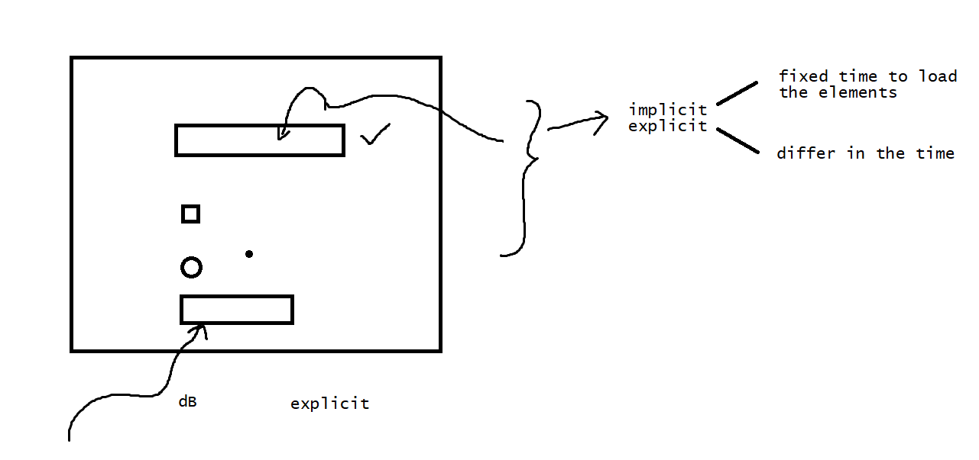

If the webelement is been allocated a fixed set of time then we use implicit

If the webelement is been allocated with different time then we use explicit

Suppose we are trying to find an element which is not been loaded the selenium need to raise an exception after a specified duration of time .

wd.manage().timeouts().implicitlyWait(1,TimeUnit.NANOSECONDS);

With in the time duration of 1 nanosec if the element is not found in loading then we need to get an exception which is raised automatically by the implicit .

import java.util.concurrent.TimeUnit;

import org.openqa.selenium.By;

import org.openqa.selenium.WebDriver;

import org.openqa.selenium.chrome.ChromeDriver;

import org.openqa.selenium.support.ui.Select;

public class SelAuto {

public static void main(String[] args) throws InterruptedException {

//register the chrome driver

System.setProperty("webdriver.chrome.driver","F:\\seleniumjars\\chromedriver.exe");

//create an obj to the driver -obj to the browser

WebDriver wd=new ChromeDriver();//wd is the controller obj to web browser

//maxmize the screen

wd.manage().window().maximize();

//web url

wd.manage().timeouts().pageLoadTimeout(2000,TimeUnit.MILLISECONDS);

wd.get("http://127.0.0.1:5500/register.html");

wd.manage().timeouts().implicitlyWait(10,TimeUnit.NANOSECONDS);

Select sc=new Select(wd.findElement(By.name("op")));

sc.selectByVisibleText("JAVA");

}

}

//explicit

import java.util.concurrent.TimeUnit;

import org.openqa.selenium.By;

import org.openqa.selenium.WebDriver;

import org.openqa.selenium.WebElement;

import org.openqa.selenium.chrome.ChromeDriver;

import org.openqa.selenium.support.ui.ExpectedConditions;

import org.openqa.selenium.support.ui.Select;

import org.openqa.selenium.support.ui.WebDriverWait;

public class SelAuto {

public static void main(String[] args) throws InterruptedException {

//register the chrome driver

System.setProperty("webdriver.chrome.driver","F:\\seleniumjars\\chromedriver.exe");

//create an obj to the driver -obj to the browser

WebDriver wd=new ChromeDriver();//wd is the controller obj to web browser

//maxmize the screen

wd.manage().window().maximize();

//web url

wd.manage().timeouts().pageLoadTimeout(2000,TimeUnit.MILLISECONDS);

wd.get("http://127.0.0.1:5500/register.html");

//wd.manage().timeouts().implicitlyWait(10,TimeUnit.NANOSECONDS);

WebElement we1=wd.findElement(By.name("id"));

WebElement we2=wd.findElement(By.name("op"));

explicit(wd,we1,200,"1");

explicitSelect(wd,we2,300);

}

public static void explicit(WebDriver wd,WebElement we,int timeout,String value) {

new WebDriverWait(wd, timeout).until(ExpectedConditions.visibilityOf(we));

we.sendKeys(value);

}

public static void explicitSelect(WebDriver wd, WebElement we, int timeout) {

new WebDriverWait(wd, timeout).until(ExpectedConditions.visibilityOf(we));

Select sc=new Select(we);

sc.selectByVisibleText("JAVA");

}

}

//Task do implicit on amazon registration

//Alert

import java.util.concurrent.TimeUnit;

import org.openqa.selenium.Alert;

import org.openqa.selenium.WebDriver;

import org.openqa.selenium.chrome.ChromeDriver;

public class SelAuto {

public static void main(String[] args) throws InterruptedException {

//register the chrome driver

System.setProperty("webdriver.chrome.driver","F:\\seleniumjars\\chromedriver.exe");

//create an obj to the driver -obj to the browser

WebDriver wd=new ChromeDriver();//wd is the controller obj to web browser

//maxmize the screen

wd.manage().window().maximize();

//web url

wd.manage().timeouts().pageLoadTimeout(2000,TimeUnit.MILLISECONDS);

wd.get("http://127.0.0.1:5500/msg.html");

Alert alert=wd.switchTo().alert();

System.out.println(alert.getText());

Thread.sleep(2000);

alert.accept();

}

}

//HTML

<!DOCTYPE html>

<html lang="en">

<head>

   <script>

    alert("hi users")

   </script>

</head>

</html>

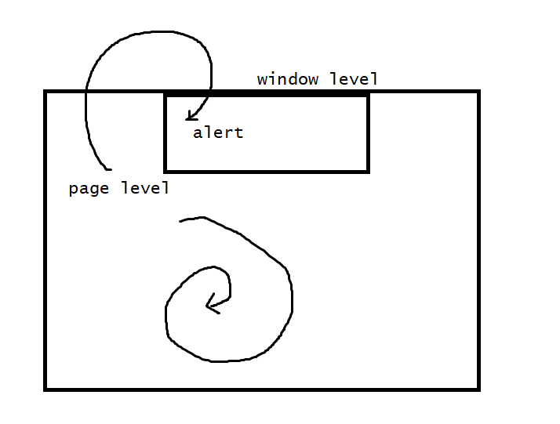

//Scrolling

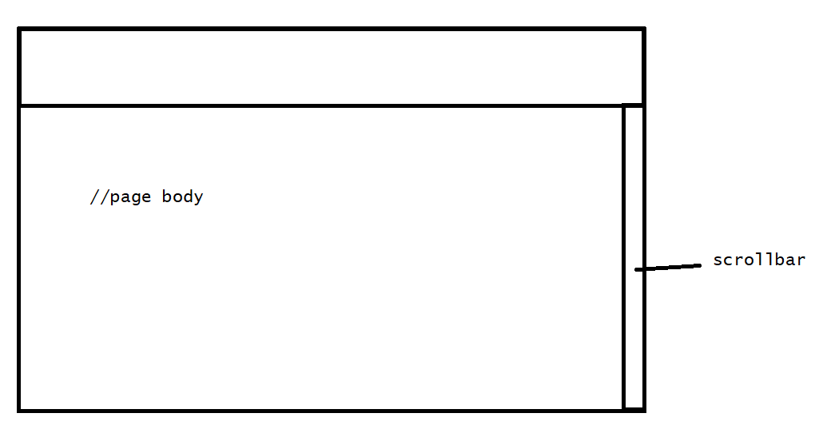

JavaScriptExecutor

1. Script->js that need to get execute
2. Argument->arg od script , optional

import java.util.concurrent.TimeUnit;

import org.openqa.selenium.Alert;

import org.openqa.selenium.By;

import org.openqa.selenium.JavascriptExecutor;

import org.openqa.selenium.WebDriver;

import org.openqa.selenium.WebElement;

import org.openqa.selenium.chrome.ChromeDriver;

public class SelAuto {

public static void main(String[] args) throws InterruptedException {

//register the chrome driver

System.setProperty("webdriver.chrome.driver","F:\\seleniumjars\\chromedriver.exe");

//create an obj to the driver -obj to the browser

WebDriver wd=new ChromeDriver();//wd is the controller obj to web browser

//maxmize the screen

wd.manage().window().maximize();

//web url

wd.get("https://www.amazon.in/");

JavascriptExecutor js=(JavascriptExecutor)wd;

//no of pixels

//js.executeScript("window.scrollBy(0,1000)");

//till find element

// WebElement we=wd.findElement(By.linkText("Help"));

// js.executeScript("arguments[0].scrollIntoView();",we);

// we.click();

//scroll down to the last

js.executeScript("window.scrollBy(0,document.body.scrollHeight)");

}

}

//generate screenshots

<https://mvnrepository.com/artifact/commons-io/commons-io/2.4>

import java.io.File;

import java.io.IOException;

import java.util.concurrent.TimeUnit;

import org.apache.commons.io.FileUtils;

import org.openqa.selenium.Alert;

import org.openqa.selenium.By;

import org.openqa.selenium.JavascriptExecutor;

import org.openqa.selenium.OutputType;

import org.openqa.selenium.TakesScreenshot;

import org.openqa.selenium.WebDriver;

import org.openqa.selenium.WebElement;

import org.openqa.selenium.chrome.ChromeDriver;

public class SelAuto {

public static void main(String[] args) throws InterruptedException, IOException {

//register the chrome driver

System.setProperty("webdriver.chrome.driver","F:\\seleniumjars\\chromedriver.exe");

//create an obj to the driver -obj to the browser

WebDriver wd=new ChromeDriver();//wd is the controller obj to web browser

//maxmize the screen

wd.manage().window().maximize();

//web url

wd.get("https://www.amazon.in/");

JavascriptExecutor js=(JavascriptExecutor)wd;

//no of pixels

//js.executeScript("window.scrollBy(0,1000)");

WebElement we=wd.findElement(By.linkText("Help"));

js.executeScript("arguments[0].scrollIntoView();",we);

if(we!=null) {

takeScreenshot(wd,"amazon");

}

we.click();

//scroll down to the last

//js.executeScript("window.scrollBy(0,document.body.scrollHeight)");

}

public static void takeScreenshot(WebDriver wd,String fileName) throws IOException {

//take the screenshot and store it as a file format

File file=((TakesScreenshot)wd).getScreenshotAs(OutputType.FILE);

//now copy the screen shot to the specified location

FileUtils.copyFile(file,new File("F:\\"+fileName+".png"));

}

}

Auto IT

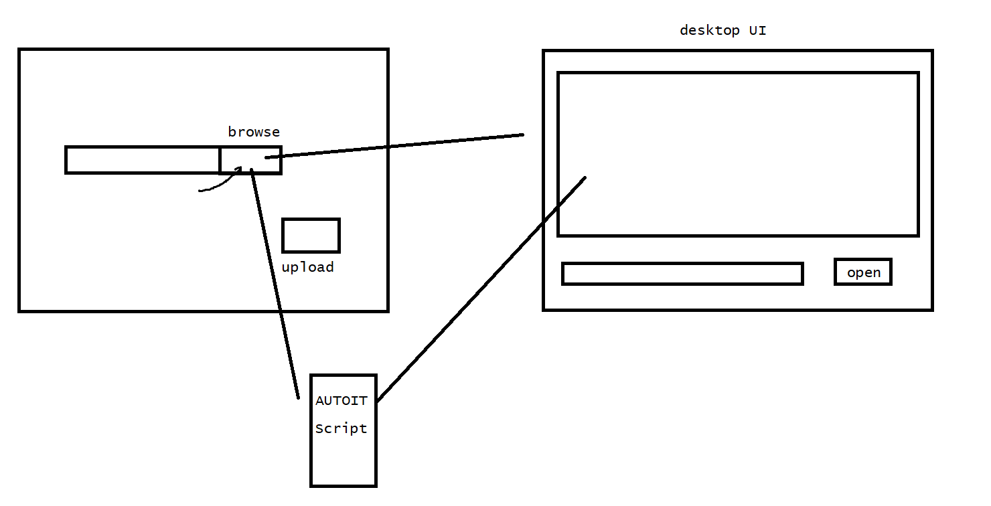

It is a freeware scripting language for automating the GUI of the desktop

It records the Keystrokes,mouse movements and the window control manipulations to automate a task which is not possible with the sel web driver .

Steps :

1. AUTO IT
2. Write the web element to access the sel code
3. Open the auto it editor and write the script to access the GUI level operations
4. Compile the script by using the AUTO IT compiler
5. Make it as a .exe file
6. Include that .exe file into the java code .

<https://www.autoitscript.com/site/autoit/downloads/>

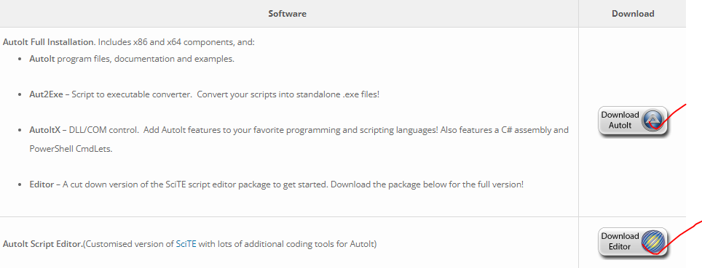

Need to download and install

1.editor

2.autoit setup

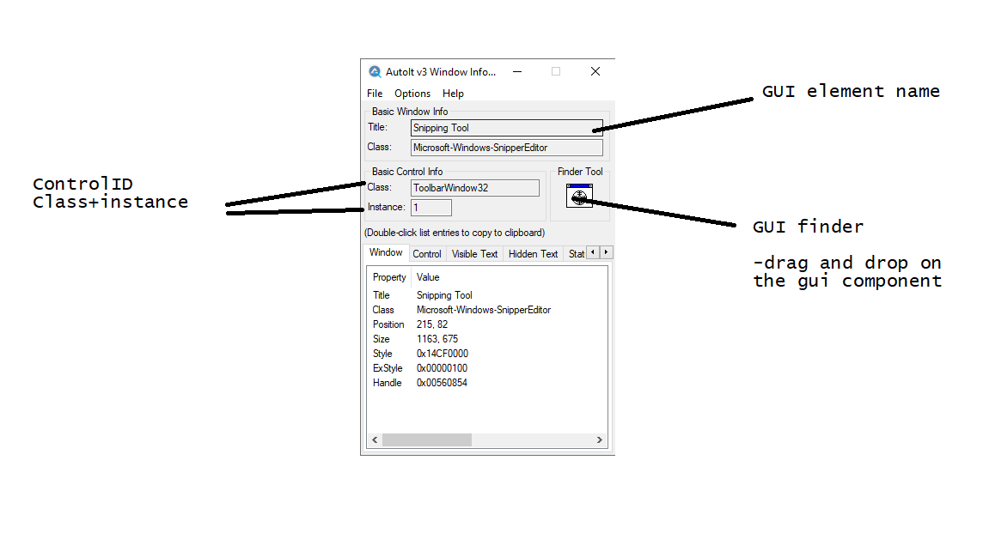

Script of AUTOIT

1. Create an autoit script file .au3
2. Write a script code

//open->Edit->filename->click on the button

ControlFocus("Open","","Edit1")

ControlSetText("Open","","Edit1","F:\absl.pdf")

ControlClick("Open","","Button1")

->Tools -> Test compile -load the compile file into the selenium code

import java.io.File;

import java.io.IOException;

import java.util.concurrent.TimeUnit;

import org.apache.commons.io.FileUtils;

import org.openqa.selenium.Alert;

import org.openqa.selenium.By;

import org.openqa.selenium.JavascriptExecutor;

import org.openqa.selenium.OutputType;

import org.openqa.selenium.TakesScreenshot;

import org.openqa.selenium.WebDriver;

import org.openqa.selenium.WebElement;

import org.openqa.selenium.chrome.ChromeDriver;

public class SelAuto {

public static void main(String[] args) throws InterruptedException, IOException {

//register the chrome driver

System.setProperty("webdriver.chrome.driver","F:\\seleniumjars\\chromedriver.exe");

//create an obj to the driver -obj to the browser

WebDriver wd=new ChromeDriver();//wd is the controller obj to web browser

//maxmize the screen

wd.manage().window().maximize();

             wd.manage().timeouts().implicitlyWait(2000,TimeUnit.MILLISECONDS);

//web url

wd.get("https://www.ilovepdf.com/pdf_to_word");

wd.findElement(By.id("pickfiles")).click();

Runtime.getRuntime().exec("F:\\fileupload.exe");

//processTask

wd.findElement(By.xpath("//*[@id=\'processTask\']")).click();

}

}

How to execute

1. Compile the auto-it file - after getting a fresh .exe
2. Run the selenium code

→Sikuli

Open source GUI-based test automation tool .

>Image recognition technique in accessing the web elements

Disadvantage

1. Physically store the images on the machine.

<https://launchpad.net/sikuli/+milestone/2.0.5>

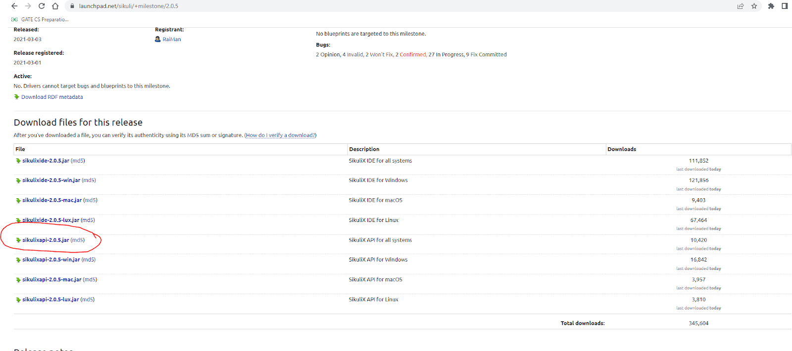

Download the jar file .

import java.io.File;

import java.io.IOException;

import java.util.concurrent.TimeUnit;

import org.apache.commons.io.FileUtils;

import org.openqa.selenium.Alert;

import org.openqa.selenium.By;

import org.openqa.selenium.JavascriptExecutor;

import org.openqa.selenium.OutputType;

import org.openqa.selenium.TakesScreenshot;

import org.openqa.selenium.WebDriver;

import org.openqa.selenium.WebElement;

import org.openqa.selenium.chrome.ChromeDriver;

import org.sikuli.script.FindFailed;

import org.sikuli.script.Pattern;

import org.sikuli.script.Screen;

public class SelAuto {

public static void main(String[] args) throws InterruptedException, IOException, FindFailed {

//register the chrome driver

System.setProperty("webdriver.chrome.driver","F:\\seleniumjars\\chromedriver.exe");

//create an obj to the driver -obj to the browser

WebDriver wd=new ChromeDriver();//wd is the controller obj to web browser

//maxmize the screen

wd.manage().window().maximize();

wd.manage().timeouts().implicitlyWait(2000,TimeUnit.MILLISECONDS);

wd.get("https://www.amazon.in/");

Screen sc=new Screen();

Pattern p3=new Pattern("F:\\image6.png");

sc.type(p3,"samsung");

Pattern p4=new Pattern("F:\\image7.png");

sc.click(p4);

}

}

Task :

1. Complete the registration page access with selenium - // data picker
2. Take the upload task and make it run on sikuli

<https://github.com/kkarthik46/mphasisimage>

>TestNg

NG -next generation

Java based test framework

>Generate some repots for the test in the physicall way on the local.

60% Junit + report generation + prioritizing +group test + parallel test

>selinium + TestNg

–goto marketplace and install testng

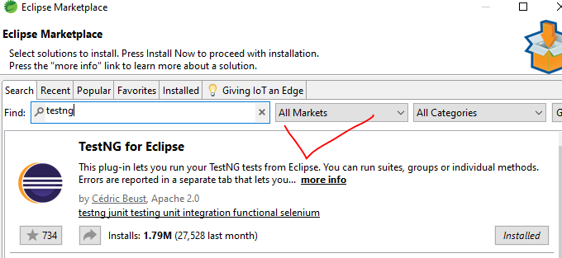

Step -1 add these dependencies -dont take 4.+

<!-- https://mvnrepository.com/artifact/org.seleniumhq.selenium/selenium-java -->

<dependency>

    <groupId>org.seleniumhq.selenium</groupId>

    <artifactId>selenium-java</artifactId>

    <version>3.141.59</version>

</dependency>

<!-- https://mvnrepository.com/artifact/io.github.bonigarcia/webdrivermanager -->

<dependency>

    <groupId>io.github.bonigarcia</groupId>

    <artifactId>webdrivermanager</artifactId>

    <version>5.4.0</version>

</dependency>

Step -2 create a TestNg class file

package com.example;

import org.openqa.selenium.WebDriver;

import org.openqa.selenium.chrome.ChromeDriver;

import org.openqa.selenium.edge.EdgeDriver;

import org.openqa.selenium.firefox.FirefoxDriver;

import org.testng.annotations.Test;

import io.github.bonigarcia.wdm.WebDriverManager;

public class NewTest {

  @Test

  public void f() {

WebDriverManager.chromedriver().setup();

//  System.setProperty("webdriver.chrome.driver","F:\\seleniumjars\\chromedriver.exe");

  WebDriver wd=new ChromeDriver();

  wd.manage().window().maximize();

  wd.get("https://www.amazon.in/");

  }

  @Test

  public void f2() {

WebDriverManager.chromedriver().setup();

//  System.setProperty("webdriver.chrome.driver","F:\\seleniumjars\\chromedriver.exe");

  WebDriver wd=new ChromeDriver();

  wd.manage().window().maximize();

  wd.get("https://www.adre.in/");

  }

}

Step -4 Check the html file for the report

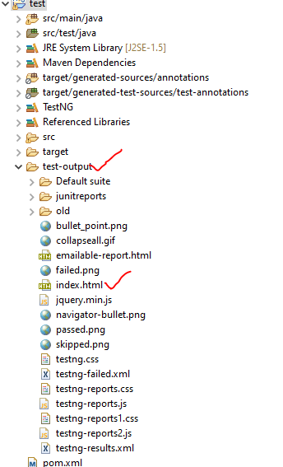

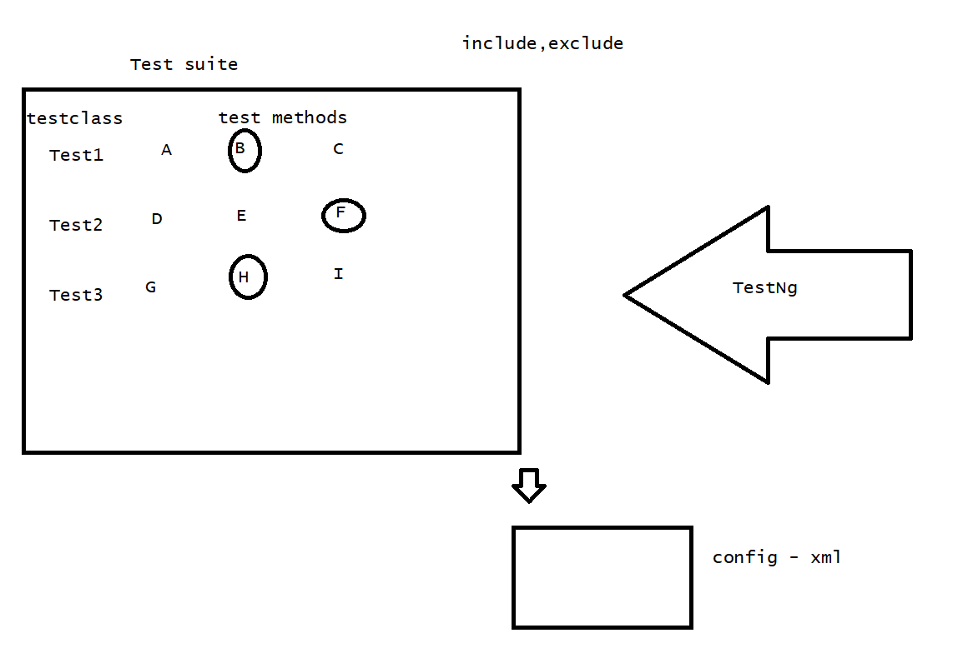

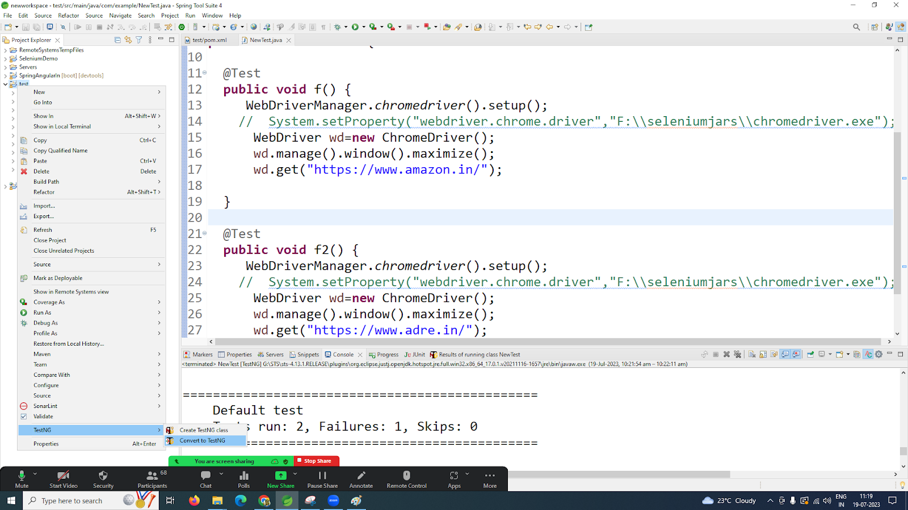

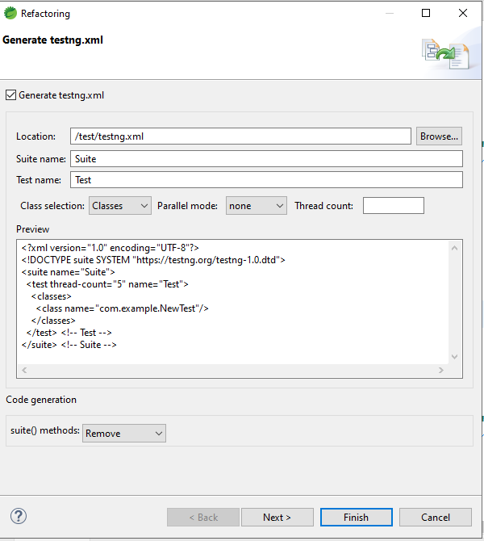

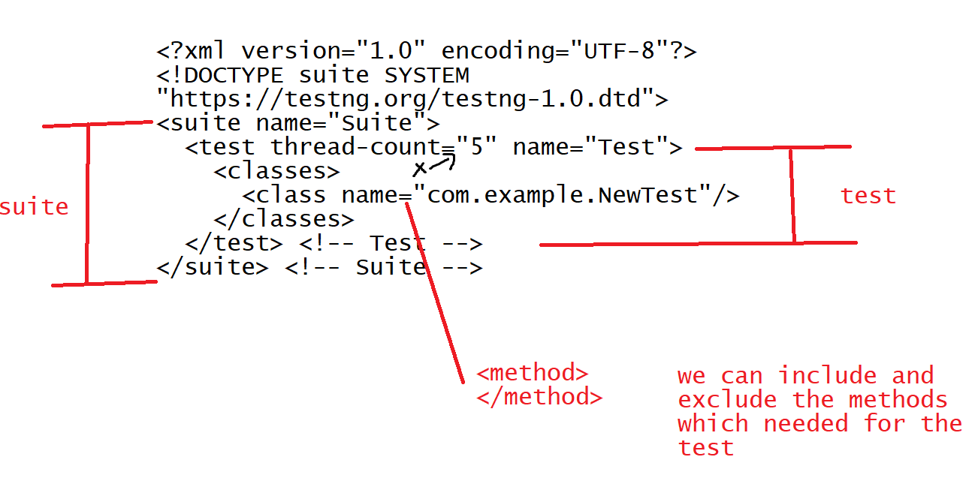

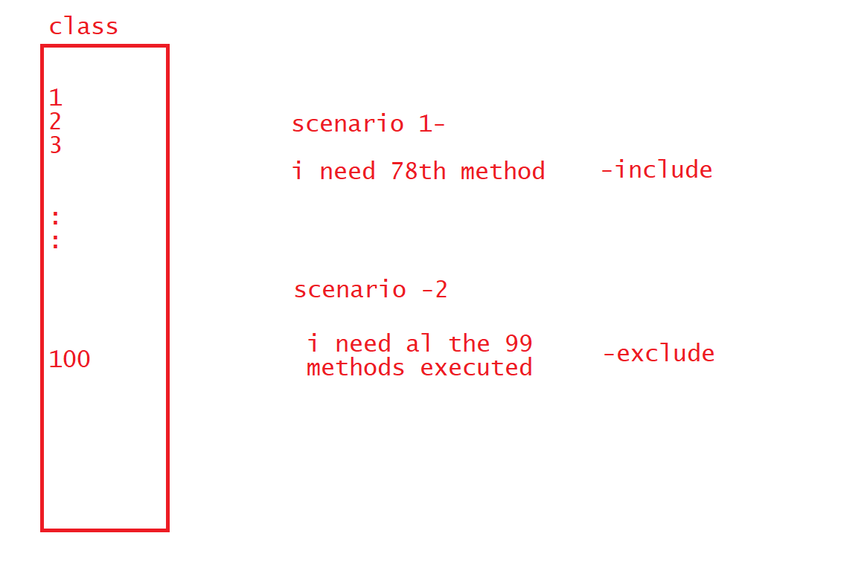

package com.example;

import org.openqa.selenium.WebDriver;

import org.openqa.selenium.chrome.ChromeDriver;

import org.testng.annotations.Test;

import io.github.bonigarcia.wdm.WebDriverManager;

public class NewTest {

  @Test

  public void test1() {

WebDriverManager.chromedriver().setup();

//  System.setProperty("webdriver.chrome.driver","F:\\seleniumjars\\chromedriver.exe");

  WebDriver wd=new ChromeDriver();

  wd.manage().window().maximize();

  wd.get("https://www.amazon.in/");

  wd.close();

  }

  @Test

  public void test2() {

System.out.println("hi");

  }

}

package com.example;

import org.openqa.selenium.WebDriver;

import org.openqa.selenium.chrome.ChromeDriver;

import org.testng.annotations.Test;

import io.github.bonigarcia.wdm.WebDriverManager;

public class NewTest1 {

@Test

  public void test3() {

WebDriverManager.chromedriver().setup();

//  System.setProperty("webdriver.chrome.driver","F:\\seleniumjars\\chromedriver.exe");

  WebDriver wd=new ChromeDriver();

  wd.manage().window().maximize();

  wd.get("https://www.google.com/");

  }

@Test

  public void test4() {

System.out.println("in test4");

  }

}

<?xml version="1.0" encoding="UTF-8"?>

<!DOCTYPE suite SYSTEM "https://testng.org/testng-1.0.dtd">

<suite name="Suite">

<!-- test 1 scenario -->

  <test  name="Test1">

    <classes>

      <class name="com.example.NewTest">

      <methods>

      <exclude name="test2"></exclude>

      </methods>

      </class>

    </classes>

  </test> <!-- Test -->

  <!-- test 2 scenario -->

   <test  name="Test2">

    <classes>

      <class name="com.example.NewTest1">

      <methods>

      <include name="test4"></include>

      </methods>

      </class>

    </classes>

  </test>

</suite> <!-- Suite -->

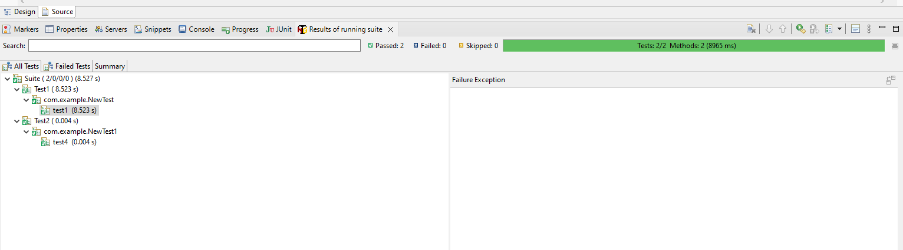

//Optimizing the code with @BeforeTest,@AfterTest

 package com.example;

import org.openqa.selenium.WebDriver;

import org.openqa.selenium.chrome.ChromeDriver;

import org.testng.annotations.AfterTest;

import org.testng.annotations.BeforeTest;

import org.testng.annotations.Test;

import io.github.bonigarcia.wdm.WebDriverManager;

public class NewTest {

WebDriver wd=null;

  @Test

  public void test1() {

  System.out.println("in test1");

  wd.get("https://www.google.com/");

  }

  @Test

  public void test2() {

  System.out.println("in test2");

  wd.get("https://www.amazon.in/");

  }

  @BeforeTest

  public void beforeTest() {

  System.out.println("in beforetest");

  WebDriverManager.chromedriver().setup();

  wd=new ChromeDriver();

  wd.manage().window().maximize();

  }

  @AfterTest

  public void afterTest() {

  System.out.println("in aftertest");

  wd.close();

  }

}

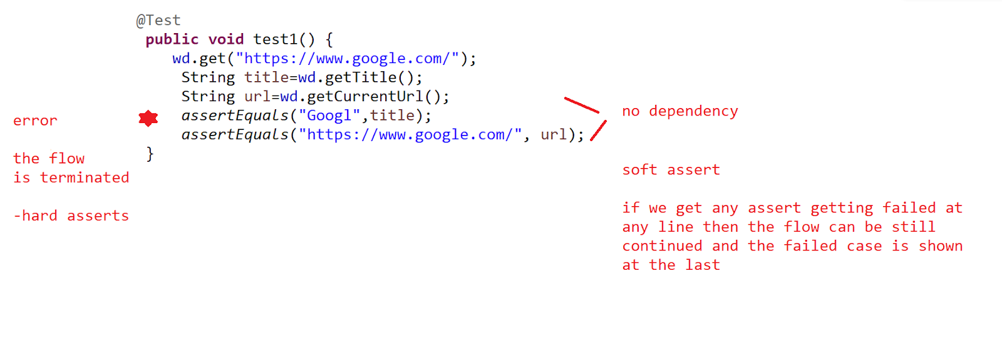

//hard assert

package com.example;

import static org.testng.Assert.assertEquals;

import org.openqa.selenium.WebDriver;

import org.openqa.selenium.chrome.ChromeDriver;

import org.testng.annotations.AfterTest;

import org.testng.annotations.BeforeTest;

import org.testng.annotations.Test;

import io.github.bonigarcia.wdm.WebDriverManager;

public class NewTest {

WebDriver wd=null;

  @Test

  public void test1() {

  wd.get("https://www.google.com/");

  String title=wd.getTitle();

  String url=wd.getCurrentUrl();

assertEquals("Googl",title);

assertEquals("https://www.google.com/", url);

  }

  @Test

  public void test2() {

  System.out.println("in test2");

  wd.get("https://www.amazon.in/");

  }

  @BeforeTest

  public void beforeTest() {

  System.out.println("in beforetest");

  WebDriverManager.chromedriver().setup();

  wd=new ChromeDriver();

  wd.manage().window().maximize();

  }

  @AfterTest

  public void afterTest() {

  System.out.println("in aftertest");

  wd.close();

  }

}

//softassert

package com.example;

import static org.testng.Assert.assertEquals;

import org.openqa.selenium.WebDriver;

import org.openqa.selenium.chrome.ChromeDriver;

import org.testng.annotations.AfterTest;

import org.testng.annotations.BeforeTest;

import org.testng.annotations.Test;

import org.testng.asserts.SoftAssert;

import io.github.bonigarcia.wdm.WebDriverManager;

public class NewTest {

WebDriver wd=null;

  @Test

  public void test1() {

  SoftAssert as=new SoftAssert();

  wd.get("https://www.google.com/");

  String title=wd.getTitle();

  String url=wd.getCurrentUrl();

  as.assertEquals("Googl",title);

  as.assertEquals("https://www.google.com/", url);

  System.out.println("after google");

  as.assertAll(); //provide all the assert failures at the last

  }

  @Test

  public void test2() {

  System.out.println("in test2");

  wd.get("https://www.amazon.in/");

  }

  @BeforeTest

  public void beforeTest() {

  System.out.println("in beforetest");

  WebDriverManager.chromedriver().setup();

  wd=new ChromeDriver();

  wd.manage().window().maximize();

  }

  @AfterTest

  public void afterTest() {

  System.out.println("in aftertest");

  wd.close();

  }

}

>Parameter based

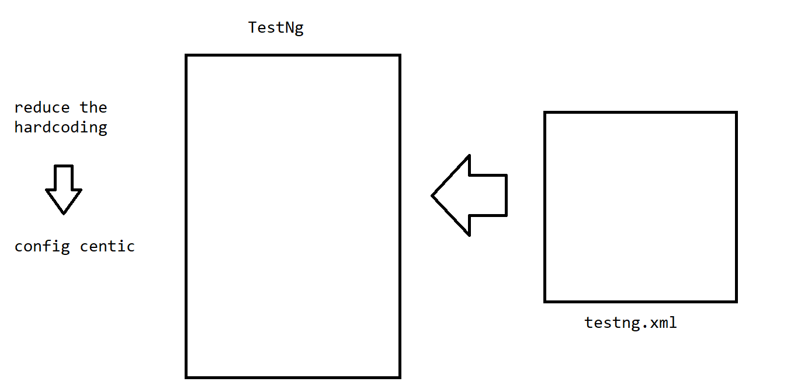

package com.example;

import static org.testng.Assert.assertEquals;

import org.openqa.selenium.WebDriver;

import org.openqa.selenium.chrome.ChromeDriver;

import org.testng.annotations.AfterTest;

import org.testng.annotations.BeforeTest;

import org.testng.annotations.Parameters;

import org.testng.annotations.Test;

import org.testng.asserts.SoftAssert;

import io.github.bonigarcia.wdm.WebDriverManager;

public class NewTest {

WebDriver wd=null;

@Parameters("url1")

  @Test

  public void test1(String url1) {

  wd.get(url1);

  }

  @Parameters("url2")

  @Test

  public void test2(String url2) {

  System.out.println("in test2");

  wd.get(url2);

  }

  @BeforeTest

  public void beforeTest() {

  System.out.println("in beforetest");

  WebDriverManager.chromedriver().setup();

  wd=new ChromeDriver();

  wd.manage().window().maximize();

  }

  @AfterTest

  public void afterTest() {

  System.out.println("in aftertest");

  wd.close();

  }

}

Task :

UI testing - Junit

UI testing - TestNg—test report

//pom.xml

//Parallel test

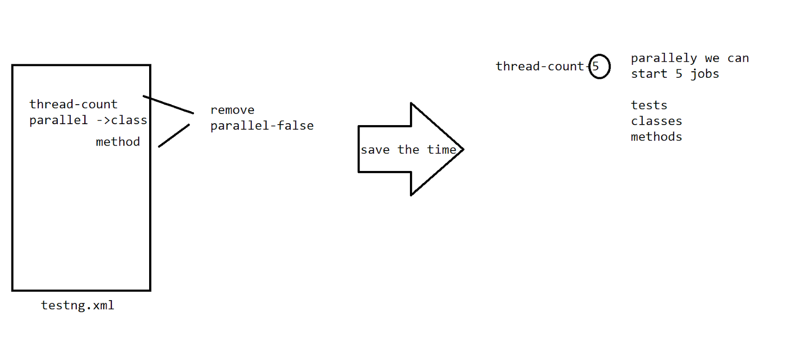

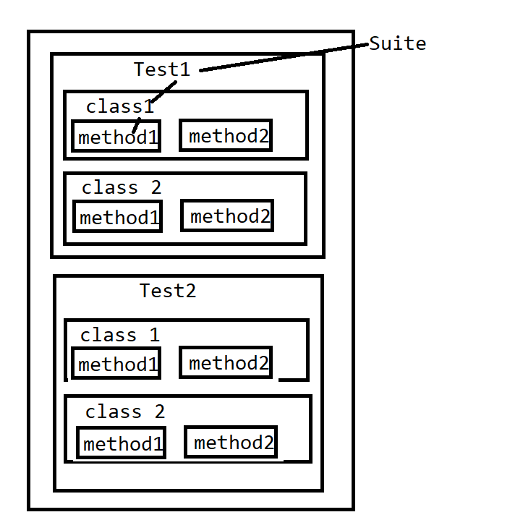

<?xml version="1.0" encoding="UTF-8"?>

<!DOCTYPE suite SYSTEM "https://testng.org/testng-1.0.dtd">

<suite name="Suite"  >

  <test  name="Test1" thread-count="5" parallel="classes">

    <classes>

      <class name="com.example.NewTest"></class>

       <class name="com.example.NewTest1"></class>

    </classes>

  </test> <!-- Test -->

</suite> <!-- Suite -->

package com.example;

import static org.testng.Assert.assertEquals;

import org.openqa.selenium.WebDriver;

import org.openqa.selenium.chrome.ChromeDriver;

import org.testng.annotations.AfterTest;

import org.testng.annotations.BeforeTest;

import org.testng.annotations.Parameters;

import org.testng.annotations.Test;

import org.testng.asserts.SoftAssert;

import io.github.bonigarcia.wdm.WebDriverManager;

public class NewTest {

WebDriver wd=null;

  @Test

  public void test1() {

  wd.get("http://www.google.com");

  }

  @Test

  public void test2() {

  wd.get("http://www.amazon.com");

  }

  @BeforeTest

  public void beforeTest() {

  System.out.println("in beforetest");

  WebDriverManager.chromedriver().setup();

  wd=new ChromeDriver();

  wd.manage().window().maximize();

  }

  @AfterTest

  public void afterTest() {

  System.out.println("in aftertest");

  wd.close();

  }

}

package com.example;

import org.openqa.selenium.WebDriver;

import org.openqa.selenium.chrome.ChromeDriver;

import org.testng.annotations.Test;

import io.github.bonigarcia.wdm.WebDriverManager;

public class NewTest1 {

@Test

  public void test3() {

WebDriverManager.chromedriver().setup();

//  System.setProperty("webdriver.chrome.driver","F:\\seleniumjars\\chromedriver.exe");

  WebDriver wd=new ChromeDriver();

  wd.manage().window().maximize();

  wd.get("https://www.simplilearn.com/");

  wd.close();

  }

}

=>Reports

1. index.html
2. emailable -report.html

In case if we need to send an email then we use the option of the test scenarios

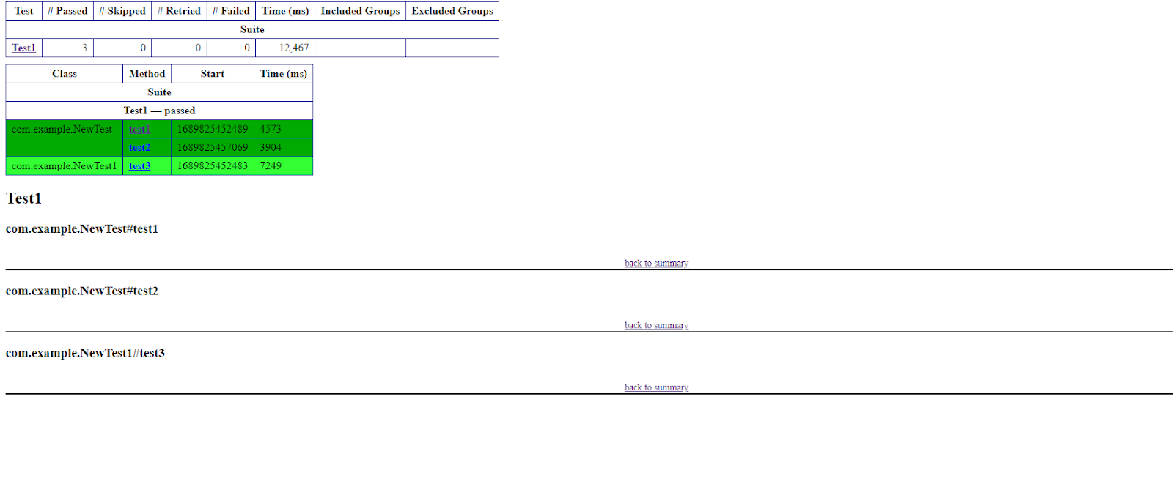

Details report info is in index.html

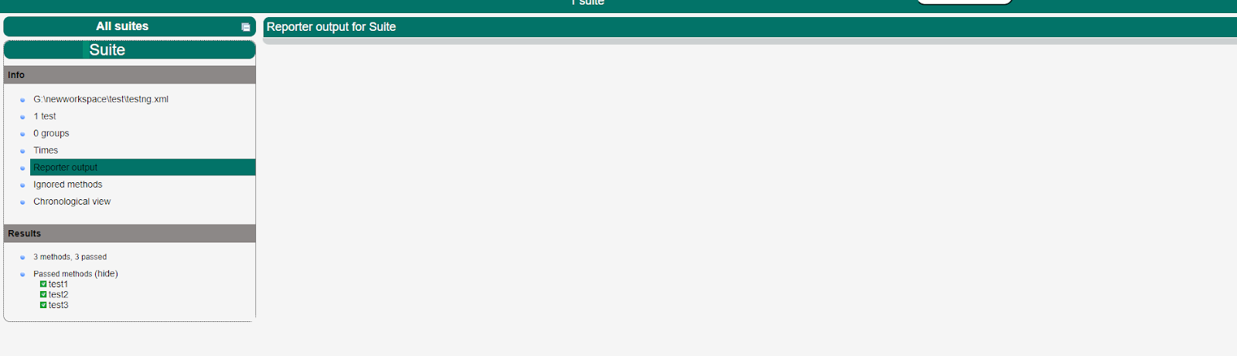

For logging of the test flow we can use

package com.example;

import static org.testng.Assert.assertEquals;

import org.openqa.selenium.WebDriver;

import org.openqa.selenium.chrome.ChromeDriver;

import org.testng.Reporter;

import org.testng.annotations.AfterTest;

import org.testng.annotations.BeforeTest;

import org.testng.annotations.Parameters;

import org.testng.annotations.Test;

import org.testng.asserts.SoftAssert;

import io.github.bonigarcia.wdm.WebDriverManager;

public class NewTest {

WebDriver wd=null;

  @Test

  public void test1() {

  wd.get("http://www.google.com");

  Reporter.log("went to test1 and used url google");

  }

  @Test

  public void test2() {

  wd.get("http://www.amazon.com");

  Reporter.log("went to test2 and used url amazon");

  }

  @BeforeTest

  public void beforeTest() {

  System.out.println("in beforetest");

  WebDriverManager.chromedriver().setup();

  wd=new ChromeDriver();

  wd.manage().window().maximize();

  Reporter.log("the browser is open");

  }

  @AfterTest

  public void afterTest() {

  System.out.println("in aftertest");

  wd.close();

  }

}

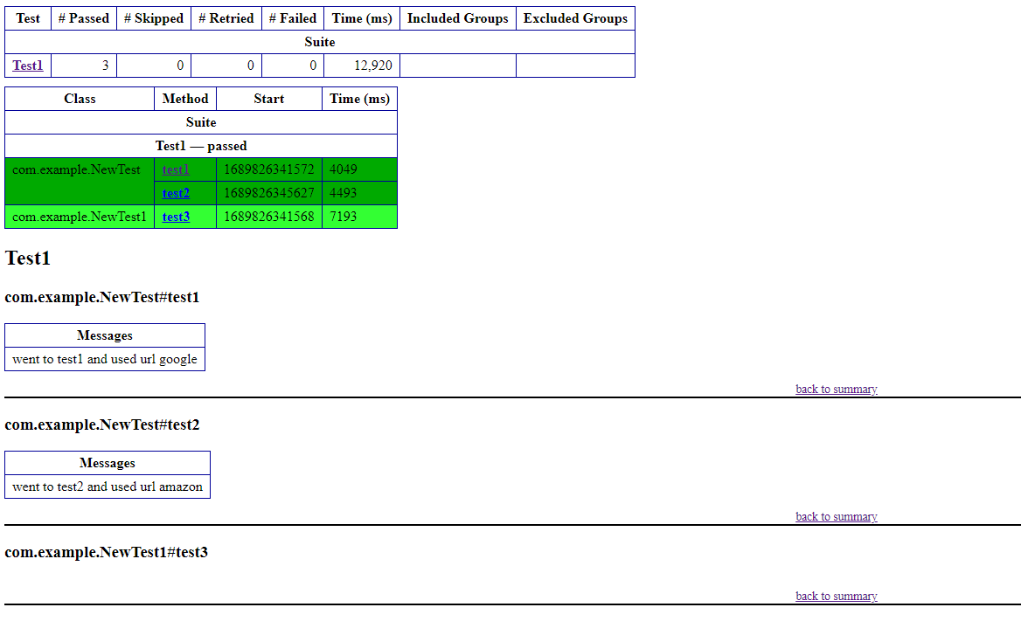

//index.html

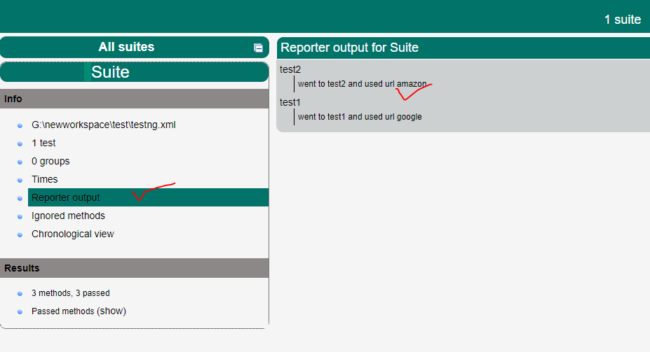

* When ever we dont mention any order of execution in the test then it will go by default in the chronological order of the methods

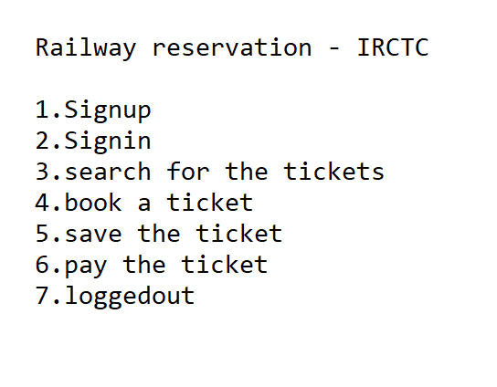

package com.example;

import static org.testng.Assert.assertEquals;

import org.openqa.selenium.WebDriver;

import org.openqa.selenium.chrome.ChromeDriver;

import org.testng.Reporter;

import org.testng.annotations.AfterTest;

import org.testng.annotations.BeforeTest;

import org.testng.annotations.Parameters;

import org.testng.annotations.Test;

import org.testng.asserts.SoftAssert;

import io.github.bonigarcia.wdm.WebDriverManager;

public class NewTest {

@Test(priority = 1)

public void signup() {

System.out.println("user siggned up");

}

@Test(priority = 2)

public void signin() {

System.out.println("user siggned in");

}

@Test(priority = 3)

public void search() {

System.out.println("user started serach");

}

@Test(priority = 4)

public void book() {

System.out.println("user booked a ticket");

}

@Test(priority = 5)

public void save() {

System.out.println("user saved a ticket");

}

@Test(priority = 6)

public void pay() {

System.out.println("user payed");

}

@Test(priority = 7)

public void logout() {

System.out.println("user logged out");

}

}

//Task :

UI Testing using priority —> existing projects →Reporter  –10 min

1. Signup
2. Signin ……

=================================================================

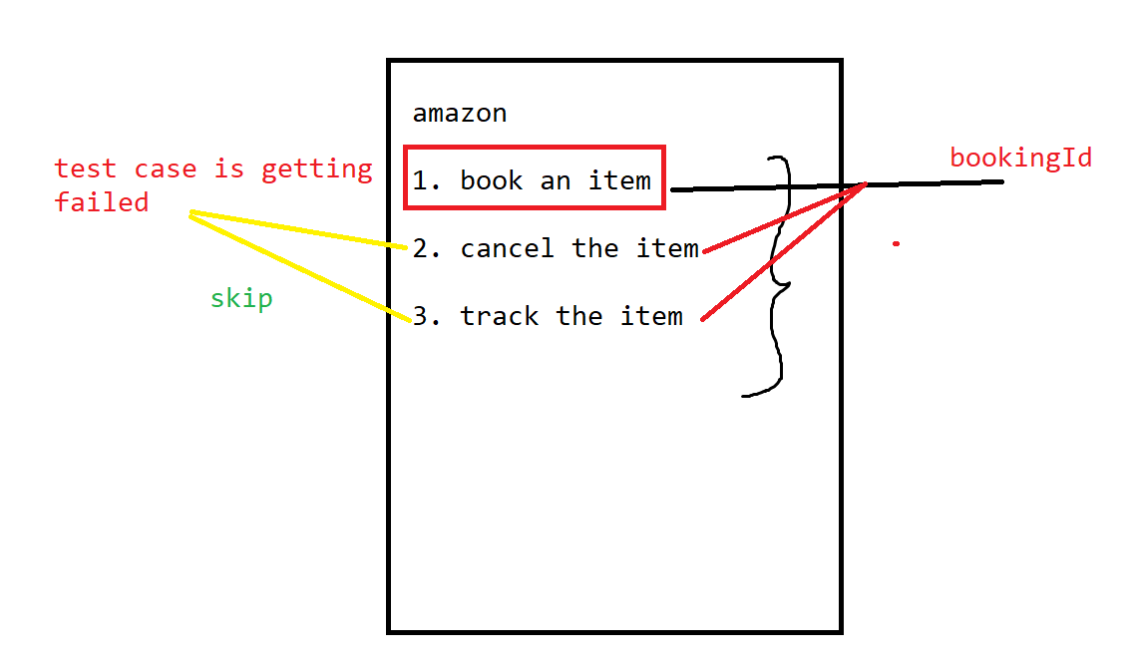

//dependency test

package com.example;

import static org.testng.Assert.assertEquals;

import org.openqa.selenium.WebDriver;

import org.openqa.selenium.chrome.ChromeDriver;

import org.testng.Reporter;

import org.testng.annotations.AfterTest;

import org.testng.annotations.BeforeTest;

import org.testng.annotations.Parameters;

import org.testng.annotations.Test;

import org.testng.asserts.SoftAssert;

import io.github.bonigarcia.wdm.WebDriverManager;

public class NewTest {

String bookId=null;

@Test(priority = 1)

public void booking() {

System.out.println("booking");

int a=50/0;

bookId="XYZ";

}

@Test(priority = 2,dependsOnMethods = {"booking"})

public void tracking() {

if(bookId!=null) {

System.out.println("shipping in progress");

}

else {

System.out.println("booking failed cannot ship");

}

}

@Test(priority = 3,dependsOnMethods = {"booking"})

public void cancelling() {

if(bookId!=null) {

System.out.println("cancellation in progress");

}

else {

System.out.println("cancellation failed ");

}

}

}

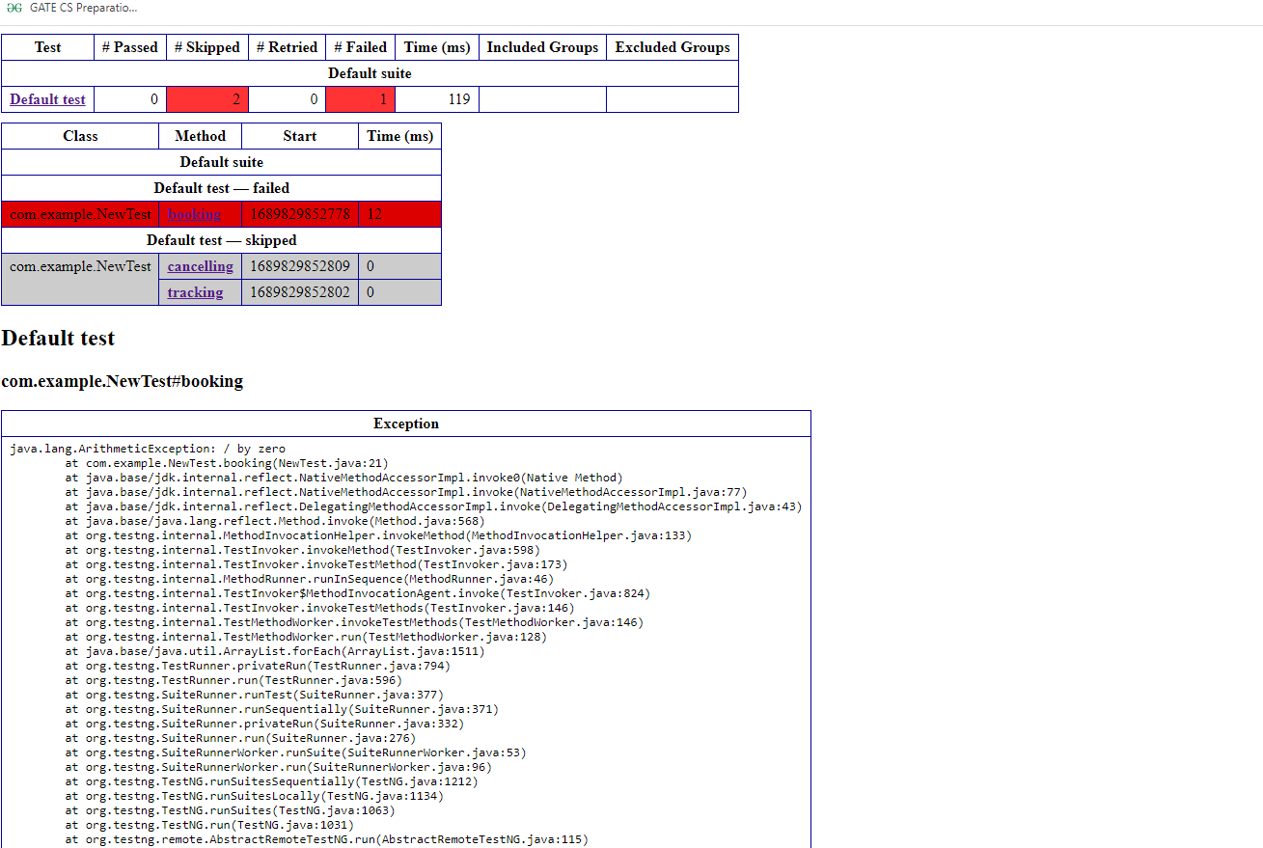

Task

If signin is failed skip with the adding of items to cart

=>Group Testing

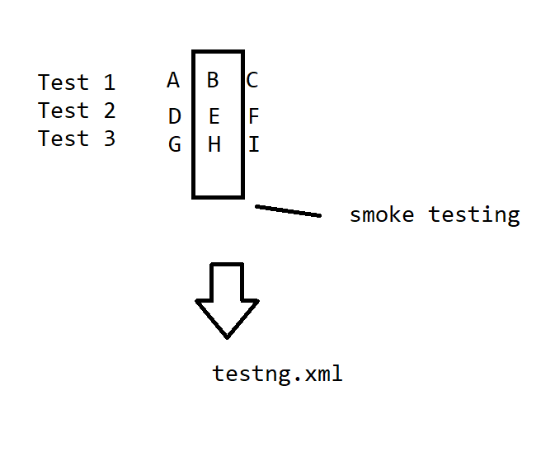

package com.example;

import static org.testng.Assert.assertEquals;

import org.openqa.selenium.WebDriver;

import org.openqa.selenium.chrome.ChromeDriver;

import org.testng.Reporter;

import org.testng.annotations.AfterTest;

import org.testng.annotations.BeforeTest;

import org.testng.annotations.Parameters;

import org.testng.annotations.Test;

import org.testng.asserts.SoftAssert;

import io.github.bonigarcia.wdm.WebDriverManager;

public class NewTest {

@Test(groups = {"smoke"})

public void test1() {

System.out.println("in test1");

}

@Test(groups = {"smoke","functional"})

public void test2() {

System.out.println("in test2");

}

@Test(groups = {"regression"})

public void test3() {

System.out.println("in test3");

}

}

package com.example;

import org.openqa.selenium.WebDriver;

import org.openqa.selenium.chrome.ChromeDriver;

import org.testng.annotations.Test;

import io.github.bonigarcia.wdm.WebDriverManager;

public class NewTest1 {

@Test(groups = {"sanity"})

public void test4() {

System.out.println("in test4");

}

@Test(groups = {"functional","regression"})

public void test5() {

System.out.println("in test5");

}

@Test(groups = {"sanity","smoke"})

public void test6() {

System.out.println("in test6");

}

}

<?xml version="1.0" encoding="UTF-8"?>

<!DOCTYPE suite SYSTEM "https://testng.org/testng-1.0.dtd">

<suite name="Suite">

  <test name="Test1">

  <groups>

  <run>

  <include name="smoke"></include>

  <exclude name="sanity"></exclude>

  <exclude name="functional"></exclude>

  </run>

  </groups>

    <classes>

      <class name="com.example.NewTest"/>

      <class name="com.example.NewTest1"/>

    </classes>

  </test> <!-- Test -->

   <test name="Test2">

 <groups>

  <run>

  <include name="sanity"></include>

  </run>

  </groups>

    <classes>

      <class name="com.example.NewTest"/>

      <class name="com.example.NewTest1"/>

    </classes>

  </test>

</suite> <!-- Suite -->

//task :

Take a test class 3 methods - 1. Open->goolge -> flipkart search of samsung  2.  Open->goolge ->Open amazon search for samsung 3.  Open->goolge ->simplilearn - login

Group - ecomerce - flipkart,amazon

            -education - simplilearn

//dataProviders

This concept is used to supply the data to the config data item from a method defined with @DataProvider

package com.example;

import static org.testng.Assert.assertEquals;

import org.openqa.selenium.WebDriver;

import org.openqa.selenium.chrome.ChromeDriver;

import org.testng.Reporter;

import org.testng.annotations.AfterTest;

import org.testng.annotations.BeforeTest;

import org.testng.annotations.DataProvider;

import org.testng.annotations.Parameters;

import org.testng.annotations.Test;

import org.testng.asserts.SoftAssert;

import io.github.bonigarcia.wdm.WebDriverManager;

public class NewTest {

WebDriver wd=null;

  @Test(dataProvider = "dp")

  public void test1(String url) {

  wd.get(url);

  Reporter.log("went to test1 and used url google");

  }

  @BeforeTest

  public void beforeTest() {

  System.out.println("in beforetest");

  WebDriverManager.chromedriver().setup();

  wd=new ChromeDriver();

  wd.manage().window().maximize();

  Reporter.log("the browser is open");

  }

  @AfterTest

  public void afterTest() {

  System.out.println("in aftertest");

  wd.close();

  }

  @DataProvider

  public Object[][] dp(){

return new Object[][] {

 //test1

  new Object[] {"https://www.google.com/"},

//test2

  new Object[] {"https://www.amazon.in/"}

};

  }

}

//task                url                             data

1. Go  to amazon search for samsung
2. Go to amazon search for apple

Docker :

<https://www.docker.com/products/docker-desktop/>

Prequistes for installations :

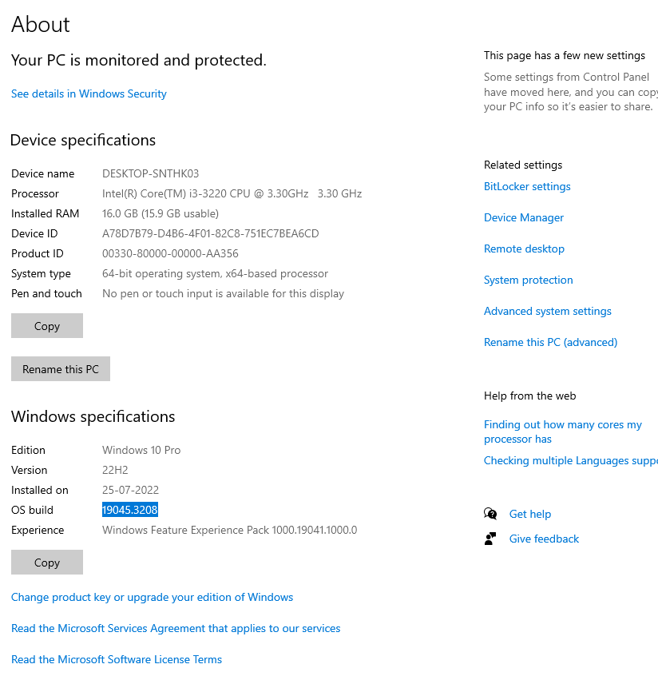

Windows OS >18000

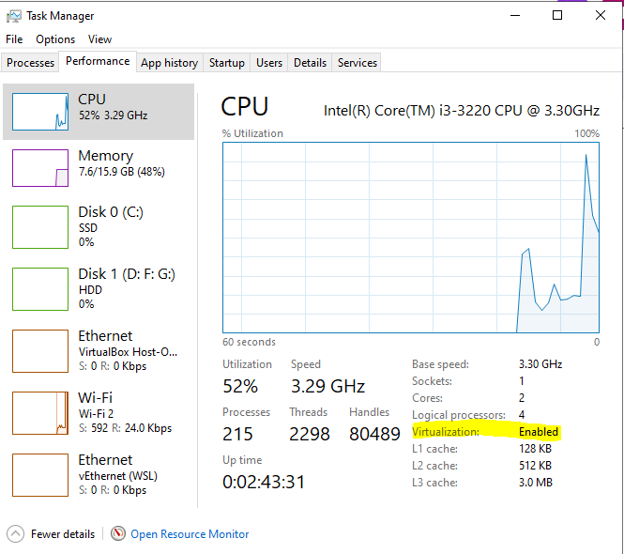

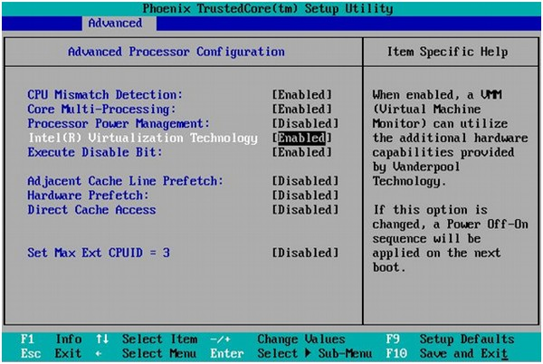

Advanced BIOS  => security

[https://desktop.docker.com/win/main/amd64/Docker%20Desktop%20Installer.exe?utm_source=docker&utm_medium=webreferral&utm_campaign=dd-smartbutton&utm_location=module&_gl=1*141f2ln*_ga*NjczOTQ2ODAwLjE2NTk4ODI4MDY.*_ga_XJWPQMJYHQ*MTY5MDE3MTQwMS4zOC4xLjE2OTAxNzE5MzguNjAuMC4w](https://desktop.docker.com/win/main/amd64/Docker%20Desktop%20Installer.exe?utm_source=docker&utm_medium=webreferral&utm_campaign=dd-smartbutton&utm_location=module&_gl=1*141f2ln*_ga*NjczOTQ2ODAwLjE2NTk4ODI4MDY.*_ga_XJWPQMJYHQ*MTY5MDE3MTQwMS4zOC4xLjE2OTAxNzE5MzguNjAuMC4w)

Install the docker desktop and restart the machine.

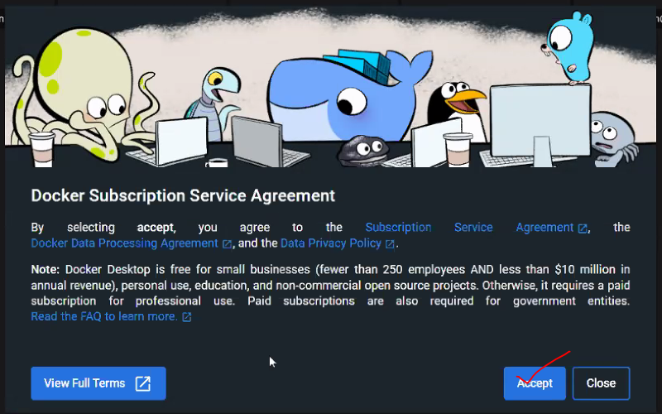

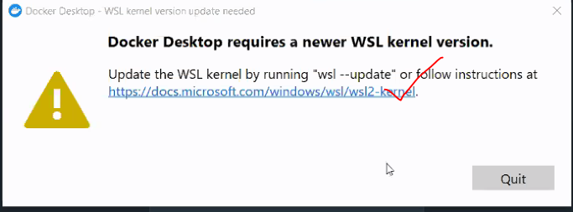

If you are not getting the below screen use the below link

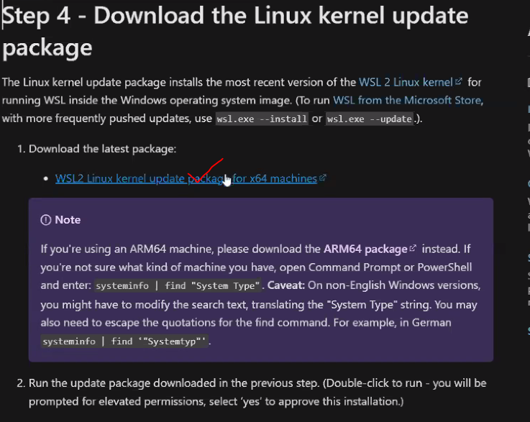

<https://wslstorestorage.blob.core.windows.net/wslblob/wsl_update_x64.msi>

Start the docker desktop

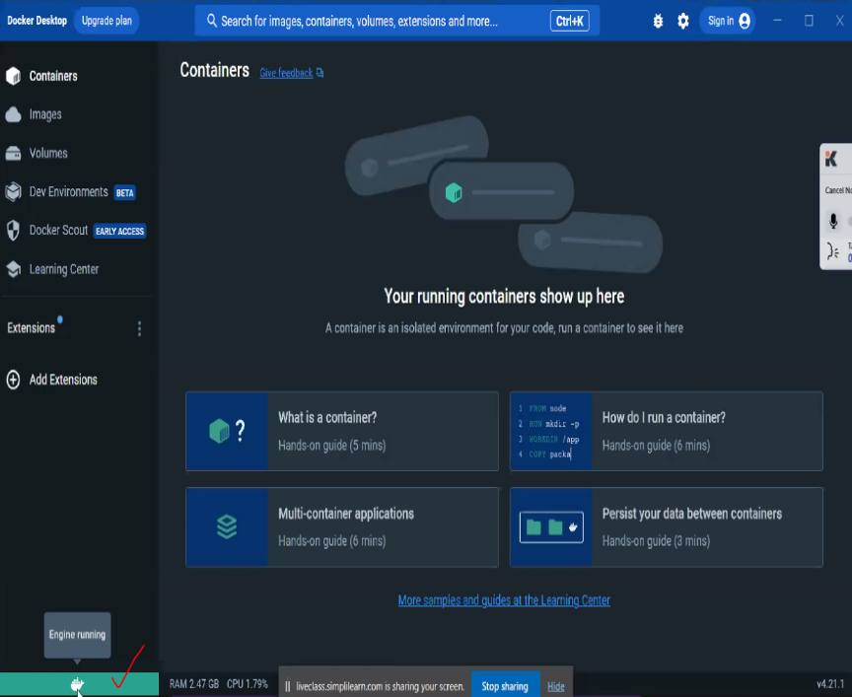

Installation -> 10 - 15 min

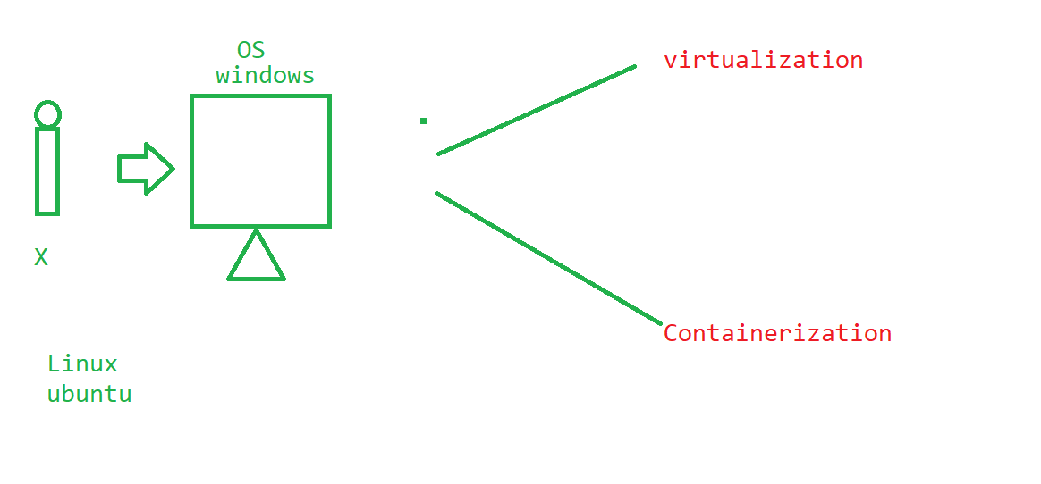

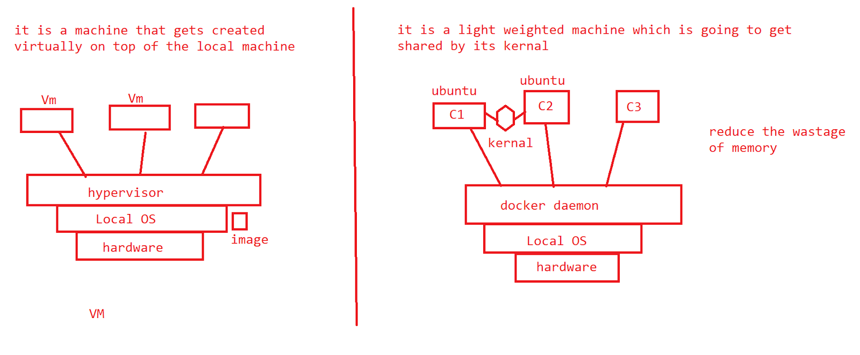

=> Creating an account in docker hub

<https://hub.docker.com/search?q=>

Go to the local docker desktop and do a sign in.

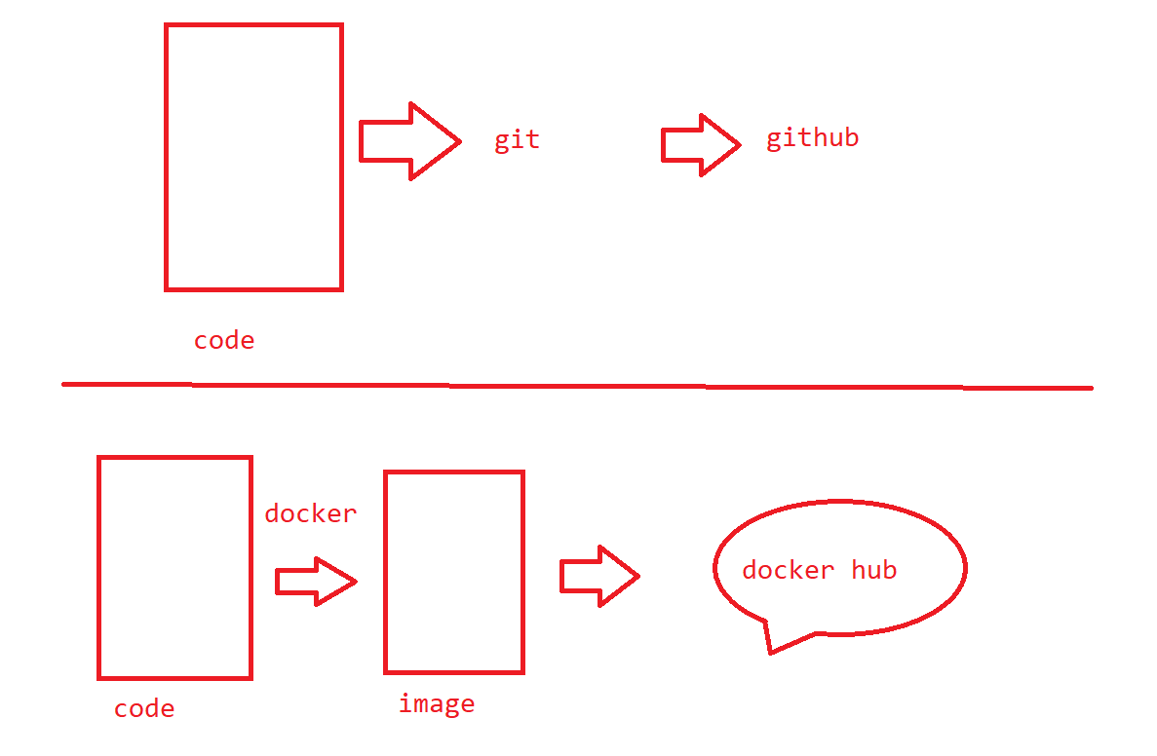

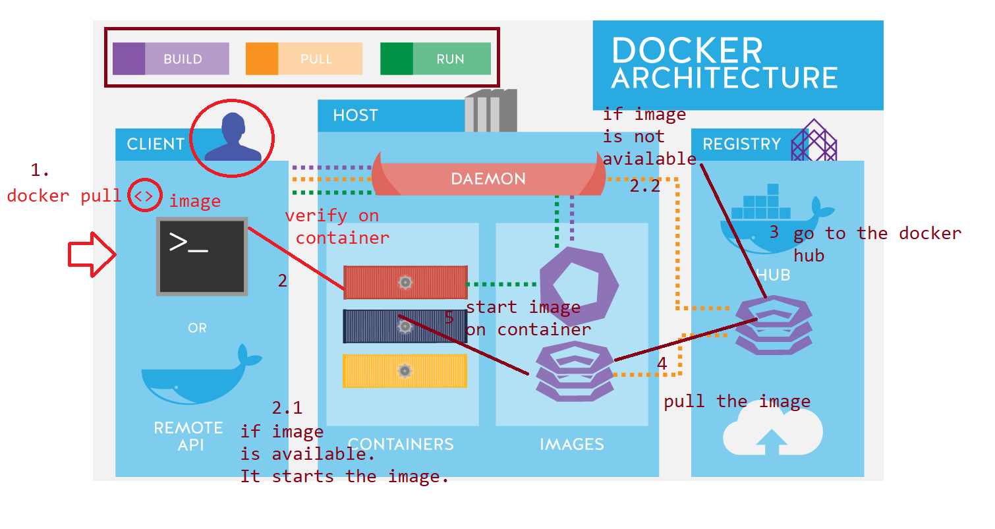

Check docker version

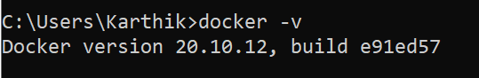

docker help

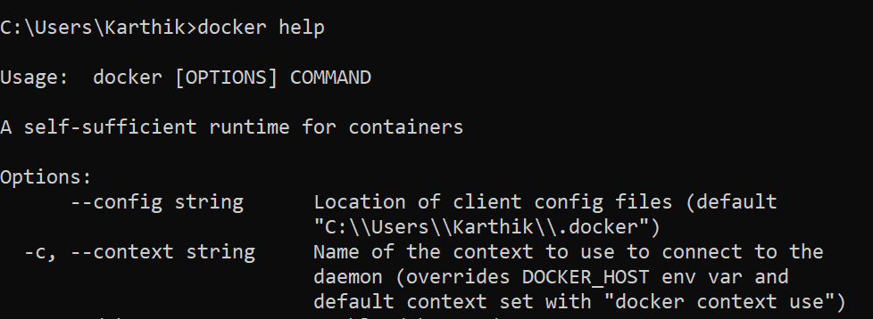

To see the list of images

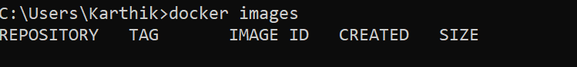

To see the present status of an image over the  container



Present status and also the past status of the containers that got stopped



//ubuntu

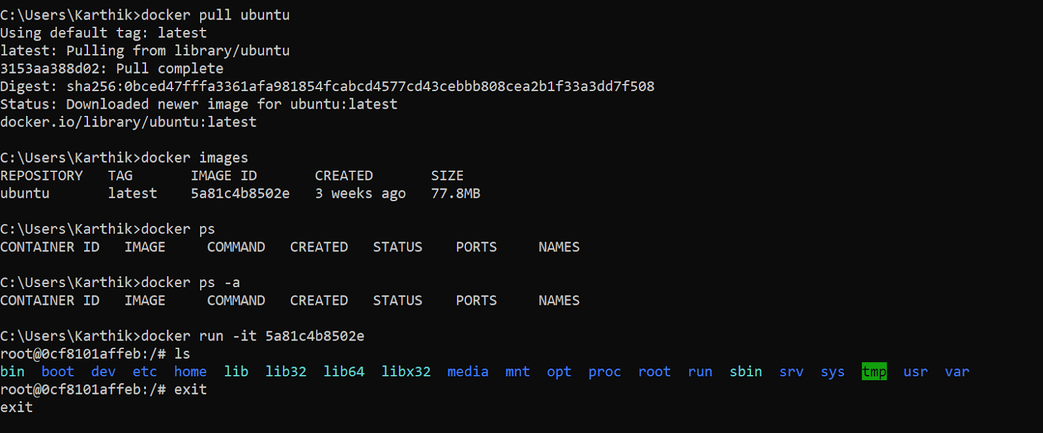

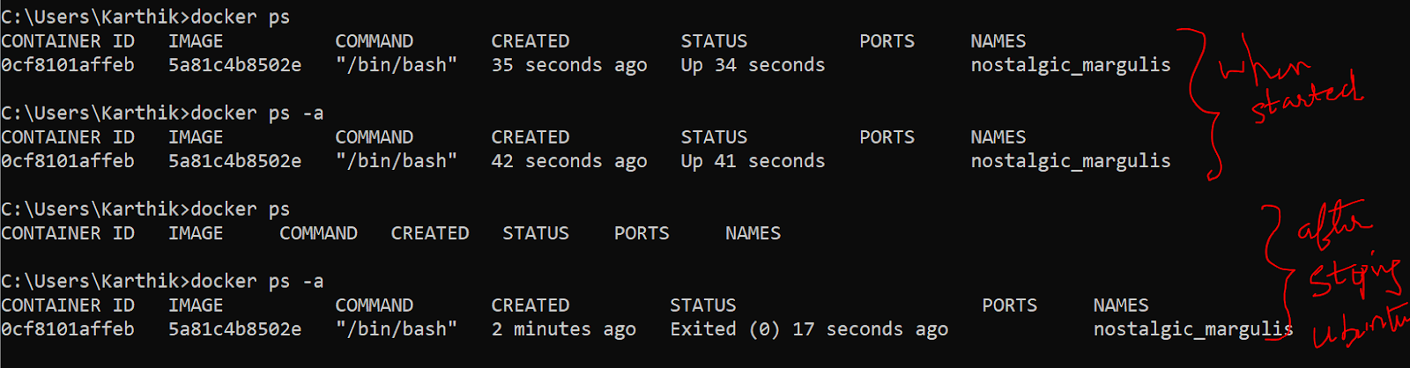

Remove the image

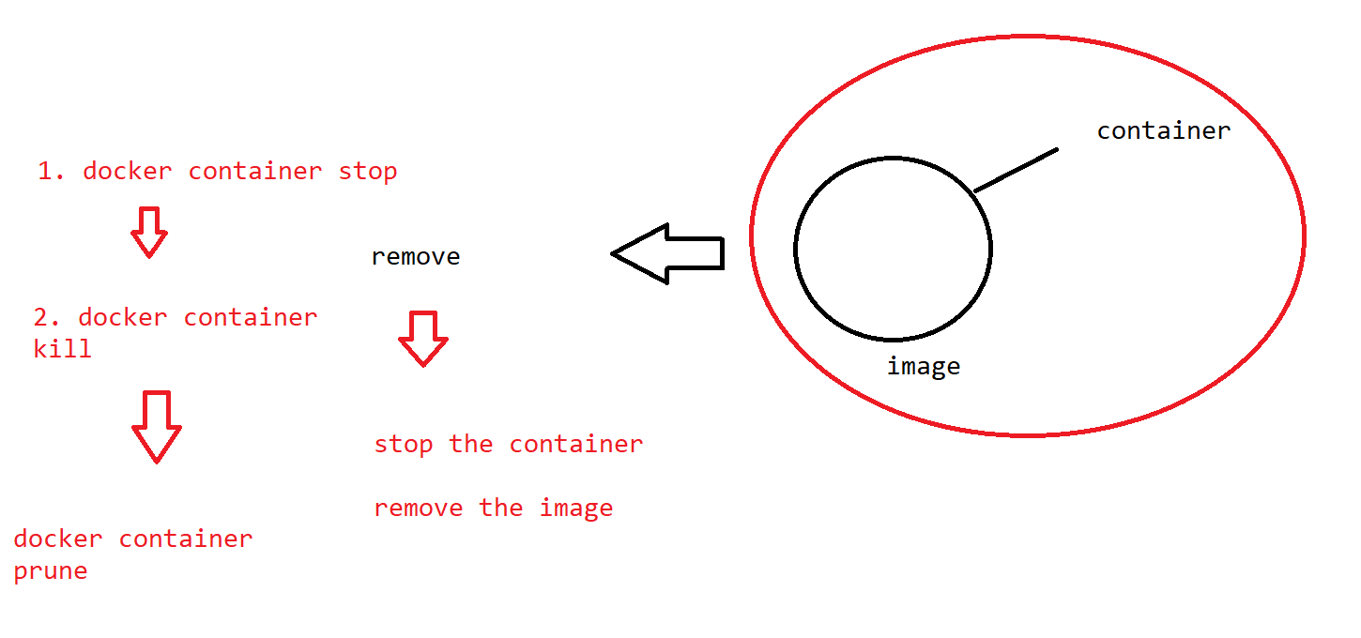

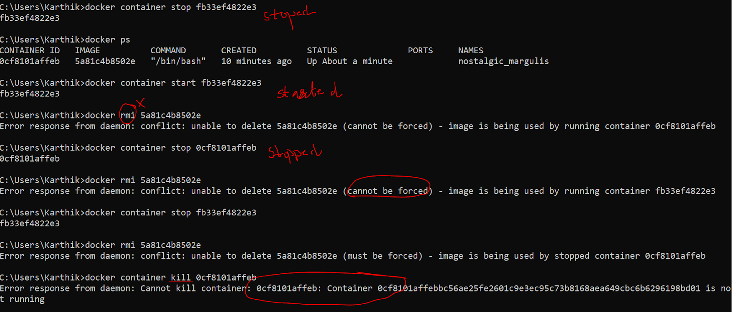

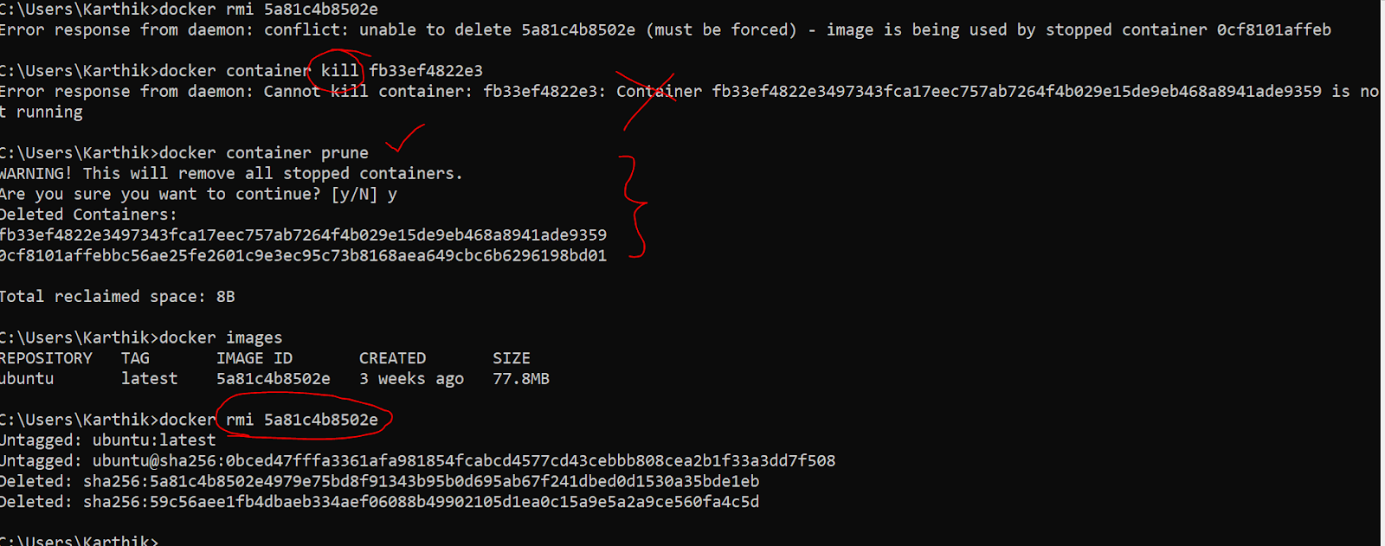

# How to make a spring boot app as an image over the docker ?

>handle without db

>handle with db

Handle without db:

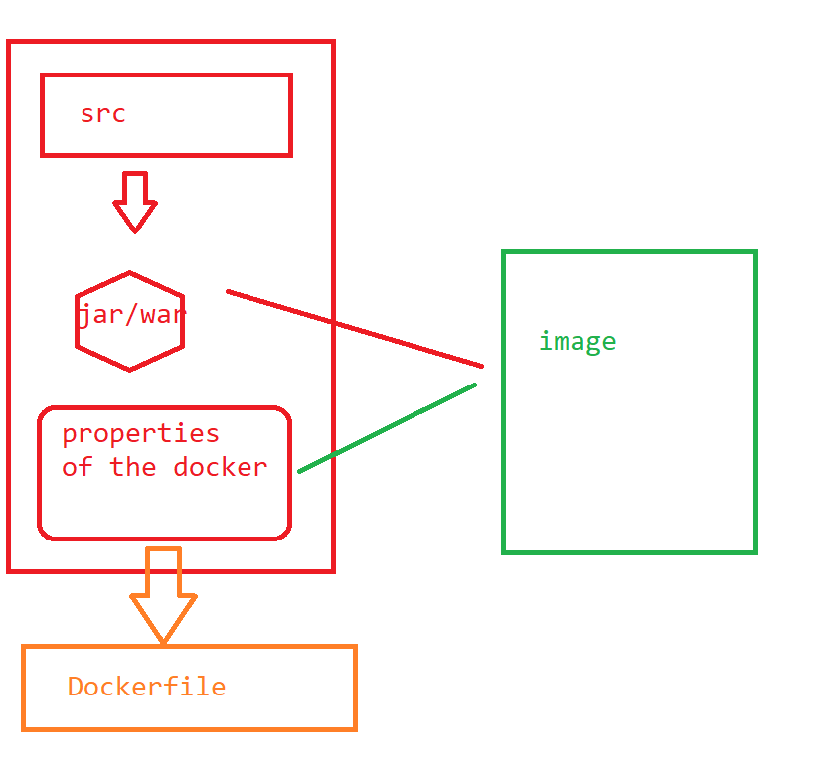

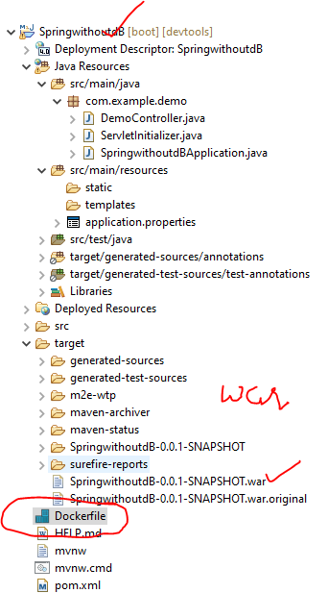

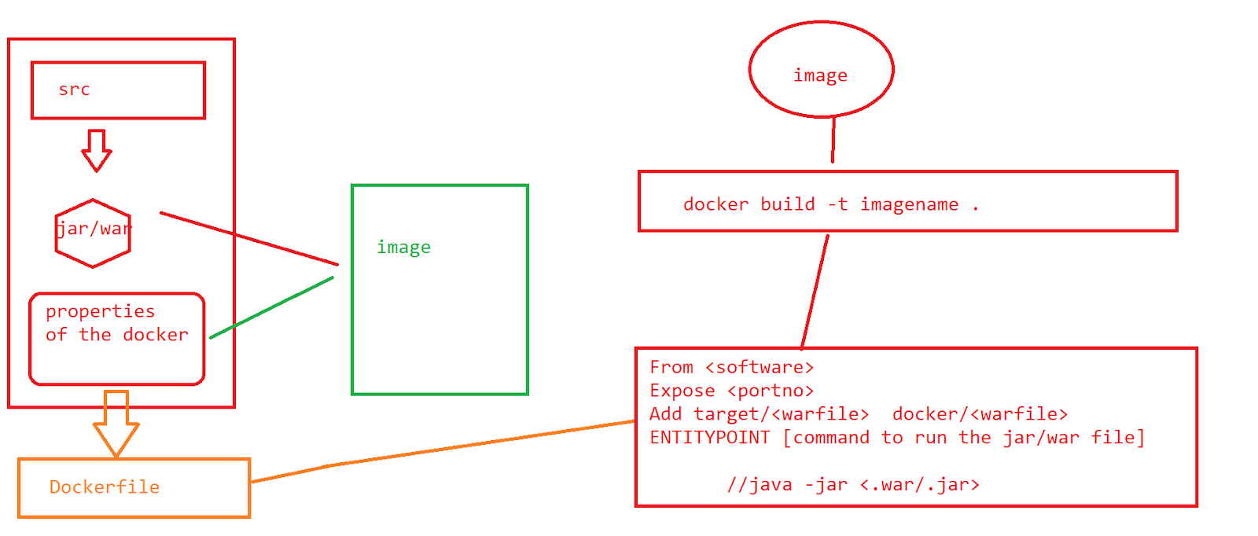

1. Write the spring code
2. Make the war file
3. Create a docker file
4. Go to docker cmd
5. Build the image

//code

package com.example.demo;

import org.springframework.stereotype.Controller;

import org.springframework.web.bind.annotation.RequestMapping;

import org.springframework.web.bind.annotation.ResponseBody;

@Controller

public class DemoController {

@ResponseBody

@RequestMapping("/")

public String display() {

return "hi learners welcome to docker !!!";

}

}

//Dockerfile

From openjdk:8

EXPOSE 8088

ADD target/SpringwithoutdB-0.0.1-SNAPSHOT.war  SpringwithoutdB-0.0.1-SNAPSHOT.war

ENTRYPOINT [ "java","-jar","/SpringwithoutdB-0.0.1-SNAPSHOT.war" ]

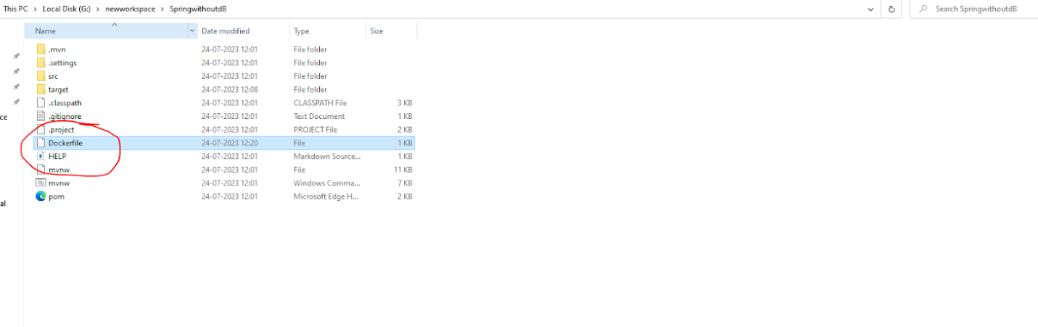

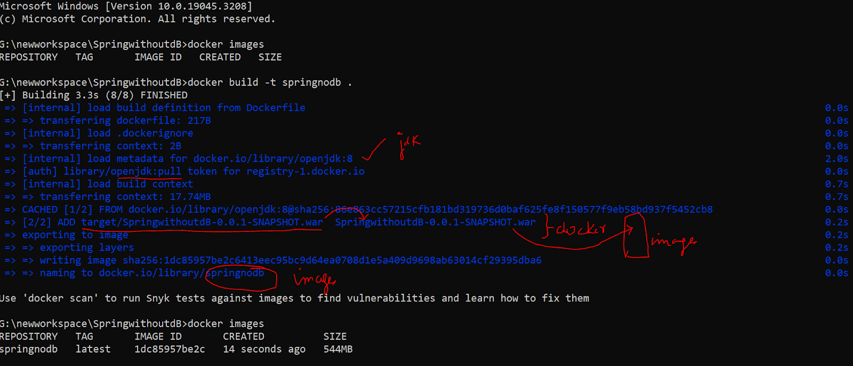

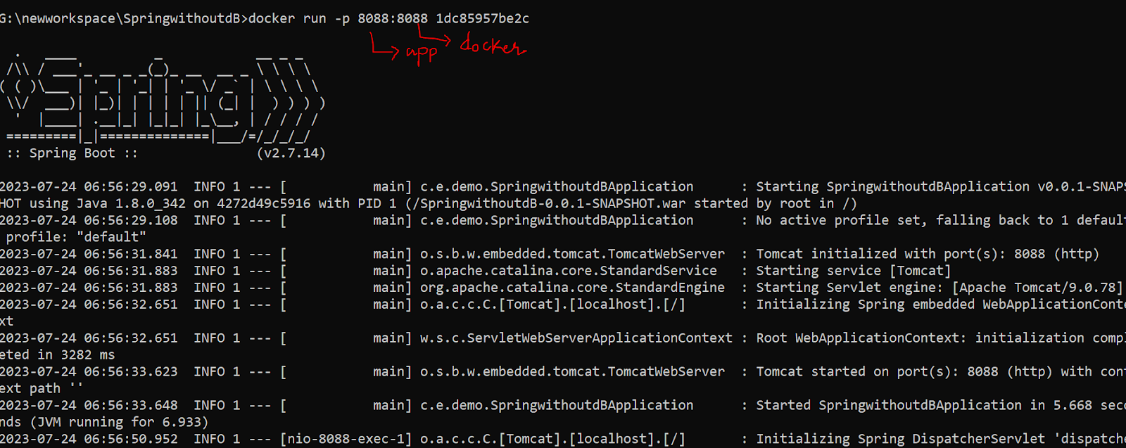

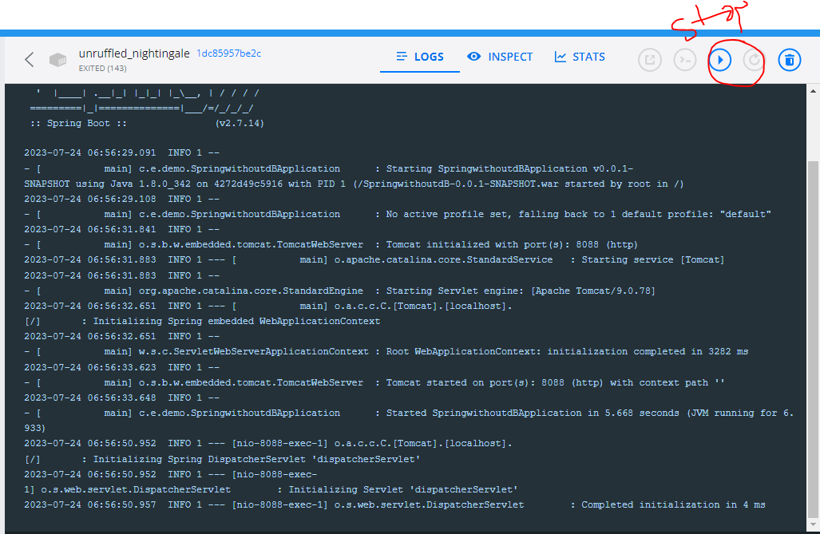

> How can i push this image onto the open platform docker hub

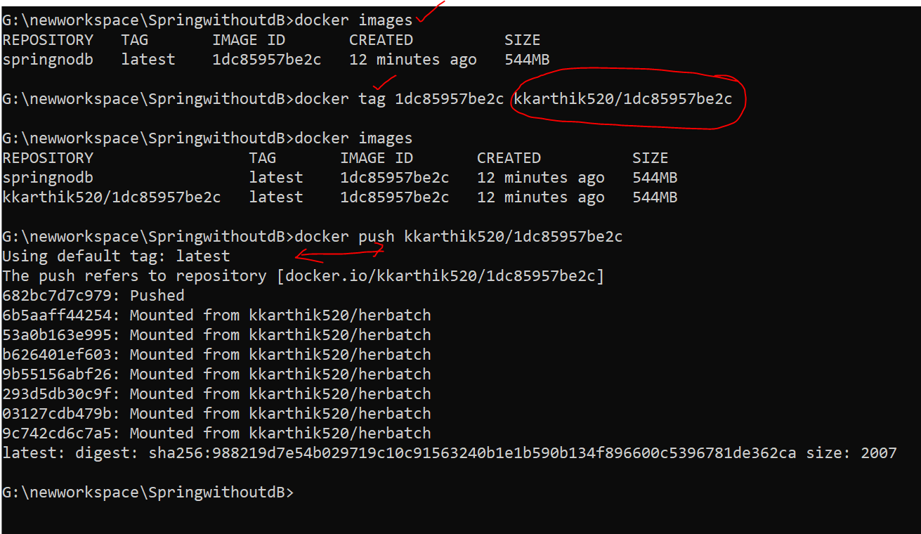

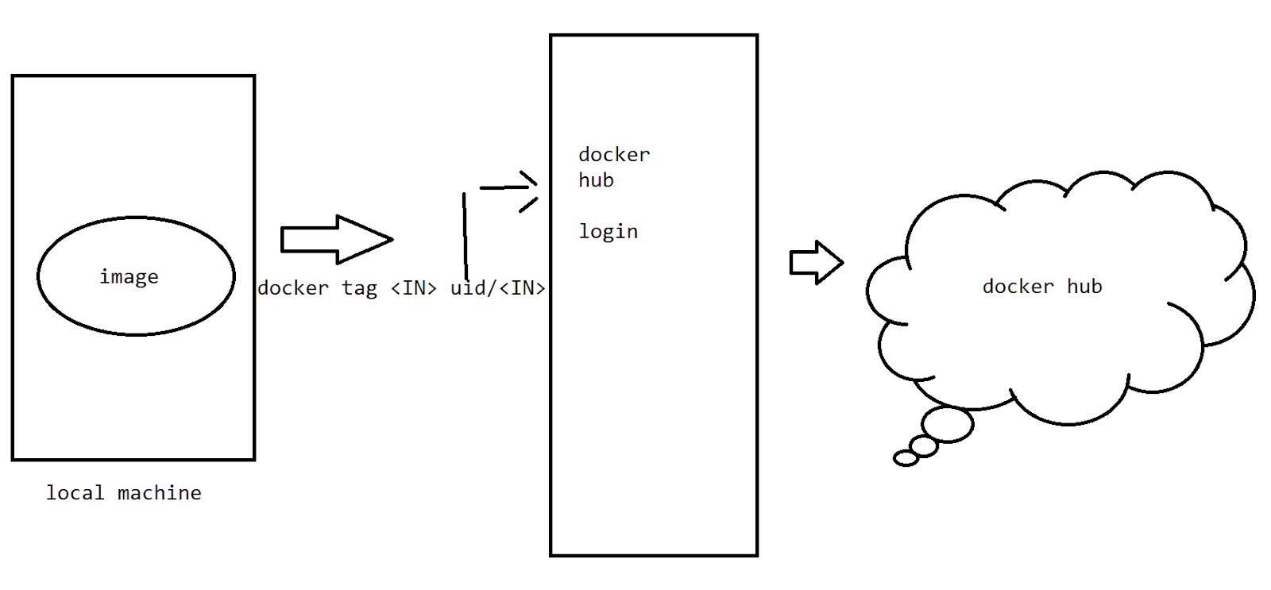

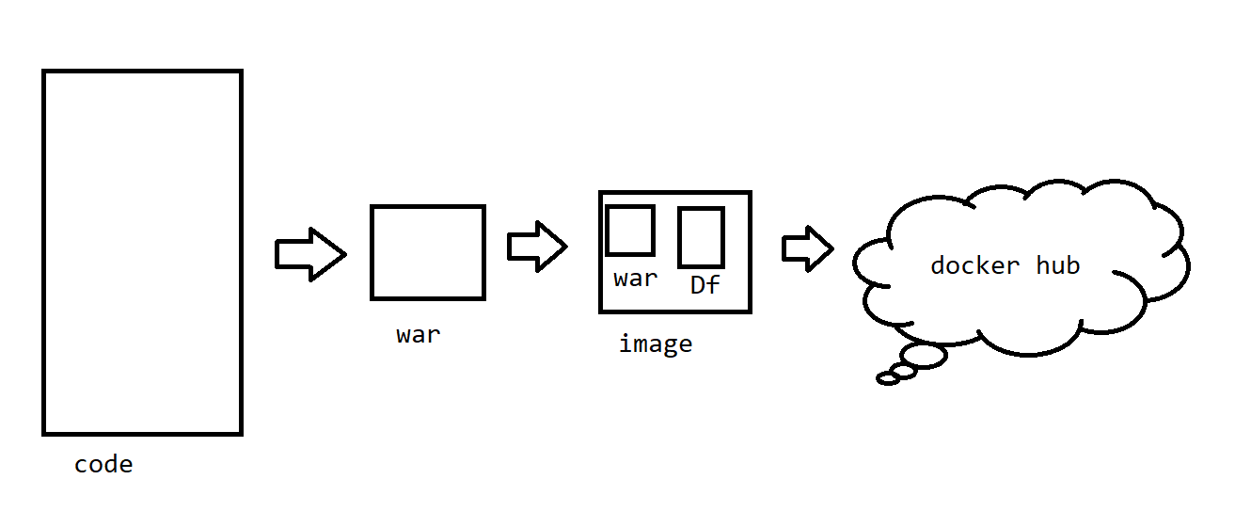

Docker config with the dB

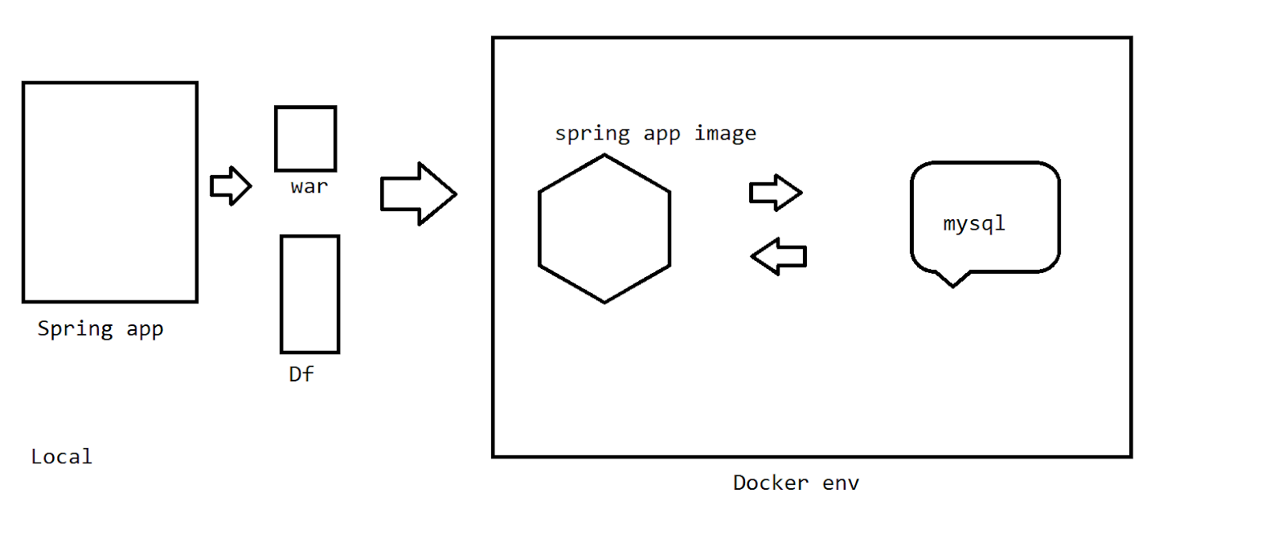

Steps :

1. Create a spring boot app with the config of the docker mysql on this app in the properties file .
2. Create a war file
3. Open the cmd
4. Config the mysql image
5. Link the image of the springapp with the image of the mysql

How to config mysql image on the docker with our credentials

1. We need to download the image from the dockerhub and name the image with our own identification
2. Do the config of the image with the username , password and the basic dB required to run this application

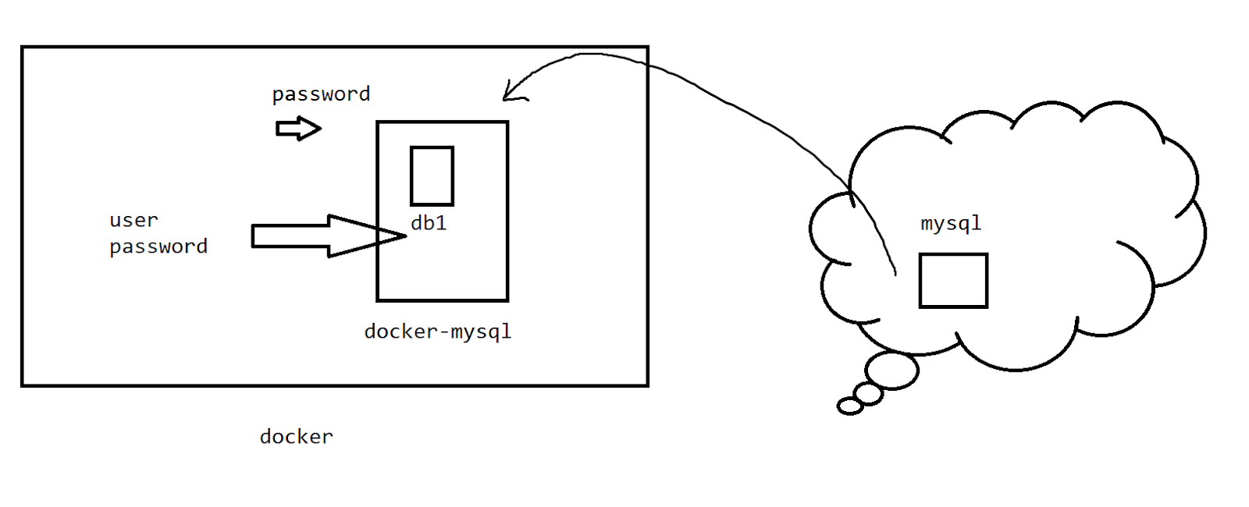

docker run --name docker-mysql -e MYSQL_ROOT_PASSWORD=password -e MYSQL_DATABASE=db1 -e MYSQL_USER=user -e MYSQL_PASSWORD=password -d mysql:latest --default-authentication-plugin=mysql_native_password

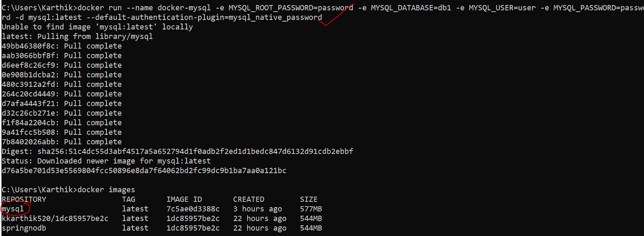

How to start mysql image

docker exec -it docker-mysql mysql -u user -ppassword

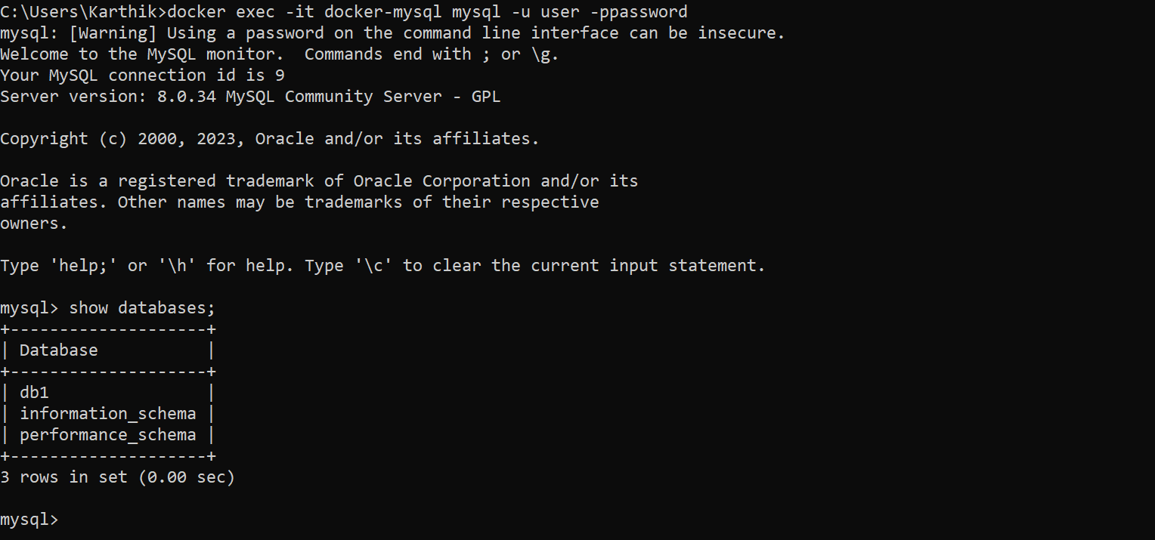

>Spring APP

<!-- JASPER DEPENDENCY -->

<dependency>

    <groupId>org.apache.tomcat</groupId>

    <artifactId>tomcat-jasper</artifactId>

    <version>9.0.78</version>

</dependency>

//application.properties

server.port=8088

#================================================================

#Jpa hibernate

spring.jpa.hibernate.ddl-auto=update

spring.jpa.hibernate.show-sql=true

spring.jpa.hibernate.dialect=org.hibernate.dialect.MySQLDialect

spring.jpa.show-sql = true

#================================================================

#datasource

spring.datasource.driver-class-name=com.mysql.cj.jdbc.Driver

spring.datasource.url=jdbc:mysql://docker-mysql:3306/db1

spring.datasource.username=user

spring.datasource.password=password

#================================================================

package com.example.demo;

import javax.persistence.Entity;

import javax.persistence.GeneratedValue;

import javax.persistence.GenerationType;

import javax.persistence.Id;

import lombok.AllArgsConstructor;

import lombok.Data;

import lombok.NoArgsConstructor;

@Entity

@Data

@NoArgsConstructor

@AllArgsConstructor

public class Employee {

@Id

@GeneratedValue(strategy = GenerationType.AUTO)

private int empno;

private String empname;

private String empemail;

private int age ;

}

package com.example.demo;

import org.springframework.data.jpa.repository.JpaRepository;

public interface EmployeeRepo extends JpaRepository<Employee,Integer> {

}

package com.example.demo;

import java.util.List;

import org.springframework.beans.factory.annotation.Autowired;

import org.springframework.stereotype.Service;

@Service

public class EmployeeDAO {

@Autowired

EmployeeRepo repo;

//insertion

public Employee insert(Employee e) {

return repo.save(e);

}

///retrival

public List<Employee> getall(){

return repo.findAll();

}

}

package com.example.demo;

import java.util.List;

import java.util.logging.Logger;

import javax.servlet.http.HttpServletRequest;

import javax.servlet.http.HttpServletResponse;

import org.springframework.beans.factory.annotation.Autowired;

import org.springframework.stereotype.Controller;

import org.springframework.web.bind.annotation.RequestMapping;

import org.springframework.web.servlet.ModelAndView;

@Controller

public class EmployeeController {

@Autowired

EmployeeDAO dao;

Logger log=Logger.getAnonymousLogger();

@RequestMapping("/")

public ModelAndView displaydefaultpage(HttpServletRequest request,HttpServletResponse resposne) {

log.info("entered into the request mapping of /");

ModelAndView mv=new ModelAndView();

mv.setViewName("index.jsp");

return mv;

}

@RequestMapping("/insert")

public ModelAndView inserting(HttpServletRequest request,HttpServletResponse resposne) {

log.info("entered into the request mapping of /insert");

ModelAndView mv=new ModelAndView();

Employee emp=new Employee();

emp.setEmpname(request.getParameter("name"));

emp.setEmpemail(request.getParameter("email"));

emp.setAge(Integer.parseInt(request.getParameter("age")));

log.info("entered assigned values");

Employee ee=dao.insert(emp);

log.info("inserted");

if(ee!=null) {

mv.setViewName("success.jsp");

}

return mv;

}

@RequestMapping("/getall")

public ModelAndView getal(HttpServletRequest request,HttpServletResponse resposne) {

log.info("entered into the request mapping of /getall");

ModelAndView mv=new ModelAndView();

List<Employee> list=dao.getall();

mv.setViewName("display.jsp");

mv.addObject("list", list);

return mv;

}

}

<%@ page language="java" contentType="text/html; charset=ISO-8859-1"

    pageEncoding="ISO-8859-1"%>

<!DOCTYPE html>

<html>

<head>

<meta charset="ISO-8859-1">

<title>Insert title here</title>

</head>

<body>

<form action="insert">

Empname<input type="text" name="name"><br>

Empemail<input type="email" name="email"><br>

Empage<input type="text" name="age"><br>

<input type="submit" value="register">

</form>

</body>

</html>

<%@ page language="java" contentType="text/html; charset=ISO-8859-1"

    pageEncoding="ISO-8859-1"%>

<!DOCTYPE html>

<html>

<head>

<meta charset="ISO-8859-1">

<title>Insert title here</title>

</head>

<body>

<h1>Insertion done successfully...!!!</h1>

<form action="getall">

<input type="submit" value="getallemployees">

</form>

</body>

</html>

<%@ page language="java" contentType="text/html; charset=ISO-8859-1"

    pageEncoding="ISO-8859-1"%>

    <%@ page import="com.example.demo.*" %>

    <%@ page import="java.util.*" %>

<!DOCTYPE html>

<html>

<head>

<meta charset="ISO-8859-1">

<title>Insert title here</title>

</head>

<body>

<%List<Employee> e=(List<Employee>)request.getAttribute("list"); %>

<table border="1">

<tr>

<th>EmpID</th><th>EmpName</th><th>EmpEmail</th><th>EmpAge</th>

</tr>

<tr>

<%for(Employee ee:e){ %>

<td><%=ee.getEmpno() %></td>

<td><%=ee.getEmpname() %></td>

<td><%=ee.getEmpemail() %></td>

<td><%=ee.getAge() %></td>

<%} %>

</tr>

</table>

</body>

</html>

package com.example.demo;

import org.junit.jupiter.api.Test;

import org.springframework.boot.test.context.SpringBootTest;

@SpringBootTest

class SpringwithdbApplicationTests {

// @Test

void contextLoads() {

}

}

From openjdk:8

EXPOSE 8088

ADD target/Springwithdb-0.0.1-SNAPSHOT.war  Springwithdb-0.0.1-SNAPSHOT.war

ENTRYPOINT [ "java","-jar","/Springwithdb-0.0.1-SNAPSHOT.war" ]

//Docker

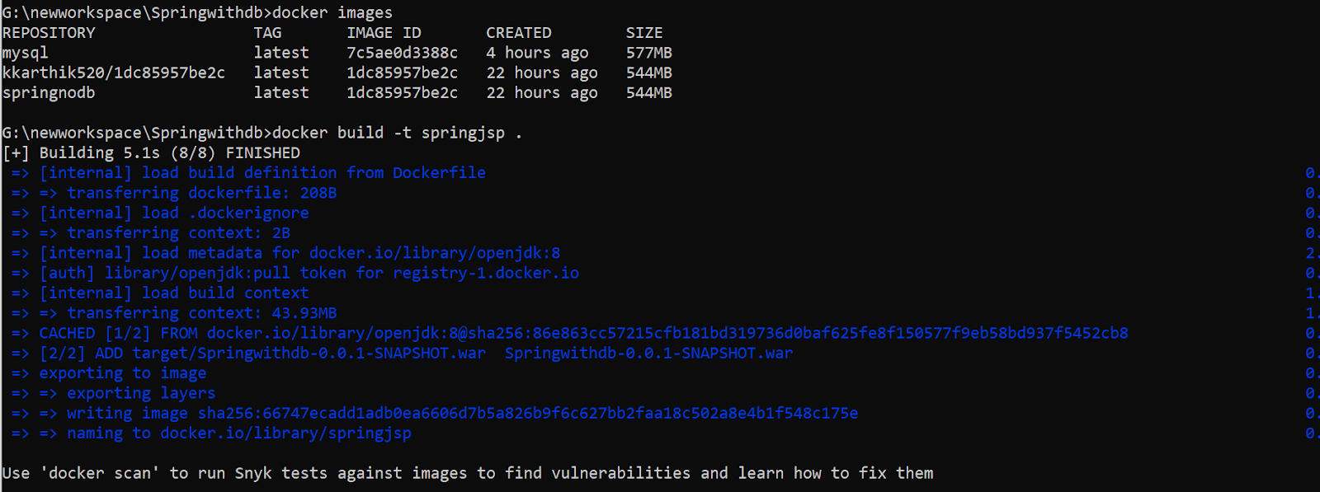

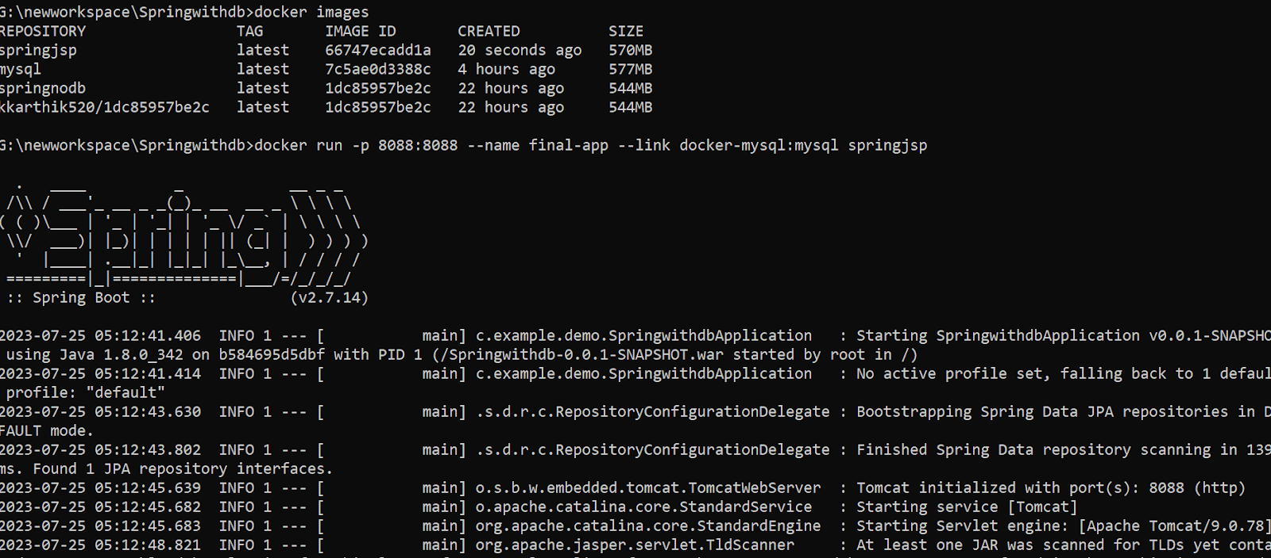

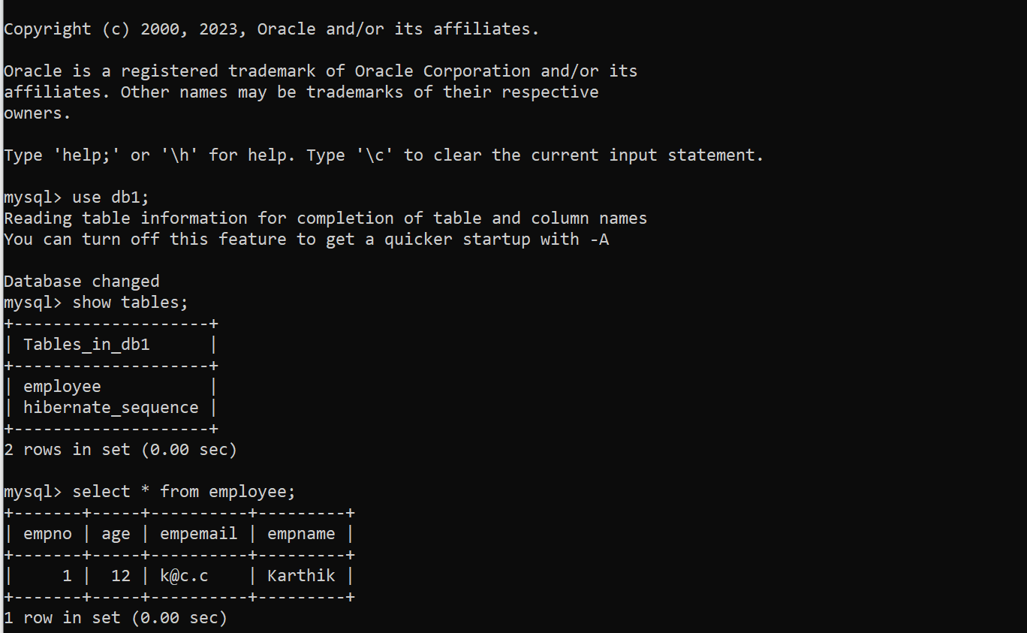

Task 👍-15 min

1. Take a Rest app - make an image run the image and validate it on postman
2. Take any end project of spring boot deploy it on the docker and run it

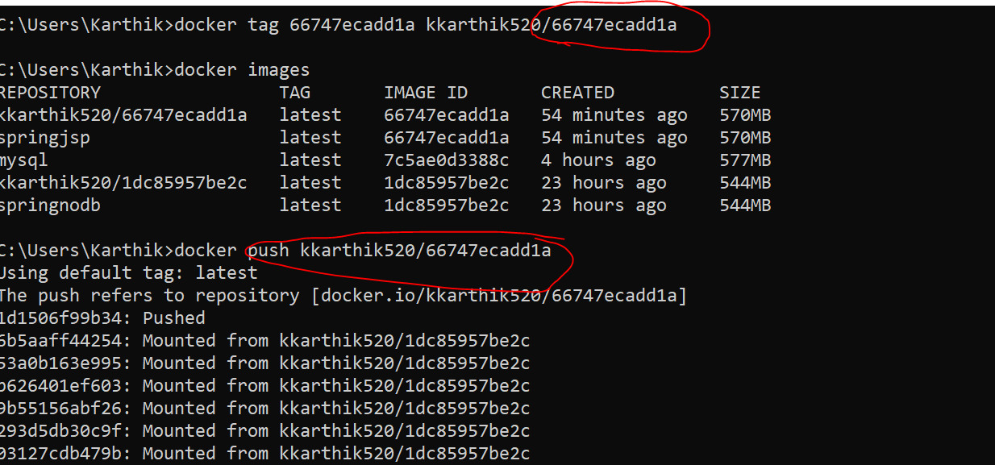

=>AWS (Amazon web service )

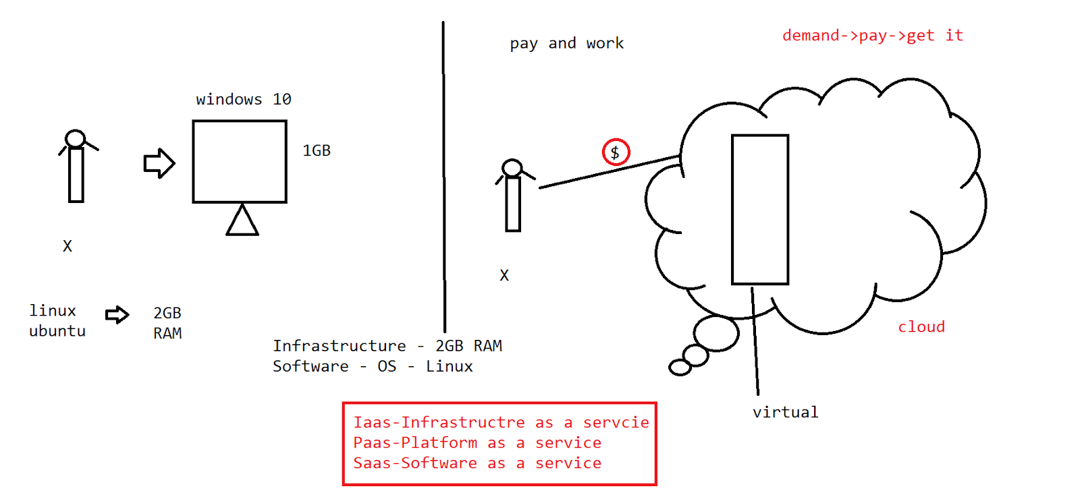

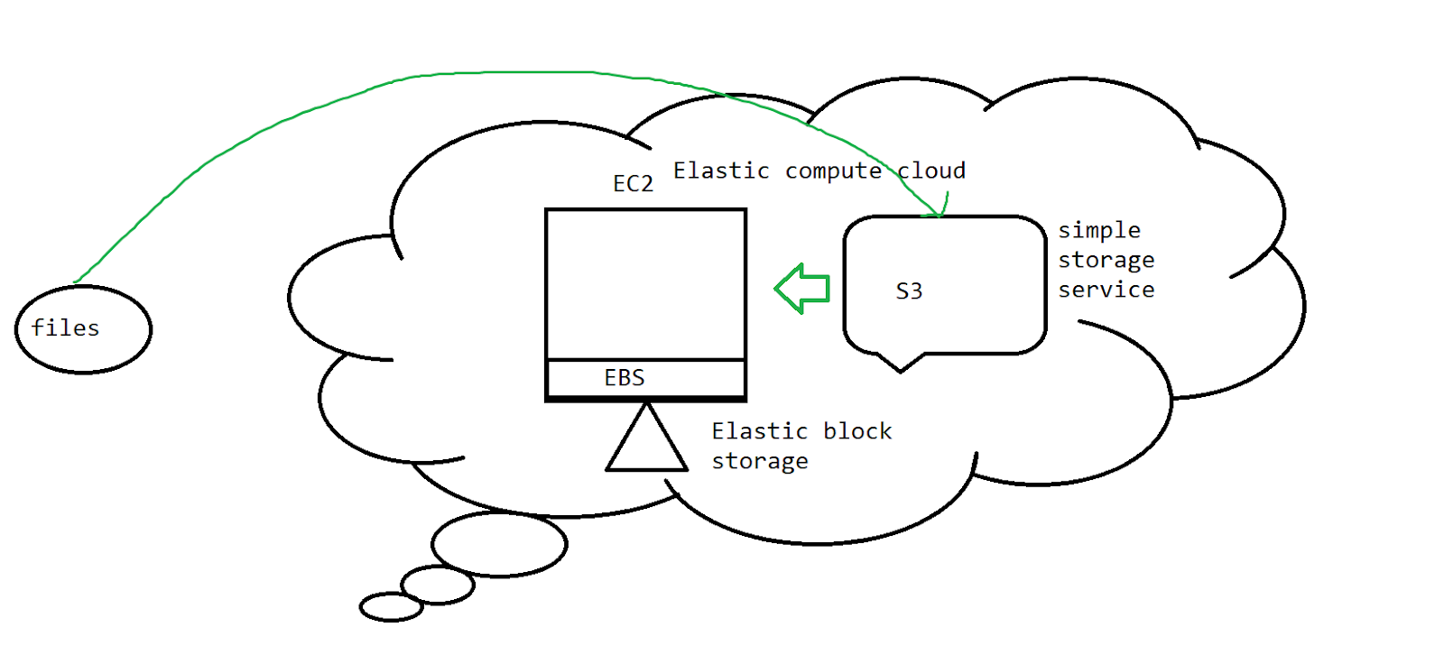

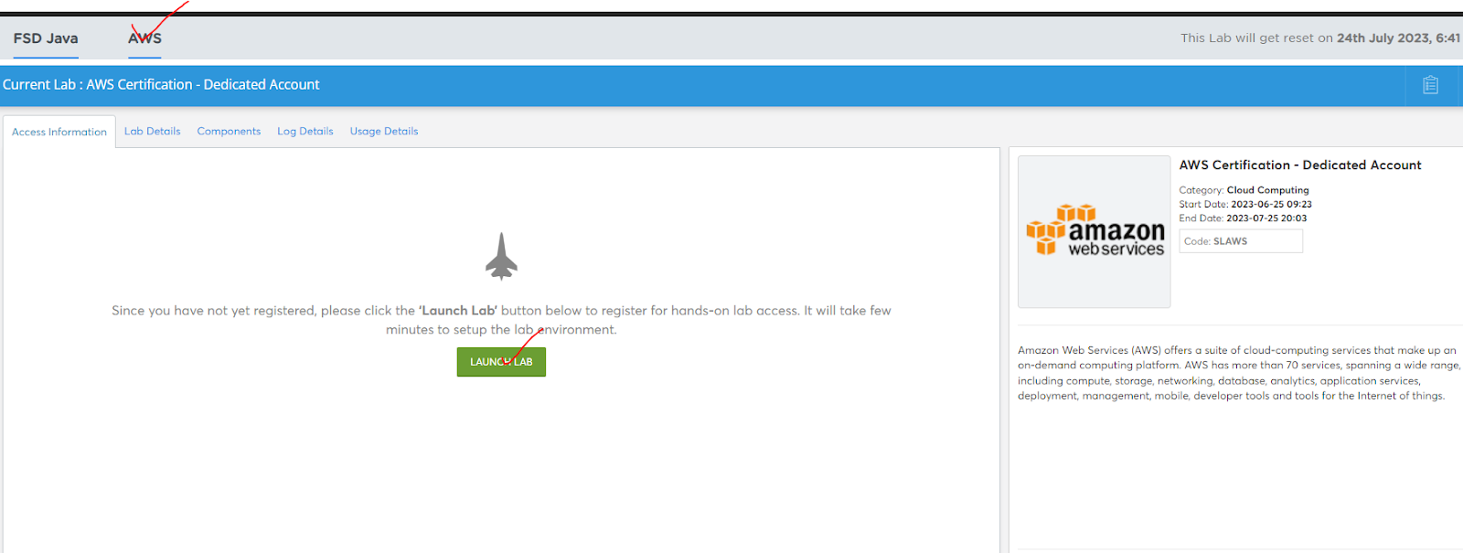

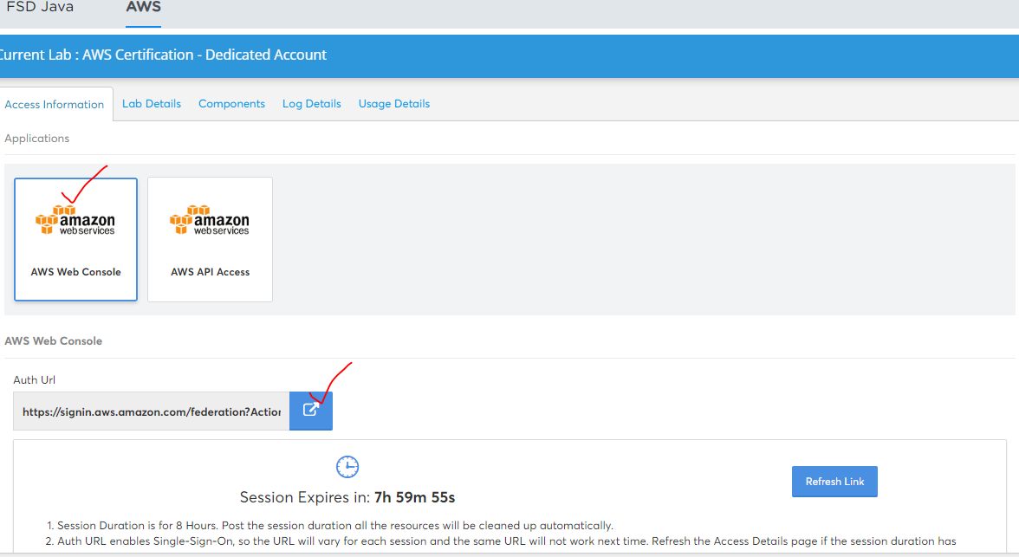

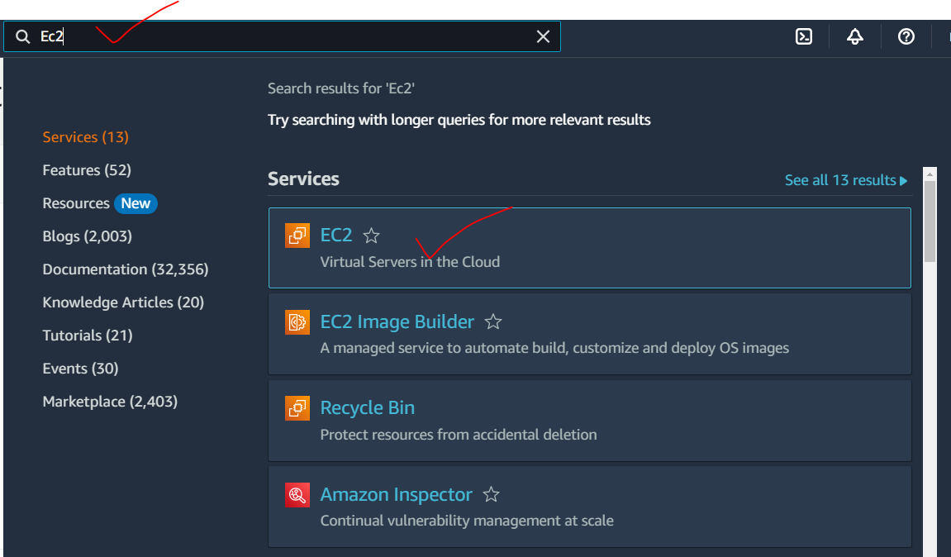

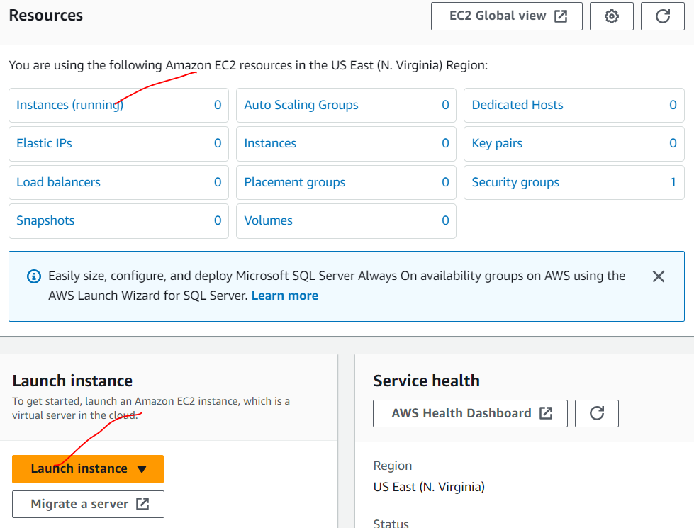

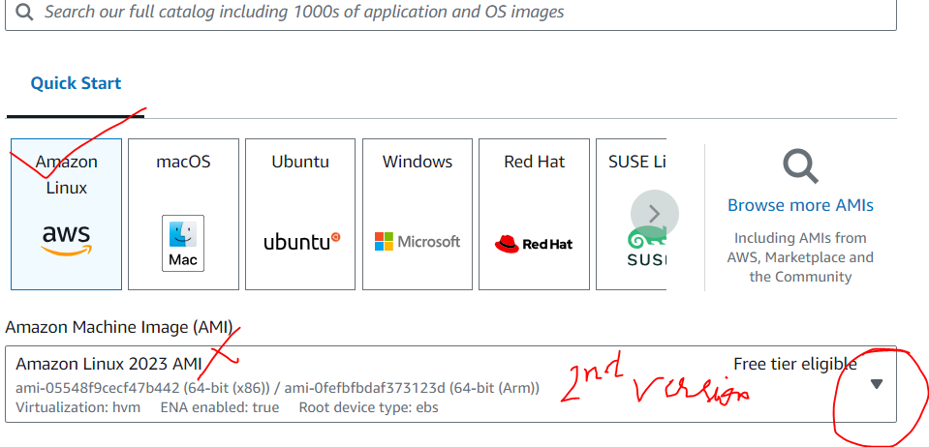

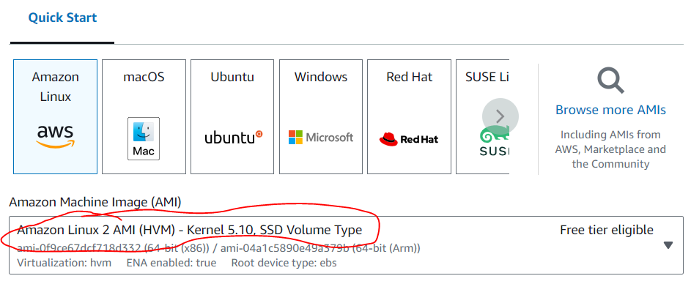

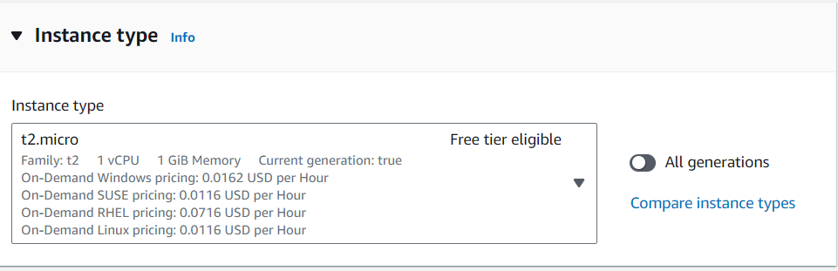

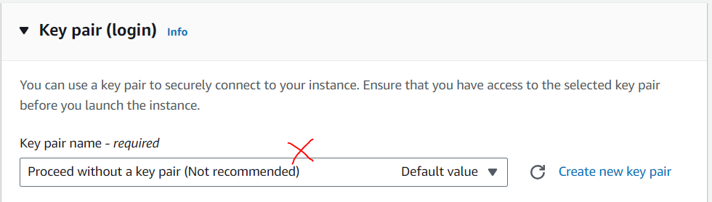

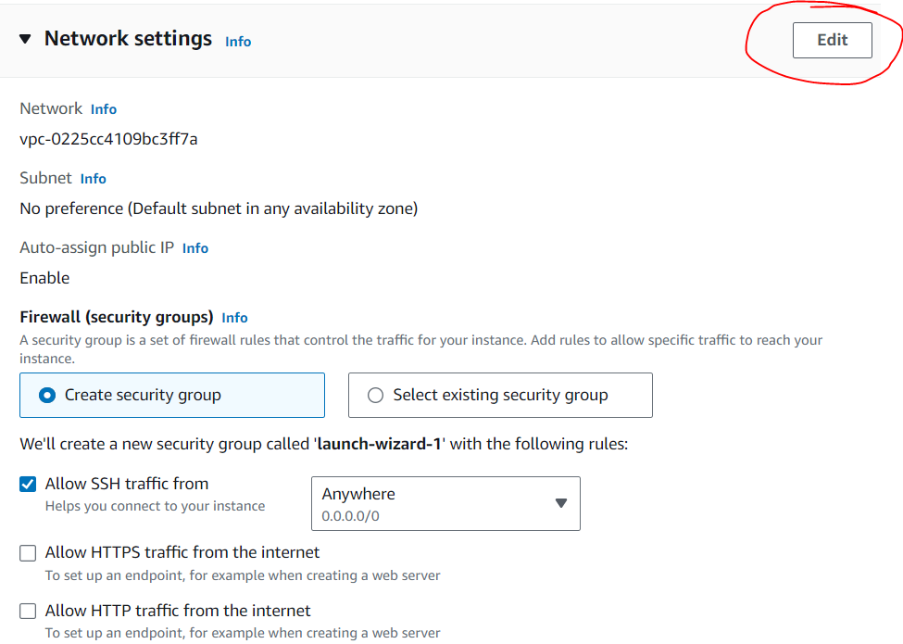

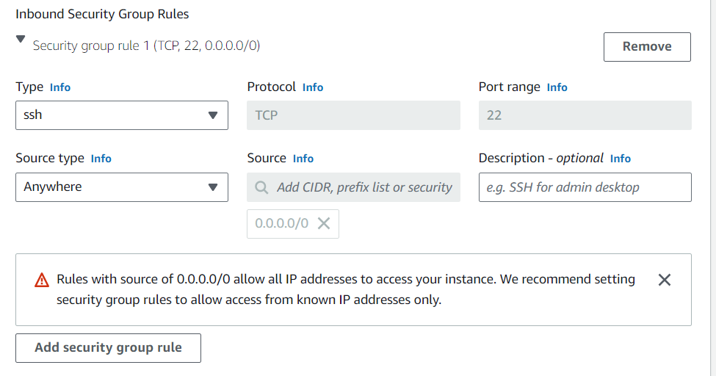

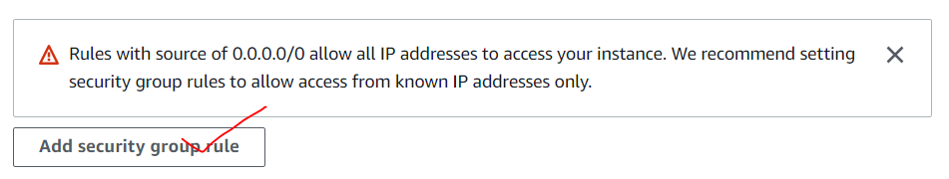

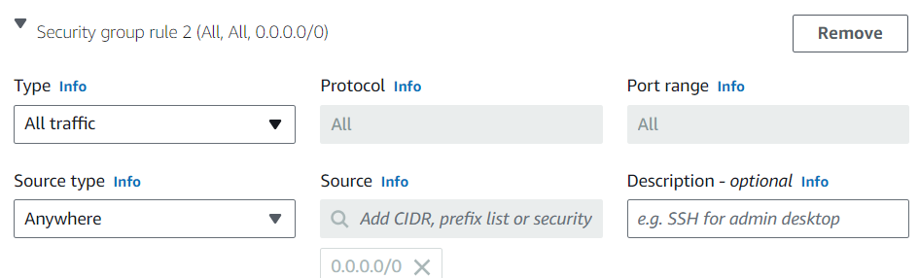

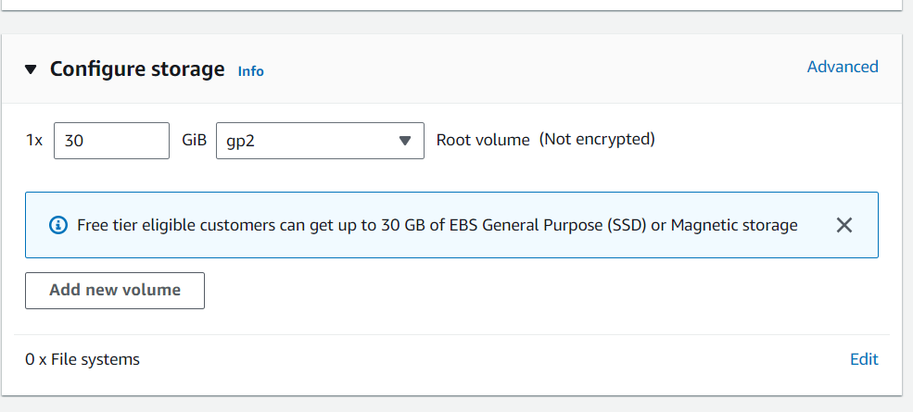

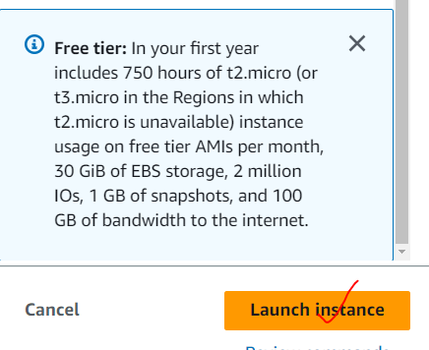

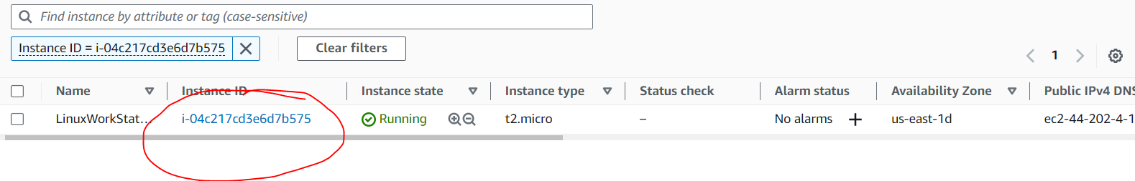

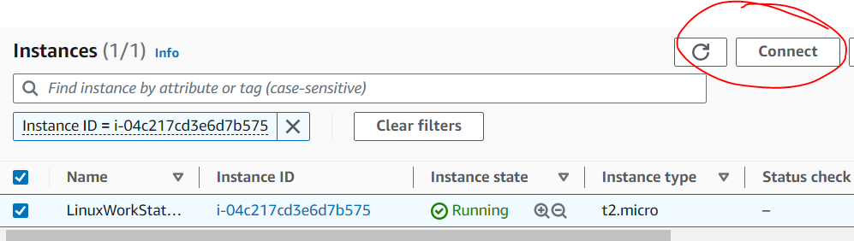

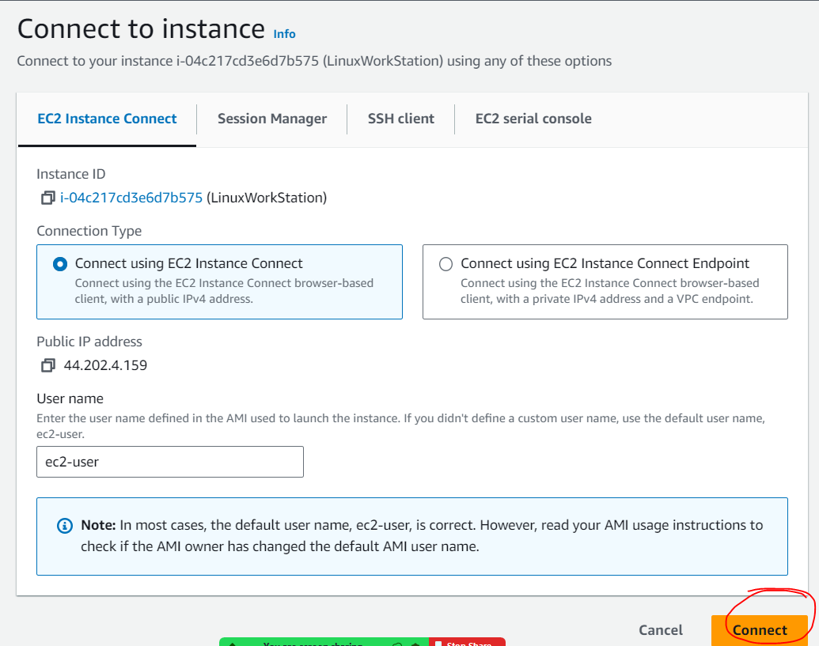

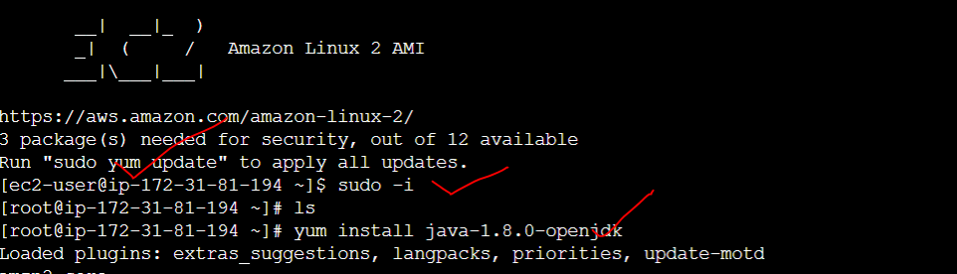

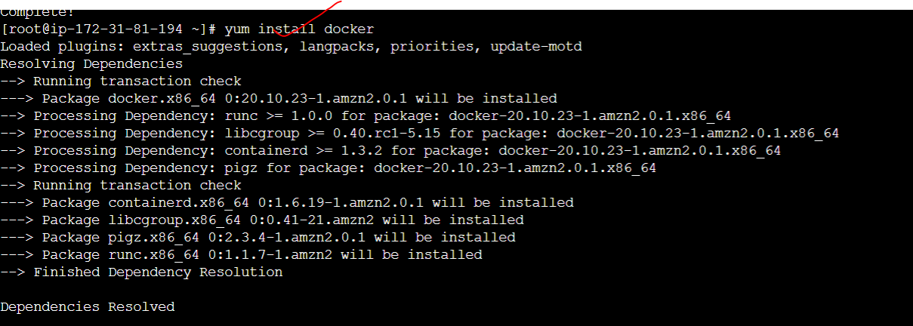

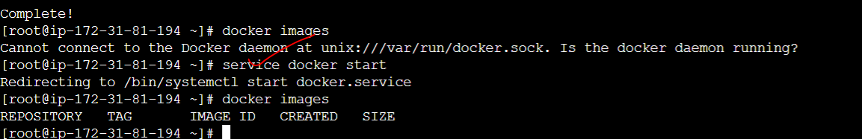

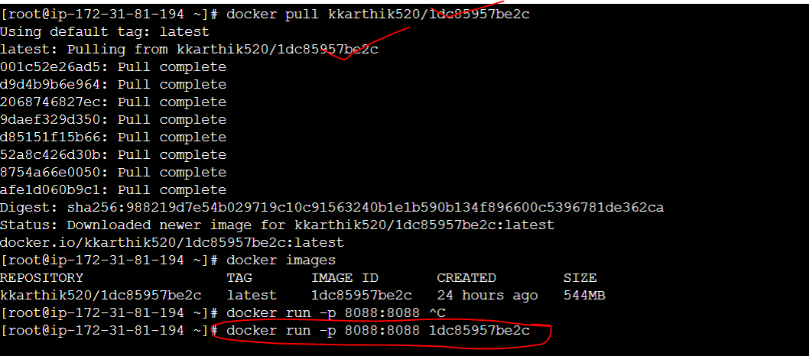

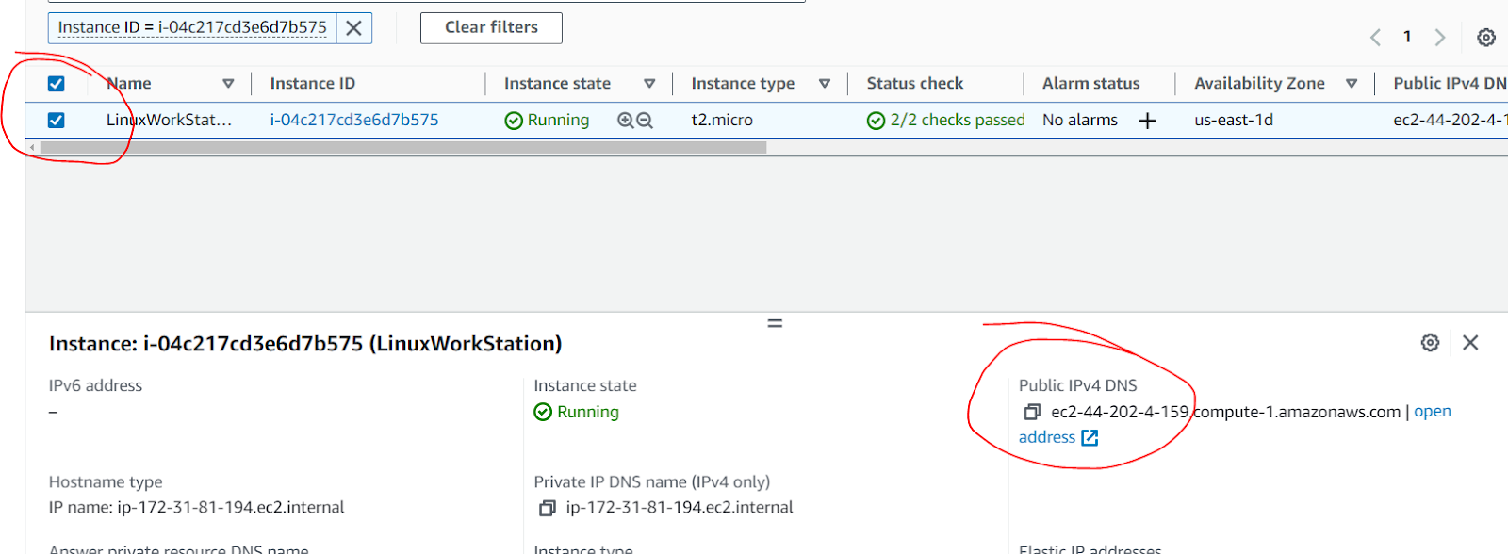

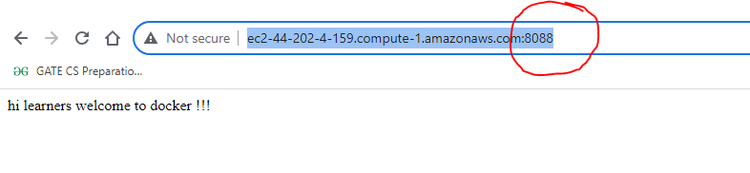

If we have a docker app with mysql as db ?

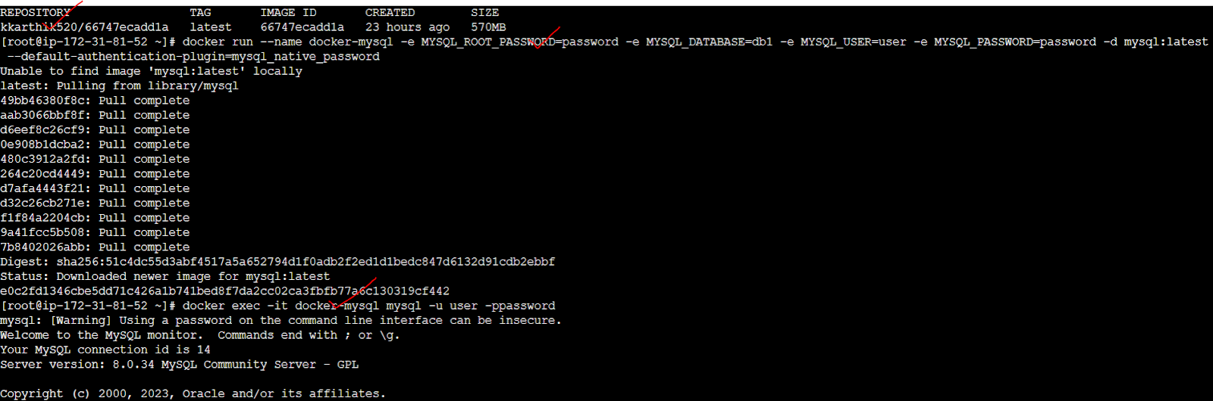

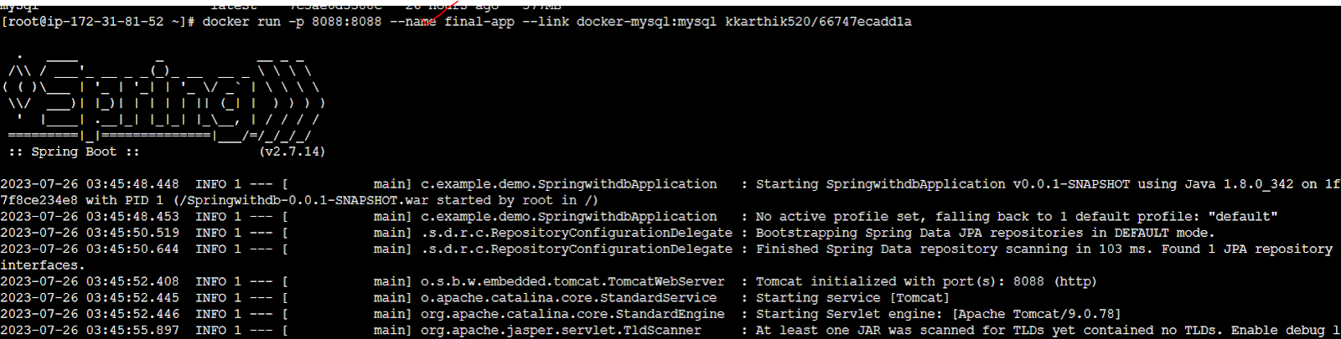

> Take phase 3 end project and deploy it on aws ec2 —-------15 min

1. Dockerfile
2. Properties change the db config
3. Docker image
4. Push this on to docker hub

> Take a spring project which has only the rest control=>via postman access it

Spring app ->war->image ->aws —url in aws take that into the postman and supply the json data—-------15 min

1. Dockerfile
2. Properties change the db config
3. Docker image
4. Push this onto the docker hub

Iam

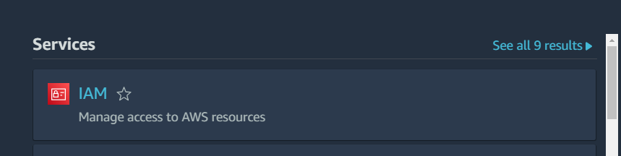

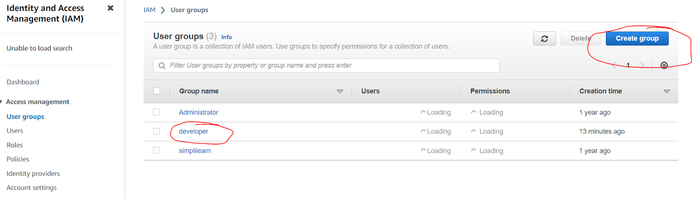

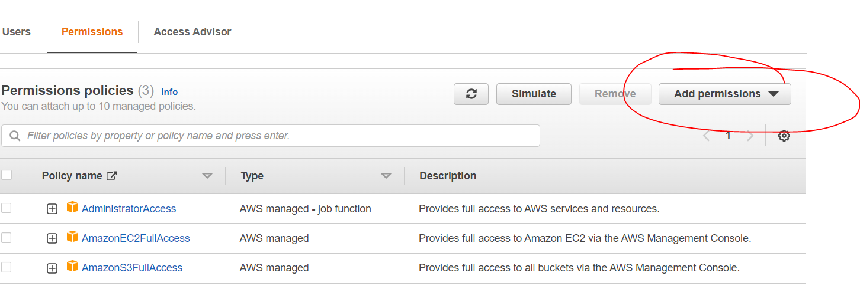

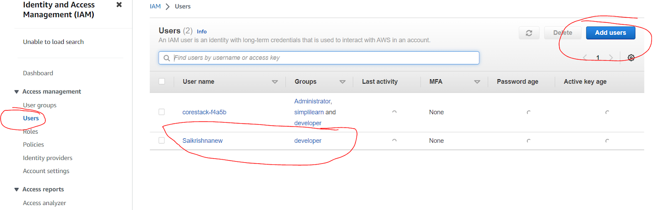

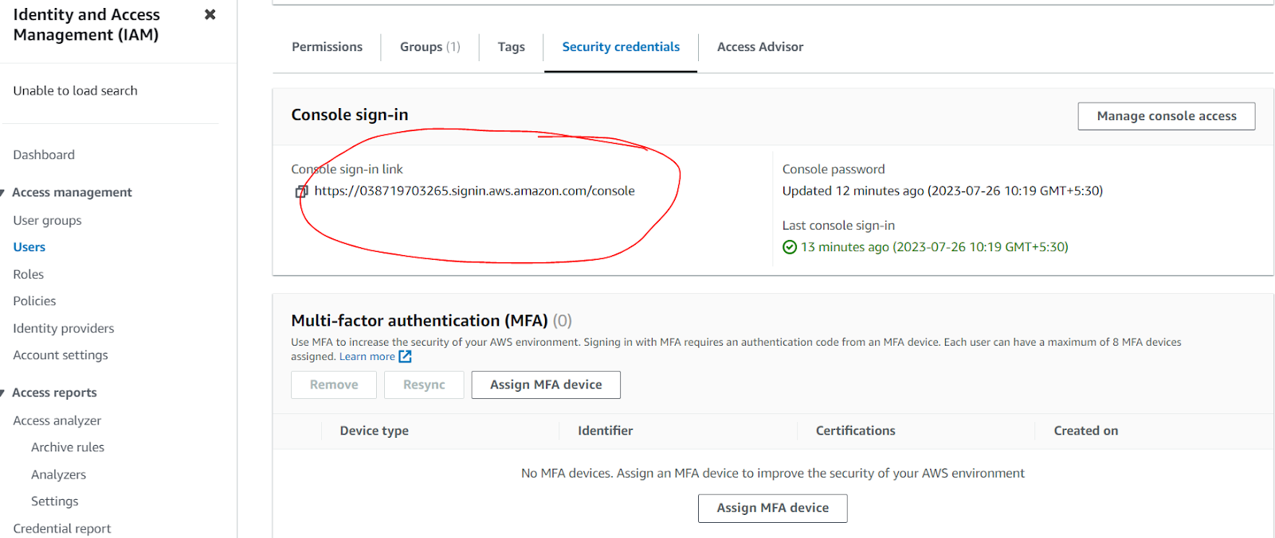

⇒ microservice on docker

//for code refer to phase 3 microservice topic

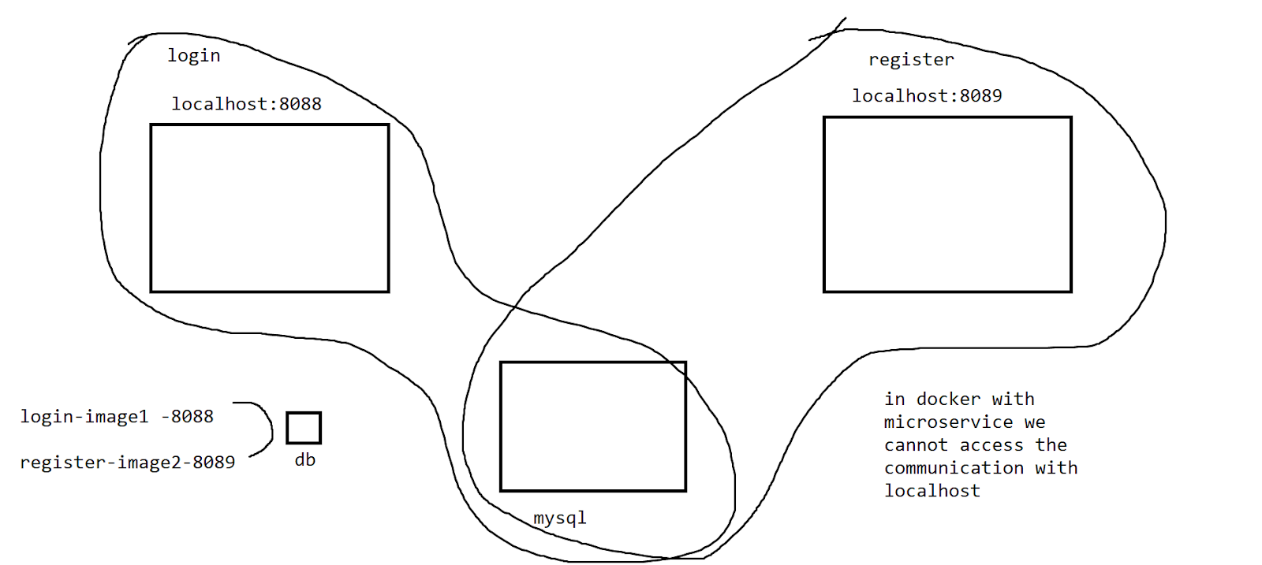

=changes with code

public String regsitermslogin(HttpServletRequest request,HttpServletResponse response) {

//home assignment to have a model and view for this to go to a jsp page

log.info("registermslogin request loaded");

String user =request.getParameter("user");

String password=request.getParameter("pwd");

String email=request.getParameter("email");

//Rest API

RestTemplate rest=new RestTemplate();

String url="http://final2:8089/register-user/"+user+"/"+password+"/"+email;

log.info(url);

rest.getForObject(url, String.class);

return "registration is successfull";

}

//properties

spring.datasource.driver-class-name=com.mysql.cj.jdbc.Driver

spring.datasource.url=jdbc:mysql://docker-mysql:3306/db1

spring.datasource.username=user

spring.datasource.password=password

//image 1 -login

kkarthik520/7b94aac6f2c4

//image 2-register

kkarthik520/76bd8a96a0e8

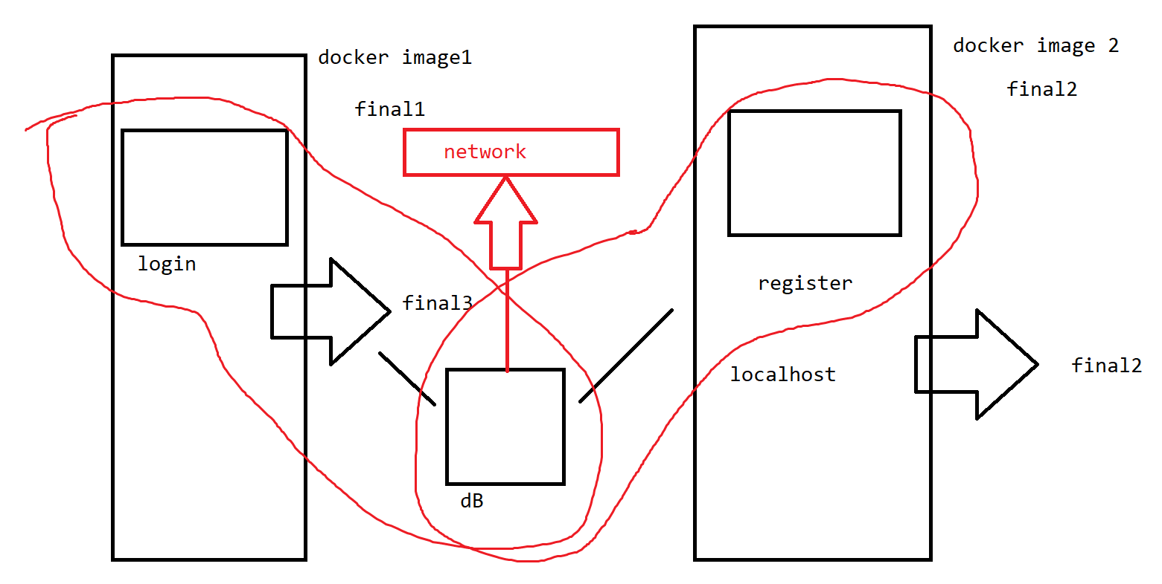

Note : when we are running microservice bring the db on to the network

Create a network

List of networks

Add the docker-mysql to the network

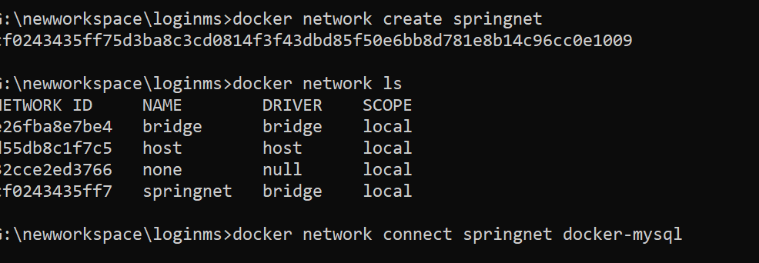

Run the images

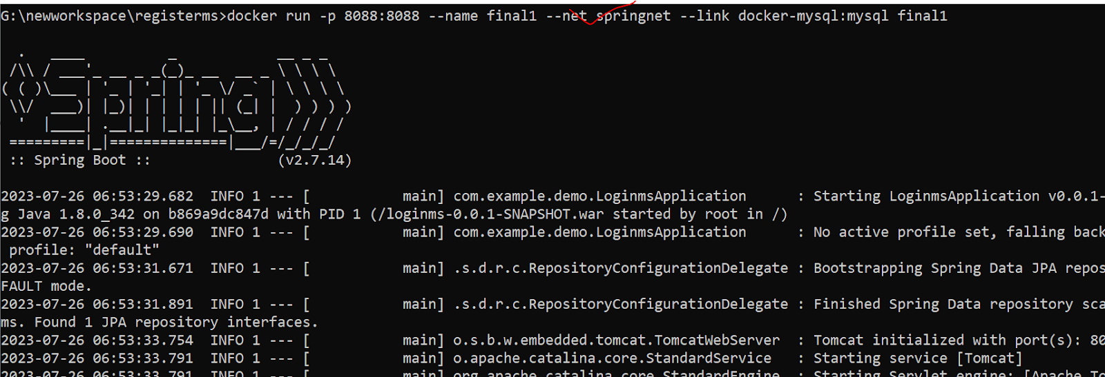

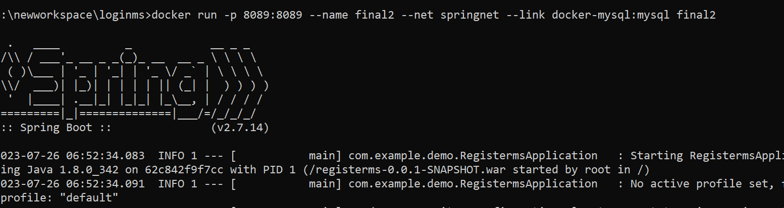

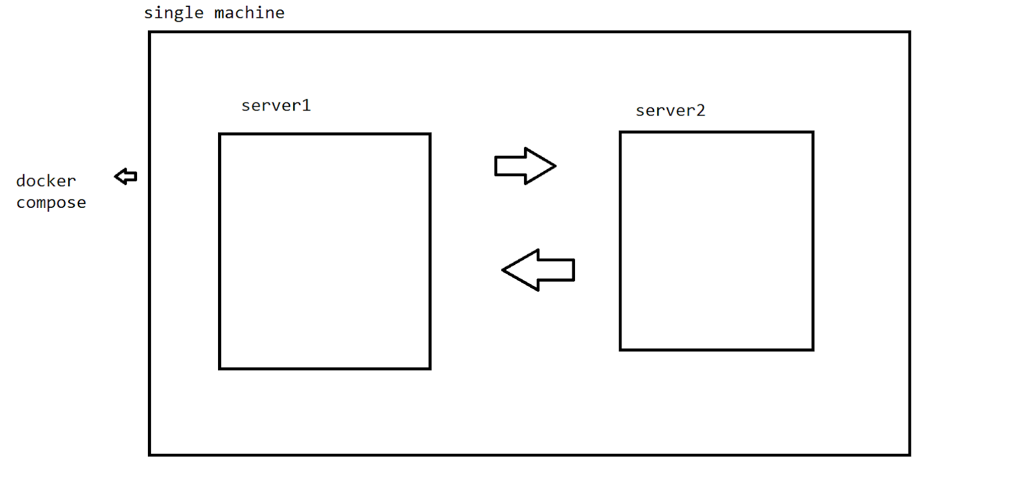

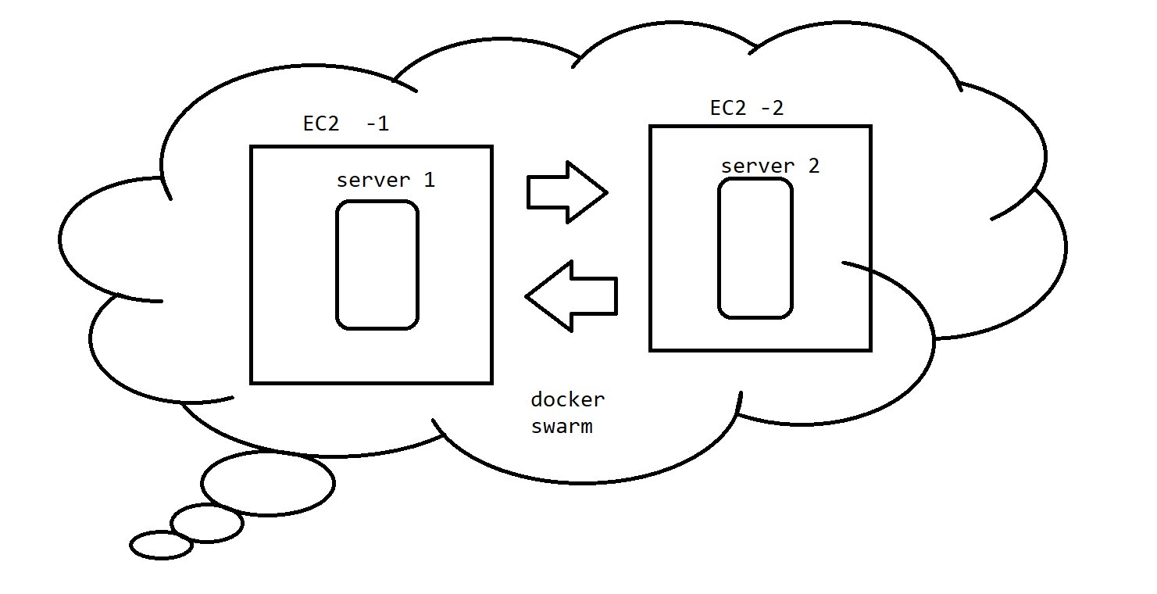

S3 Bucket:

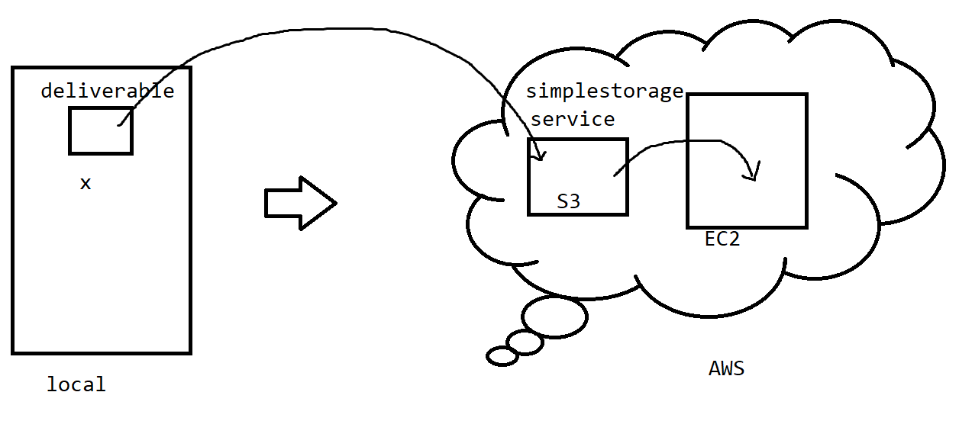

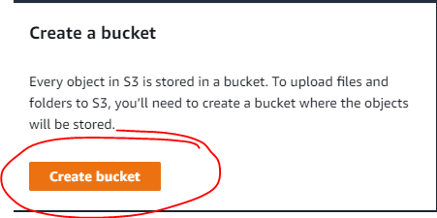

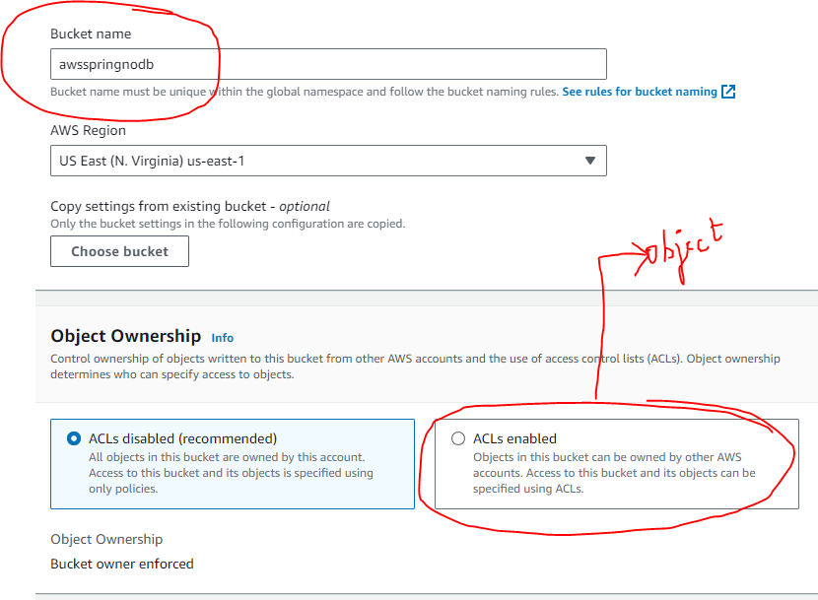

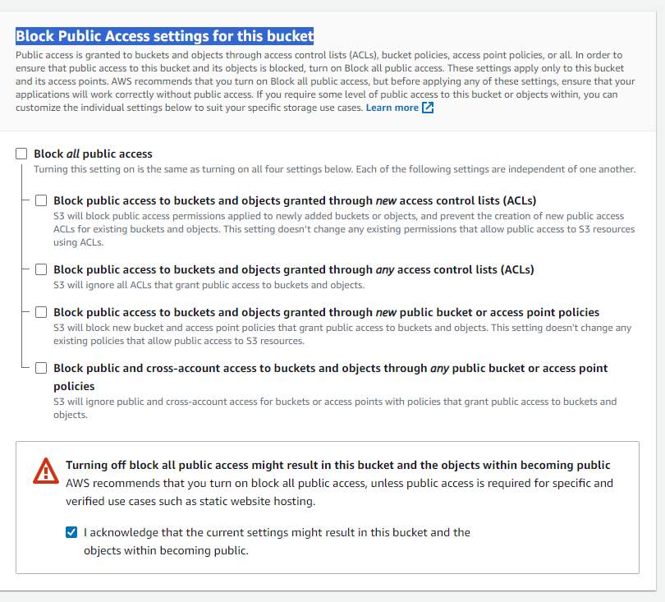

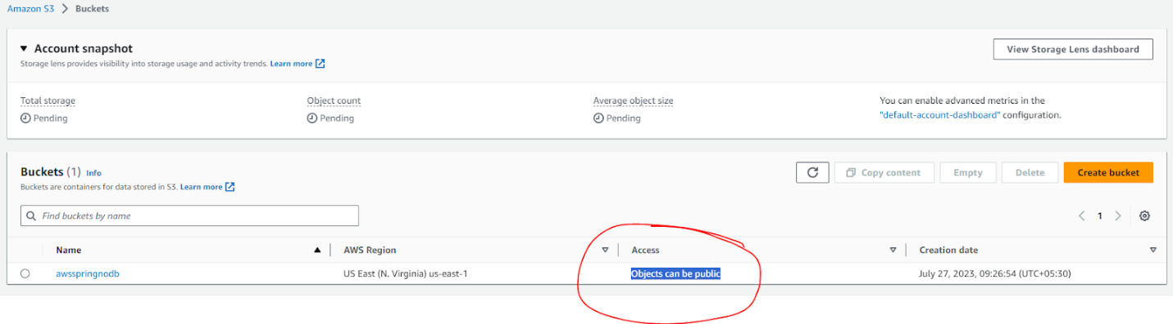

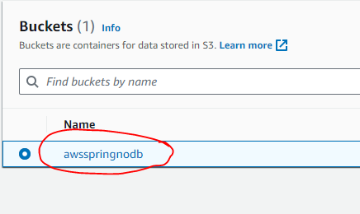

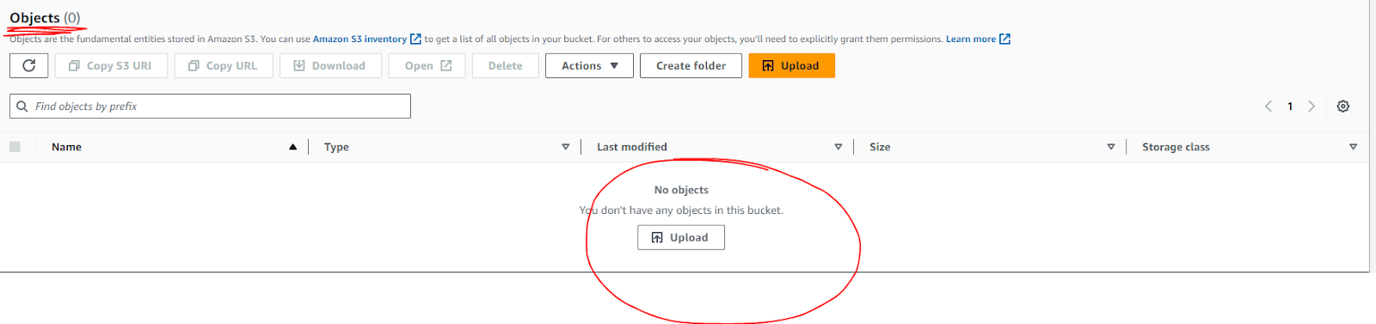

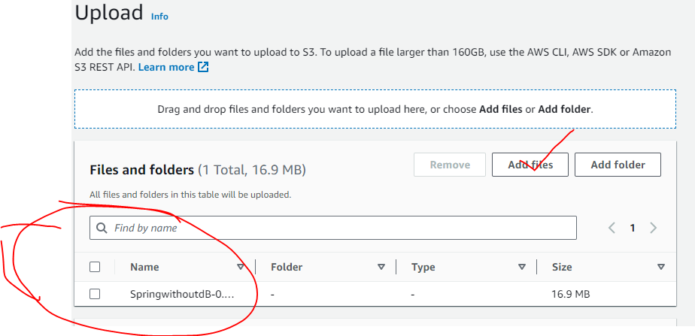

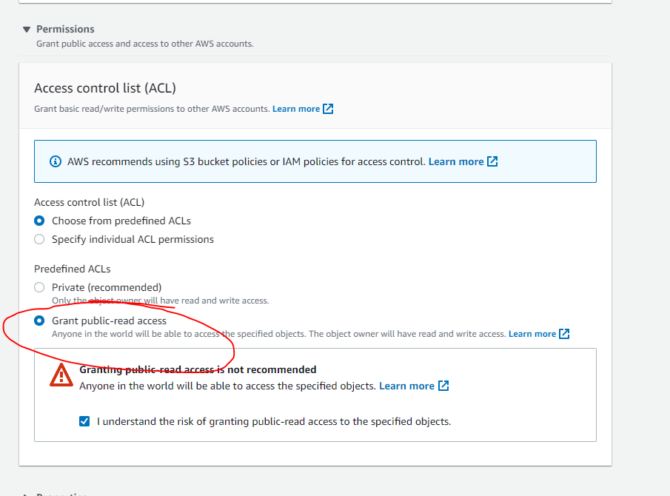

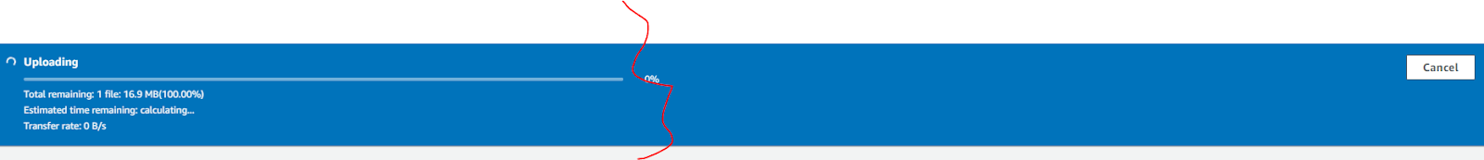

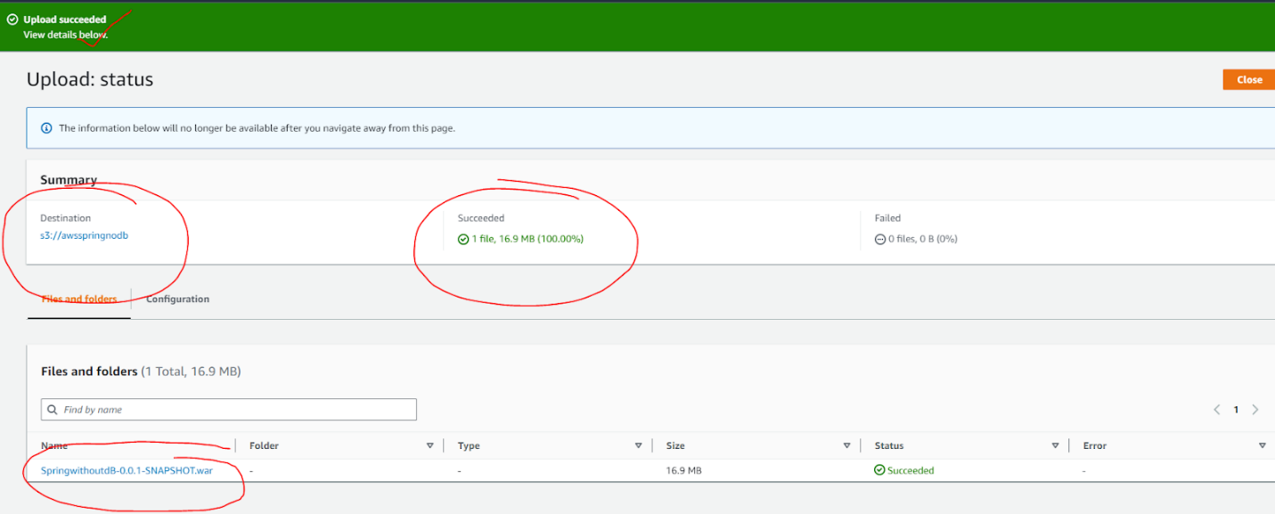

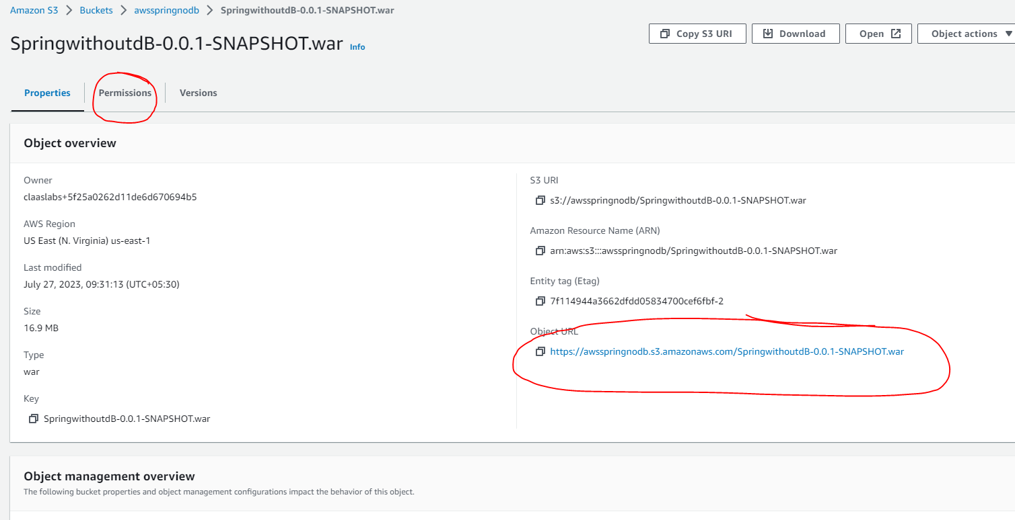

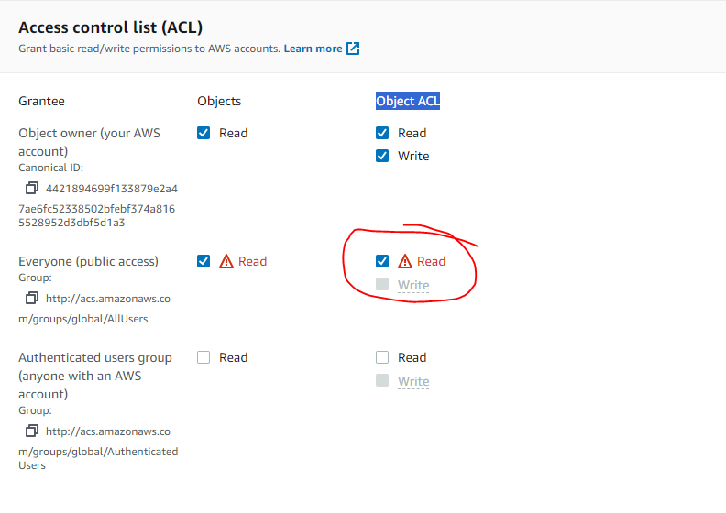

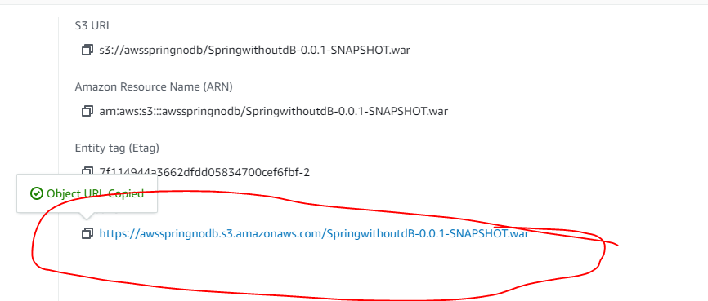

https://awsspringnodb.s3.amazonaws.com/SpringwithoutdB-0.0.1-SNAPSHOT.war



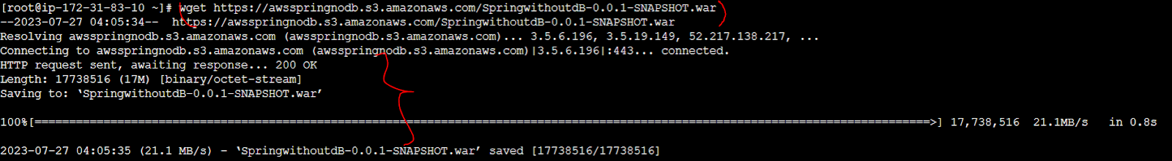

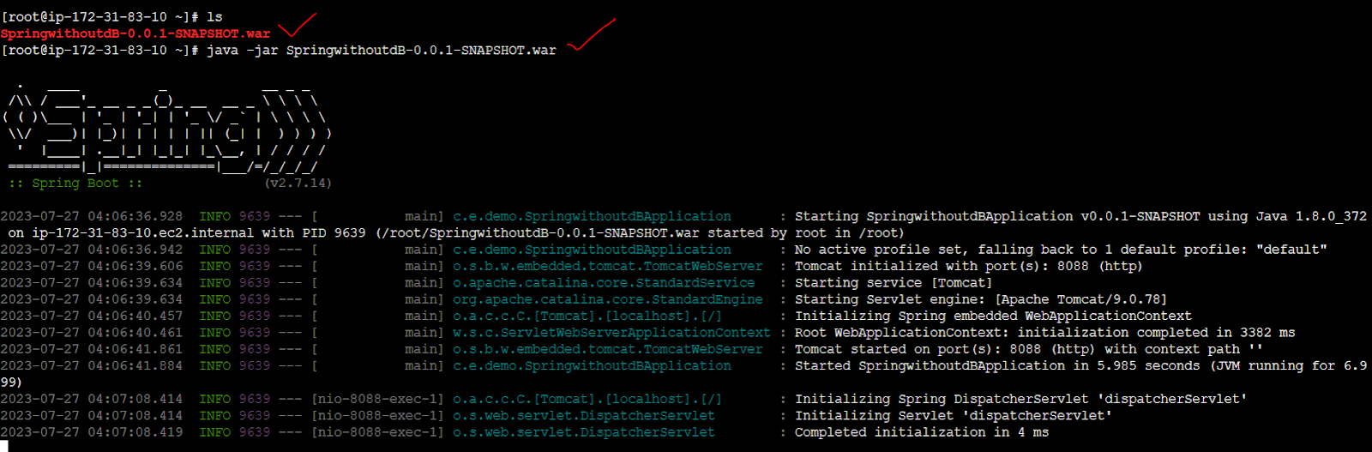

To terminate aws console use control+c

RDS

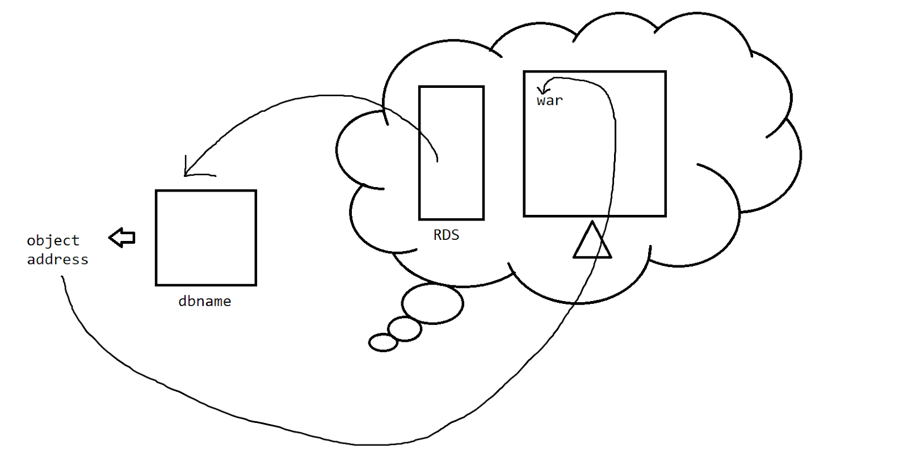

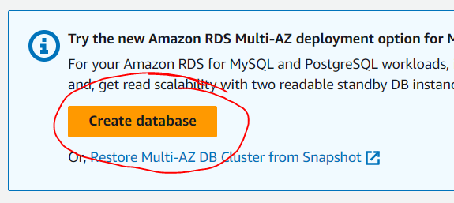

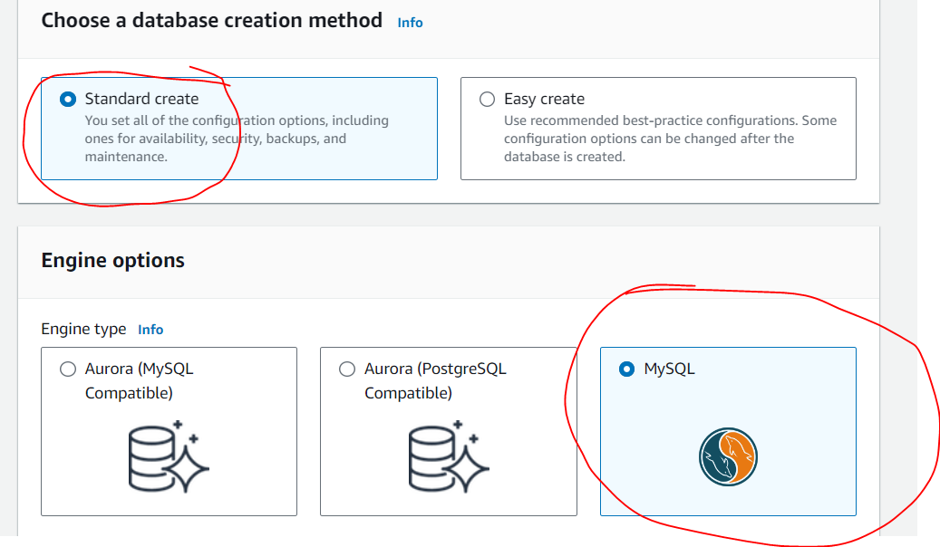

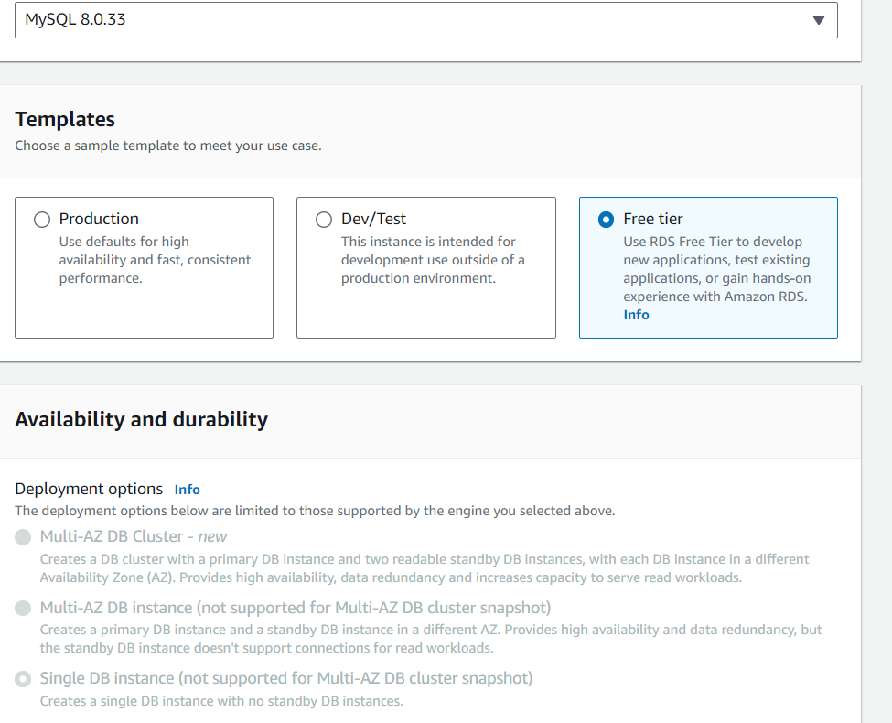

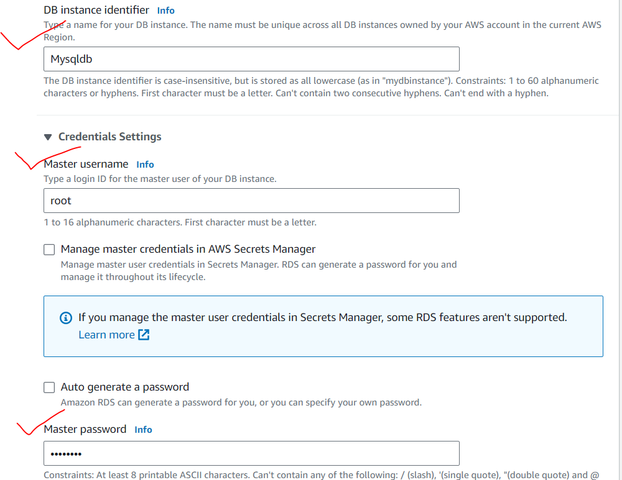

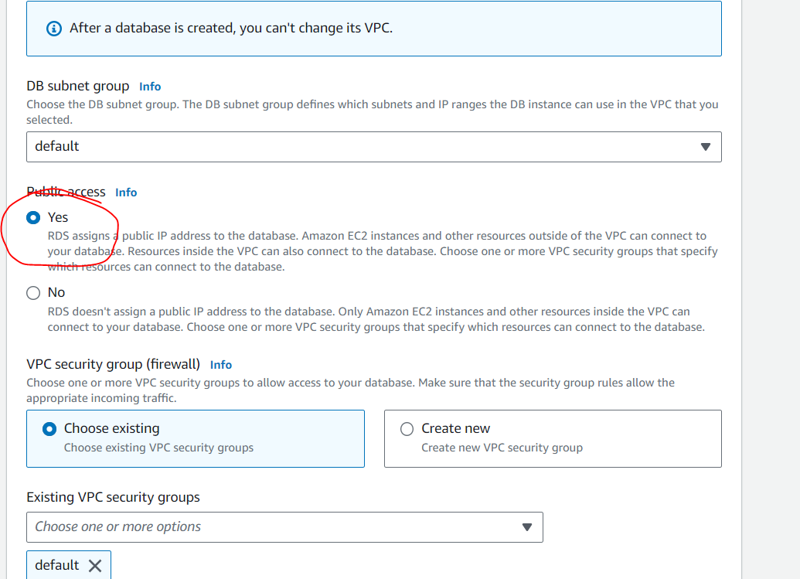

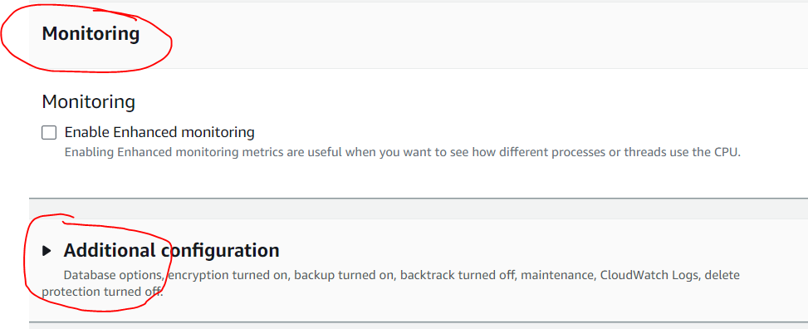

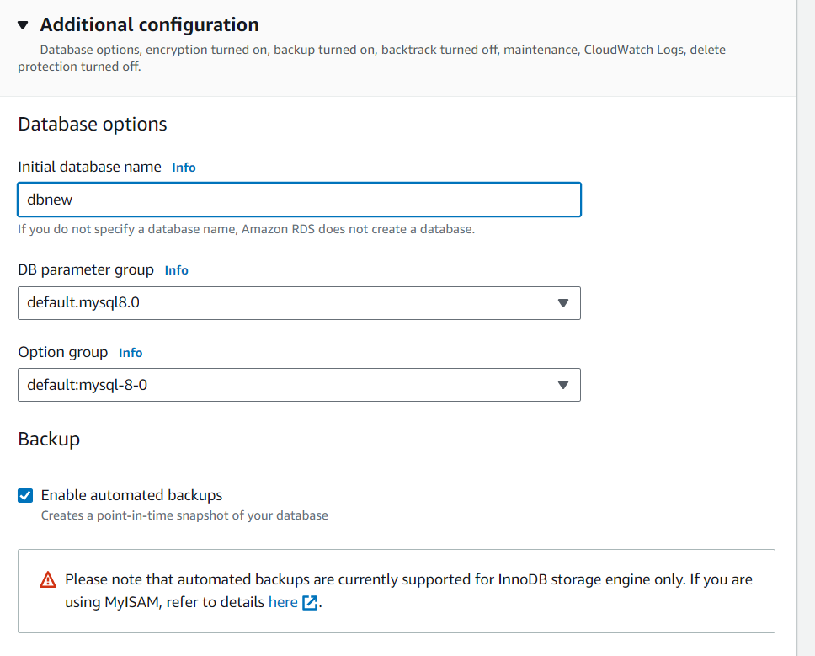

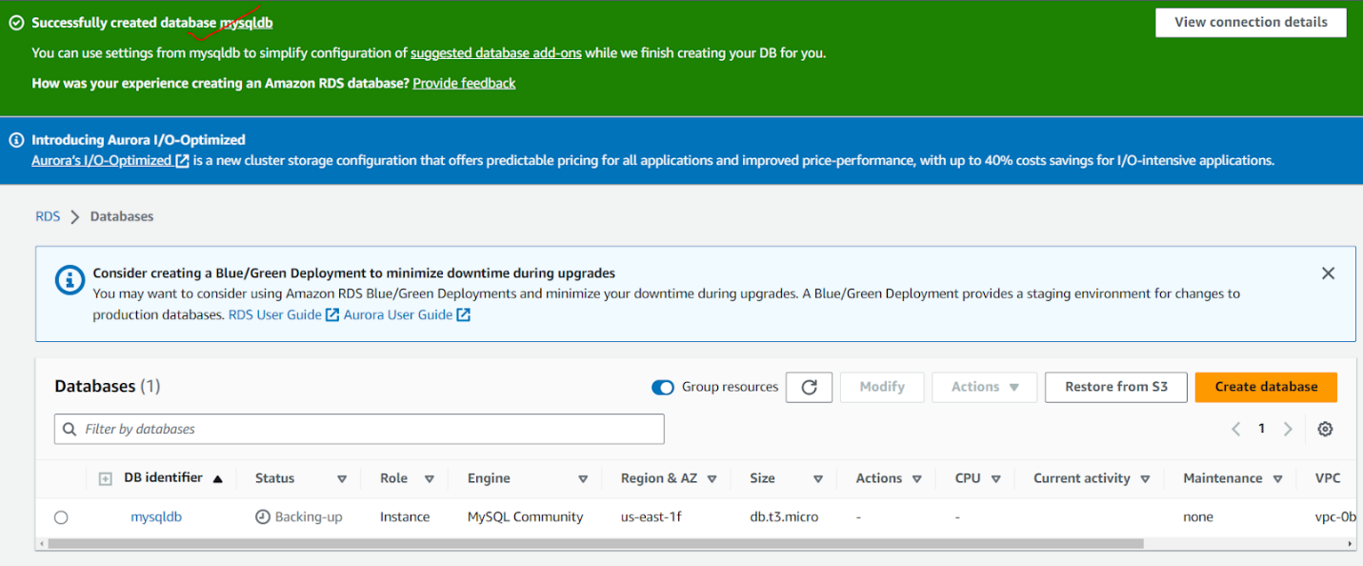

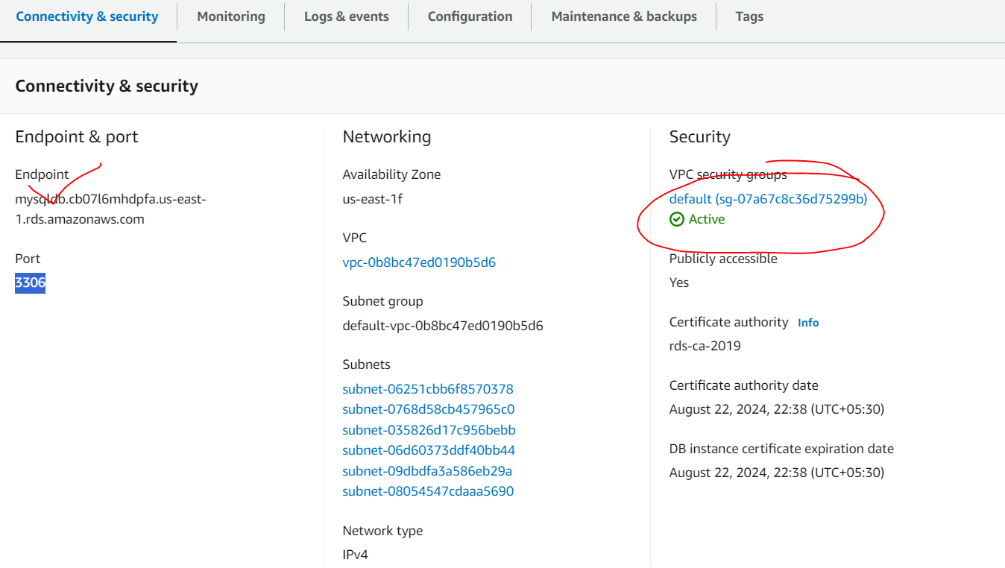

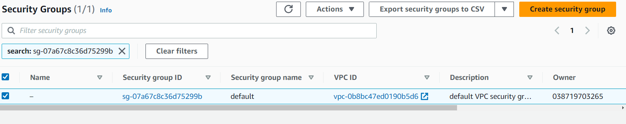

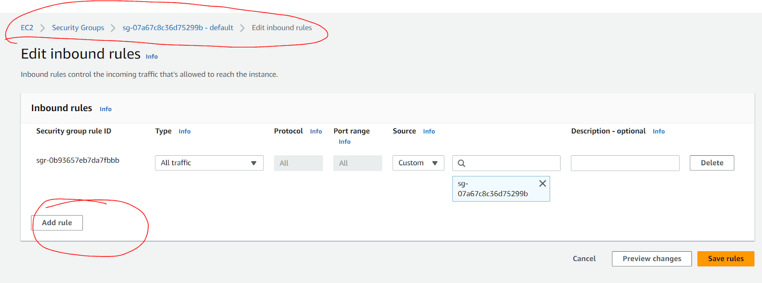

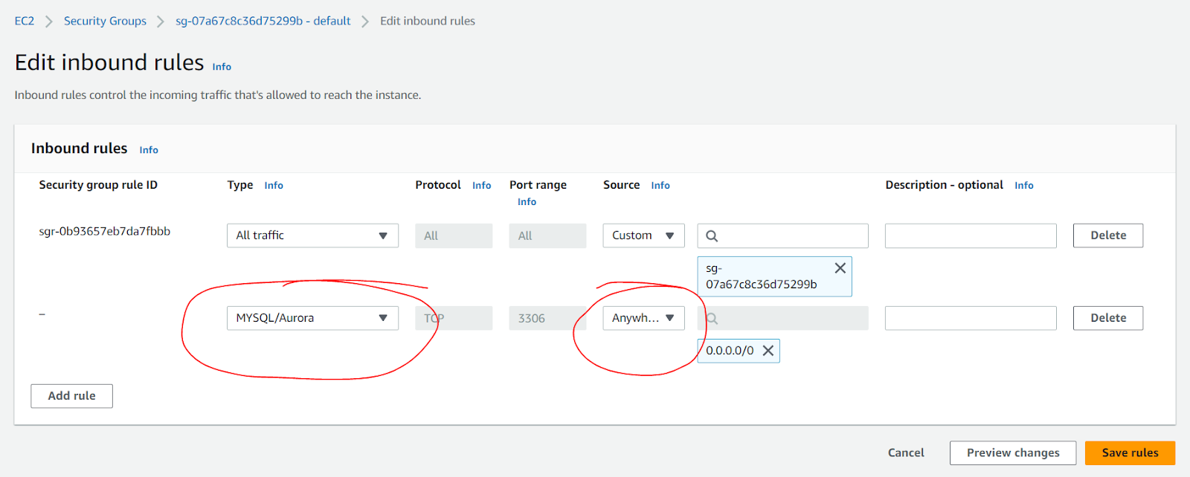

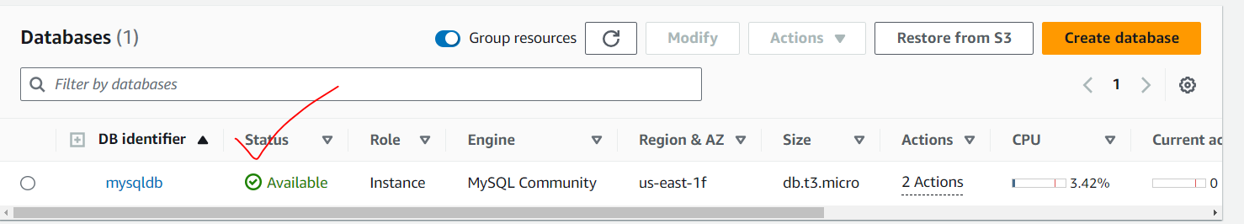

Open MySQL

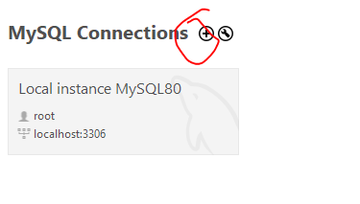

Copy

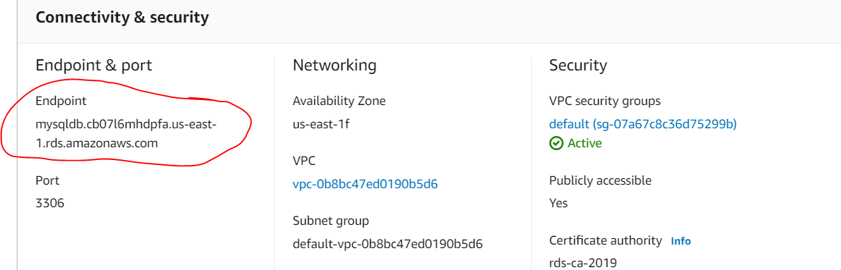

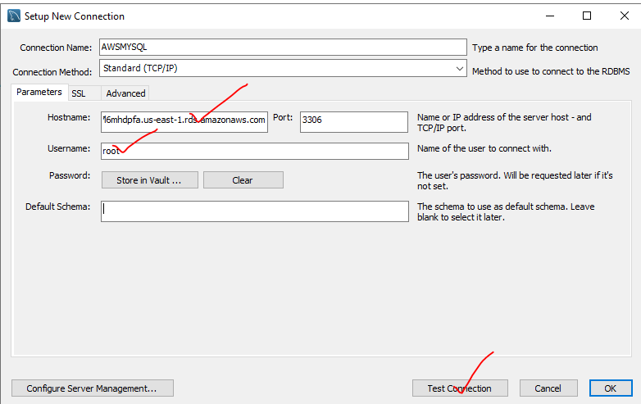

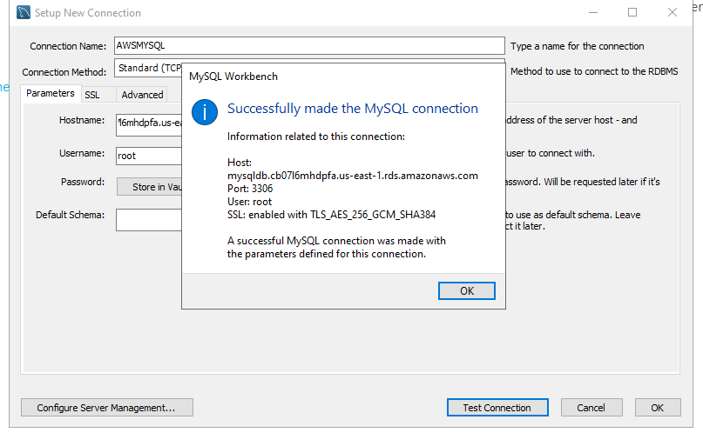

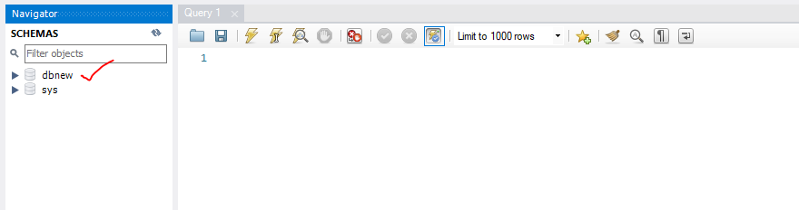

//Take a spring boot application

//go to the properties

server.port=8088

#================================================================

#Jpa hibernate

spring.jpa.hibernate.ddl-auto=update

spring.jpa.hibernate.show-sql=true

spring.jpa.hibernate.dialect=org.hibernate.dialect.MySQLDialect

spring.jpa.show-sql = true

#================================================================

#datasource

spring.datasource.driver-class-name=com.mysql.cj.jdbc.Driver

spring.datasource.url=jdbc:mysql://mysqldb.cb07l6mhdpfa.us-east-1.rds.amazonaws.com:3306/dbnew

spring.datasource.username=root

spring.datasource.password=12345678

#================================================================

With db on S3

1. Upload the war file with the db changes of RDS config
2. Go to EC2

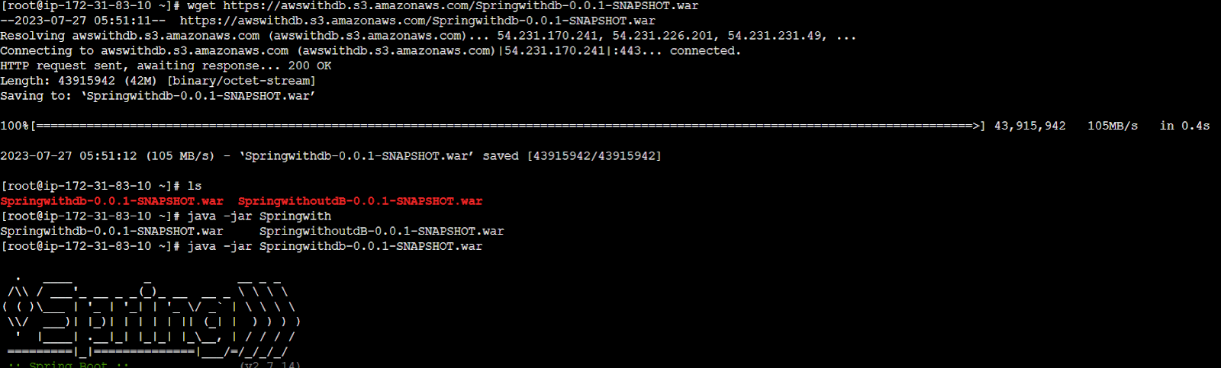

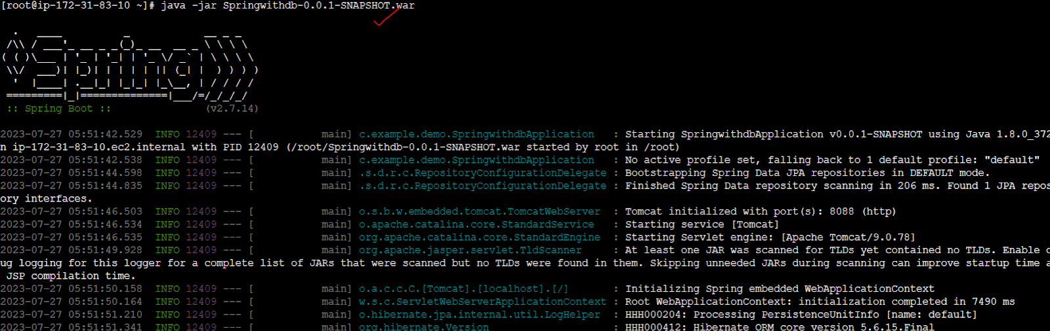

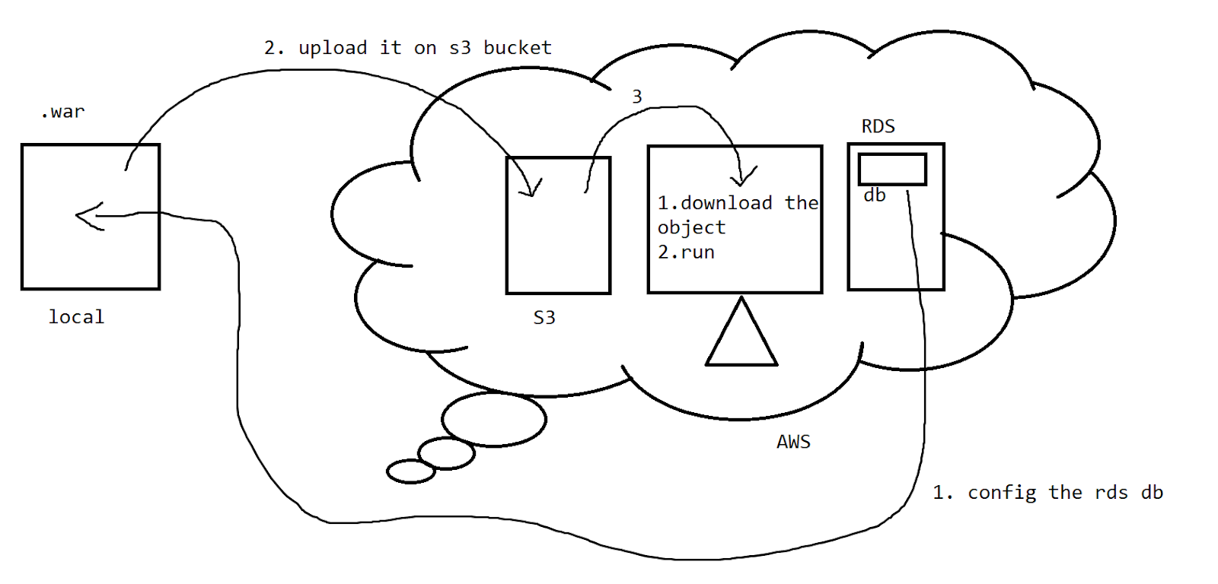

Task 👍

Complete the phase 3 end project - S3

>Angular hosting on S3

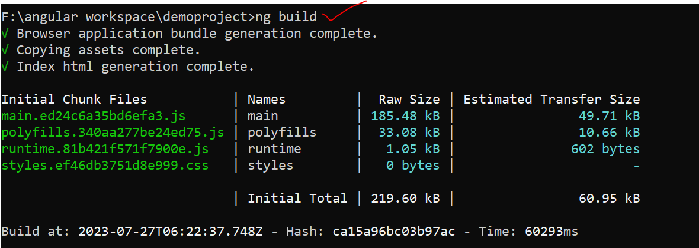



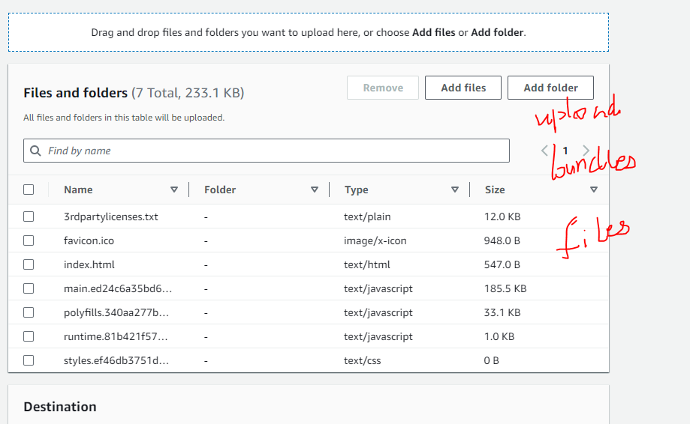

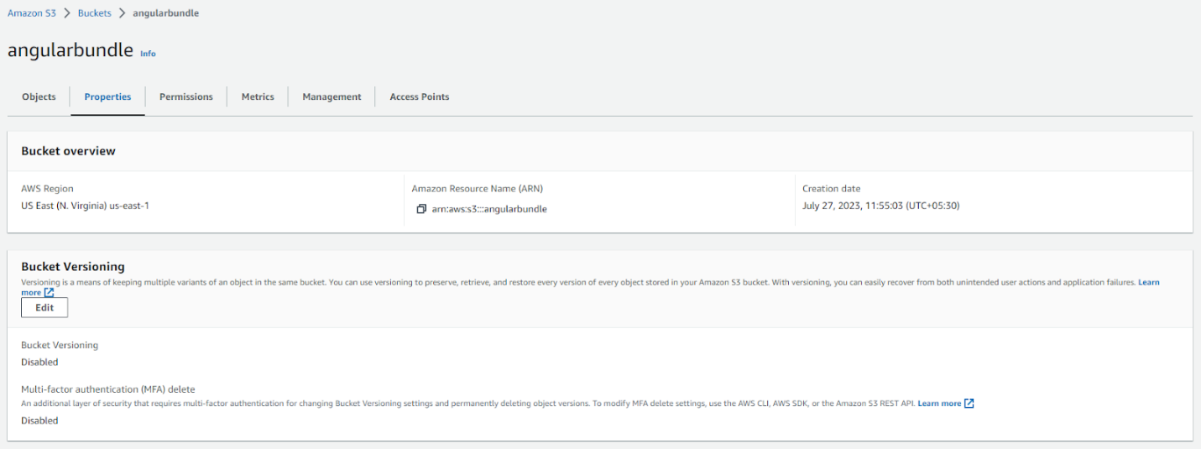

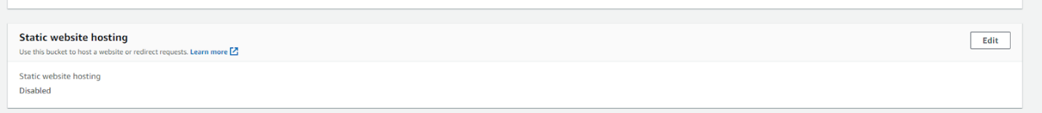

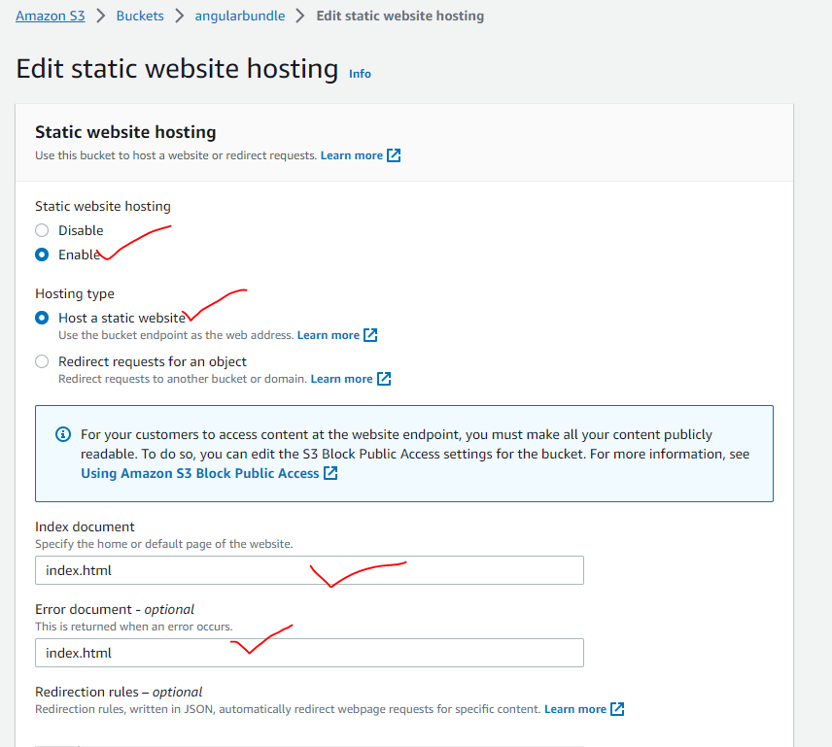

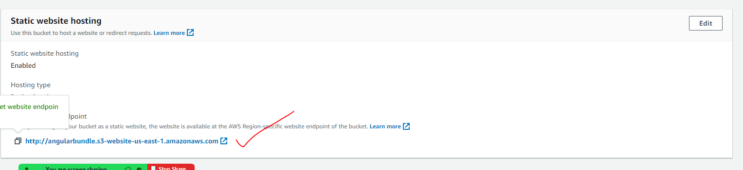

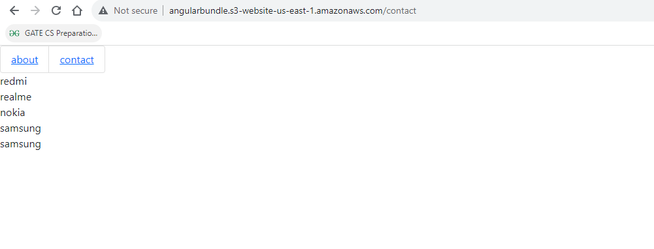

Angular with the Spring boot dB?

1. Create the Spring boot application
2. Change the properties

server.port=8088

#================================================================

#Jpa hibernate

spring.jpa.hibernate.ddl-auto=update

spring.jpa.hibernate.dialect=org.hibernate.dialect.MySQLDialect

spring.jpa.show-sql=true

#================================================================

#datasource

spring.datasource.driver-class-name=com.mysql.jdbc.Driver

spring.datasource.url=jdbc:mysql://mysqldb.cb07l6mhdpfa.us-east-1.rds.amazonaws.com:3306/dbnew

spring.datasource.username=root

spring.datasource.password=12345678

#================================================================

1. Make the war file
2. Upload this in the S3
3. Download on to EC2 as a war file
4. Run it
5. Open service in the Angular file change the localhost address to the ec2 cloud address

import { HttpClient } from '@angular/common/http';

import { Injectable } from '@angular/core';

@Injectable({

  providedIn: 'root'

})

export class UserRegistrationServiceService {

  constructor(private http:HttpClient) { }

  //insert

  //if the response is a java object then it will be auto converted to json if not we need to convert it

  public doregistration(user:any){

    return this.http.post("http://ec2-44-211-163-218.compute-1.amazonaws.com:8088/register",user,{responseType:'text' as 'json'});

  }

//getusers

public getusers(){

  return this.http.get("http://ec2-44-211-163-218.compute-1.amazonaws.com:8088/getAllusers");

}

//search by email

public getuserbyemail(email:any){

  return this.http.get("http://ec2-44-211-163-218.compute-1.amazonaws.com:8088/findbyemail/"+email);

}

//delete by id

public deletebyid(id:any){

  return this.http.delete("http://ec2-44-211-163-218.compute-1.amazonaws.com:8088/cancel/"+id);

}

}

Do bundle generation

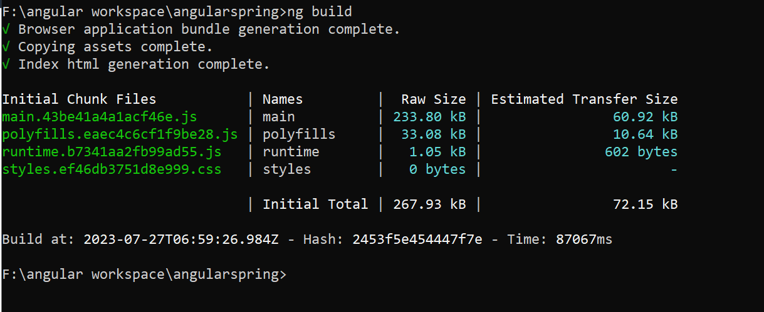



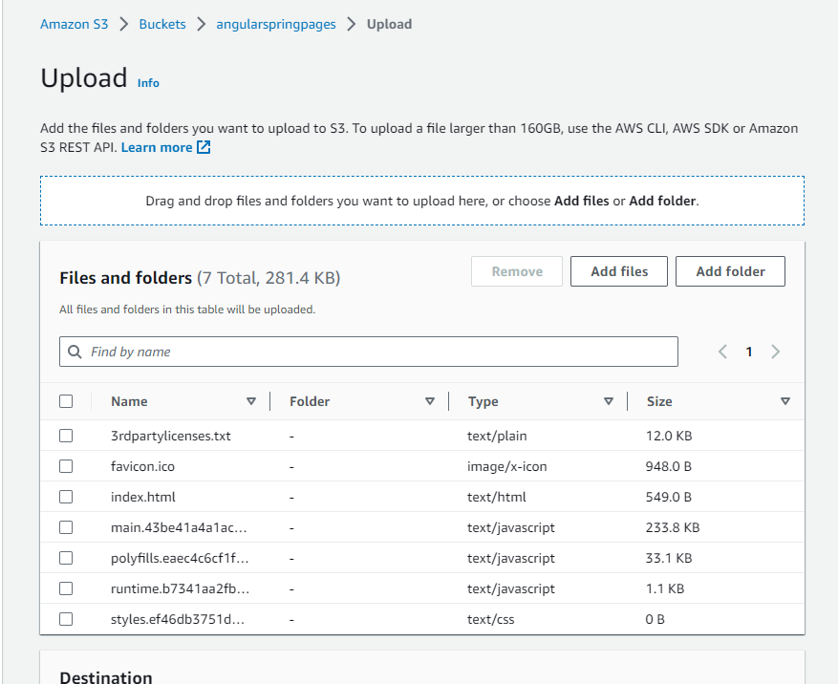

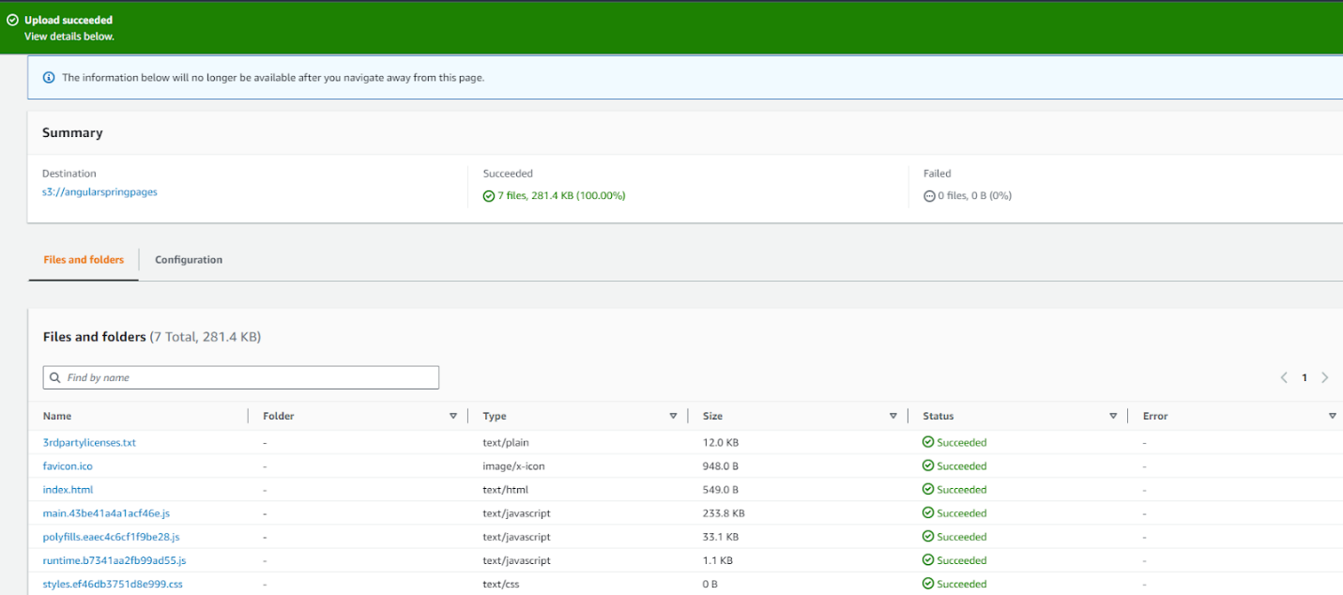

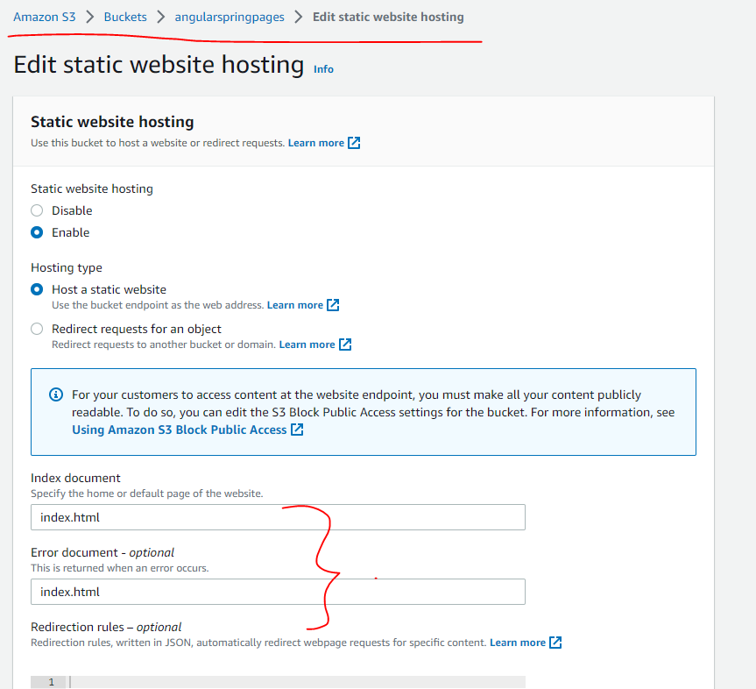

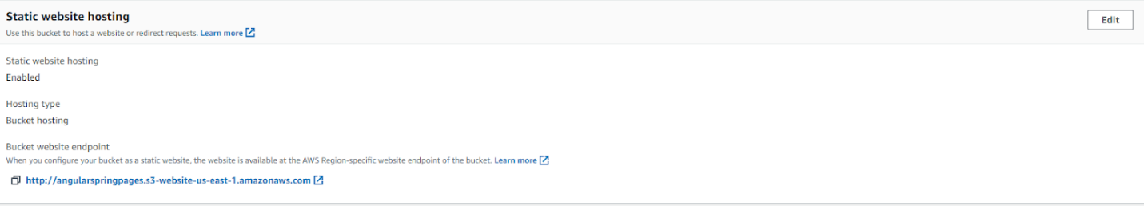

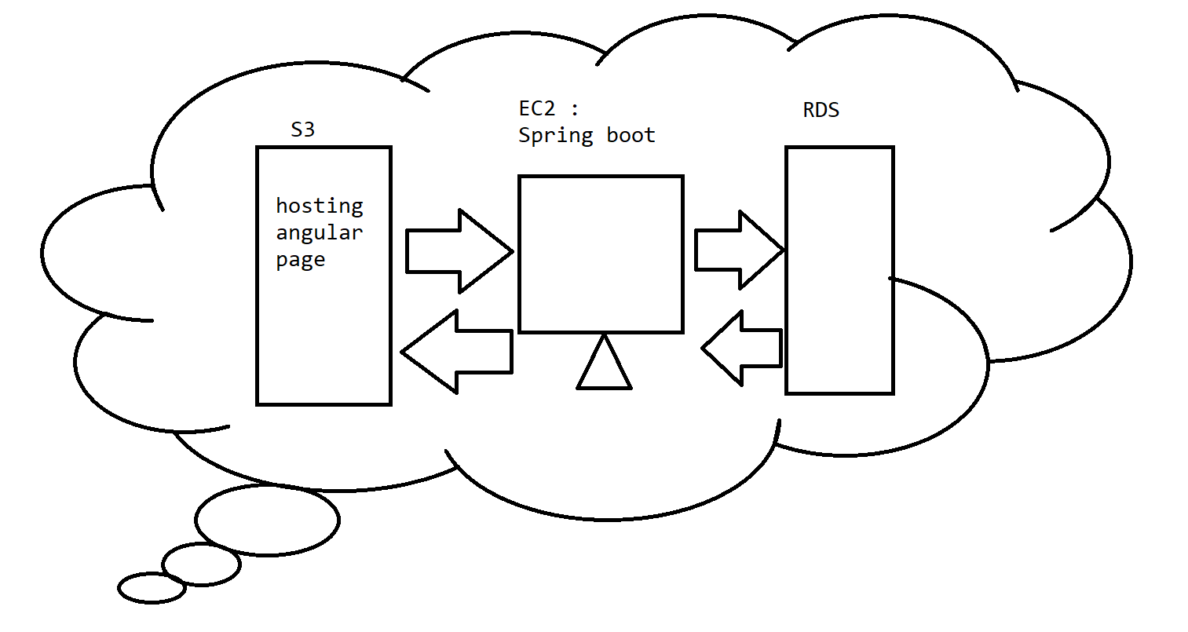

Task

TestNG report for the selenium operation on the aws cloud angular - spring boot application

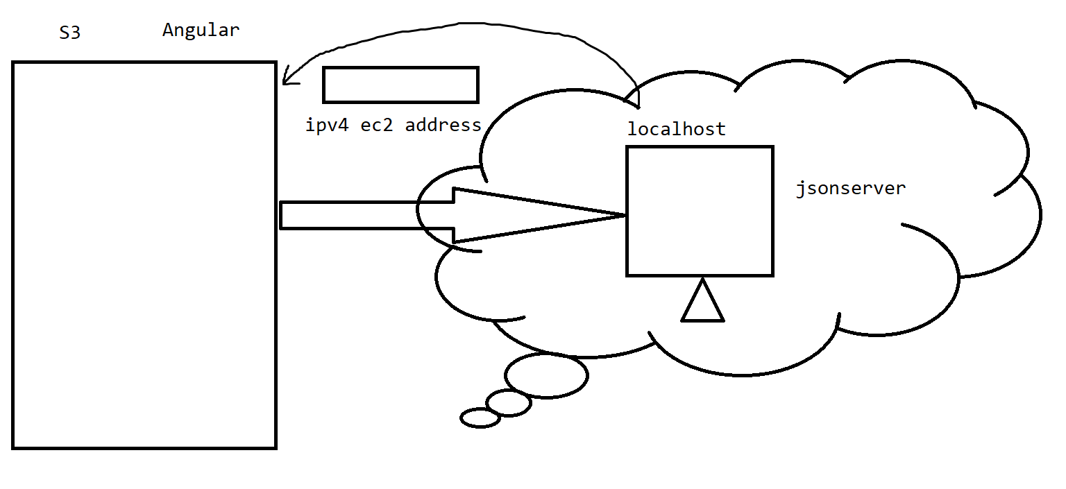

Install json server over ec2

1. curl -fsSL https://rpm.nodesource.com/setup_16.x | bash -
2. sudo yum install -y nodejs
3. sudo npm install -g json-server

//prepare your json data

In vi editor

Press i -insert

Keep ur json data

Use

Press esc

:wq

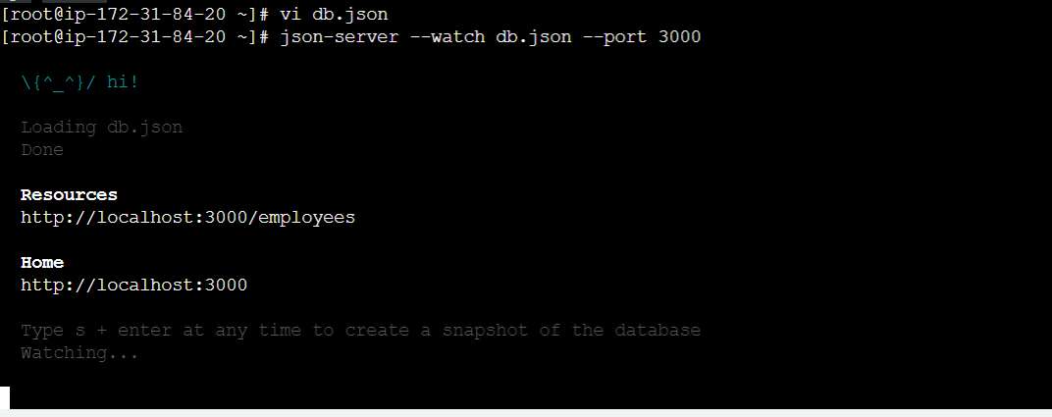

ec2-52-91-35-16.compute-1.amazonaws.com:3000/employees

//Test an angular project with json server-10 min

//Jenkins

It is an automated process tool used to perform the actions .

<https://www.jenkins.io/download/>

Min java - 11

<https://www.oracle.com/in/java/technologies/javase/jdk11-archive-downloads.html>

Download jdk 11

>create an oracle account

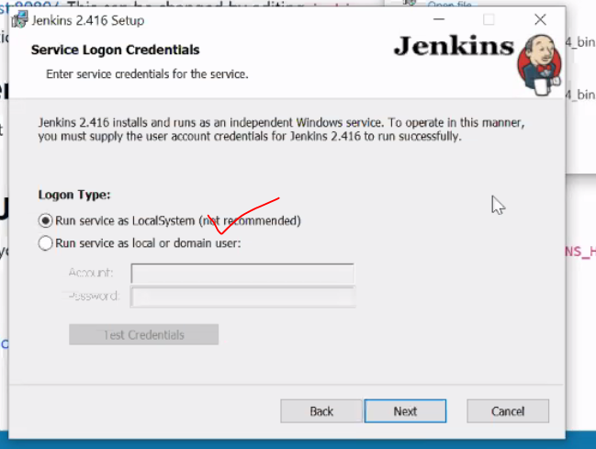

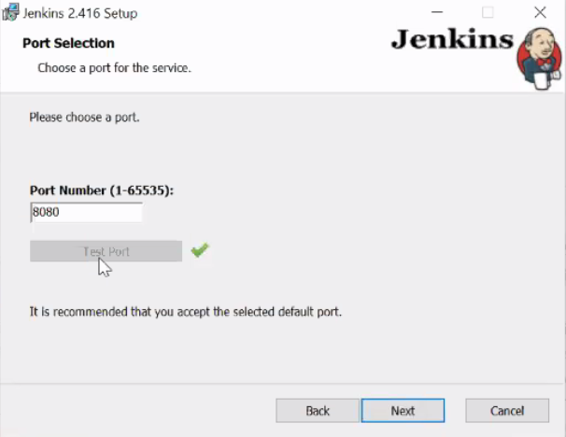

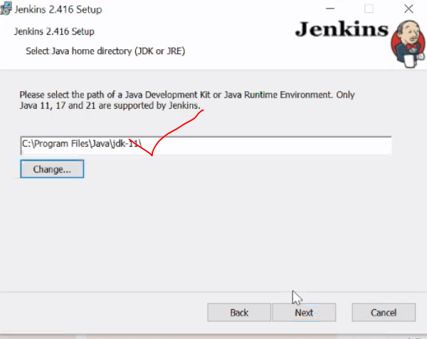

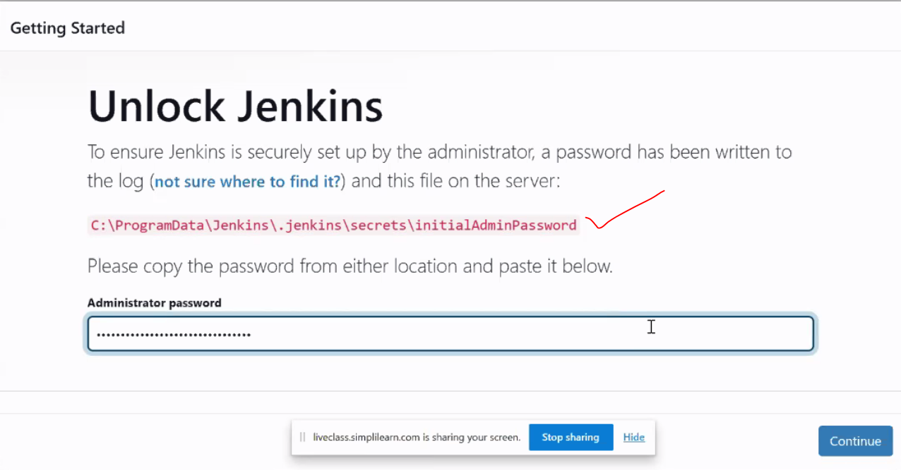

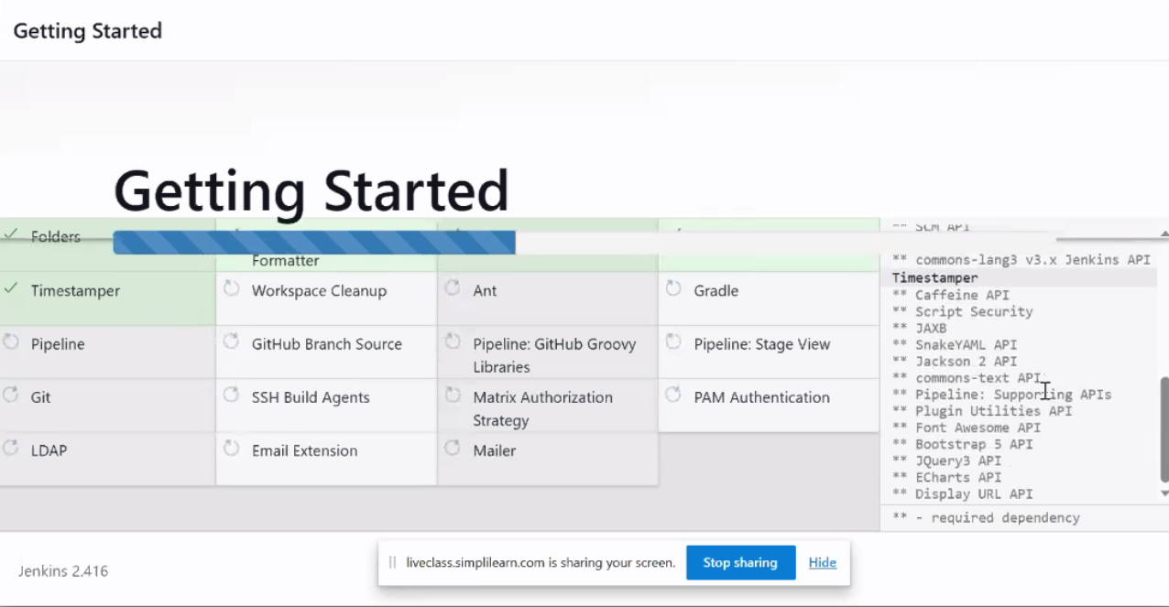

Model -1

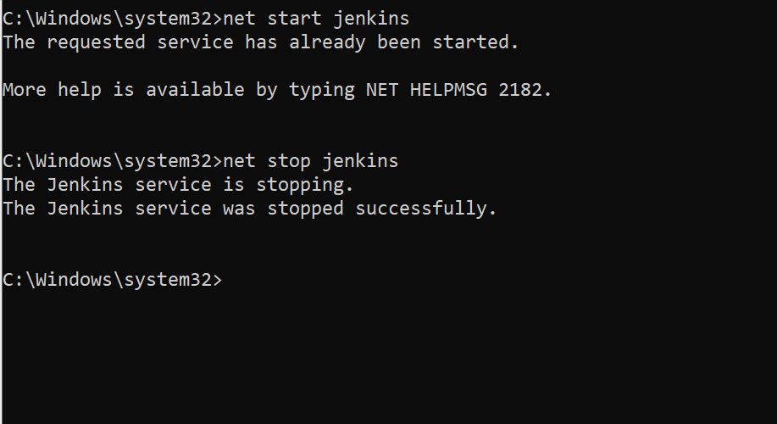

Model -2

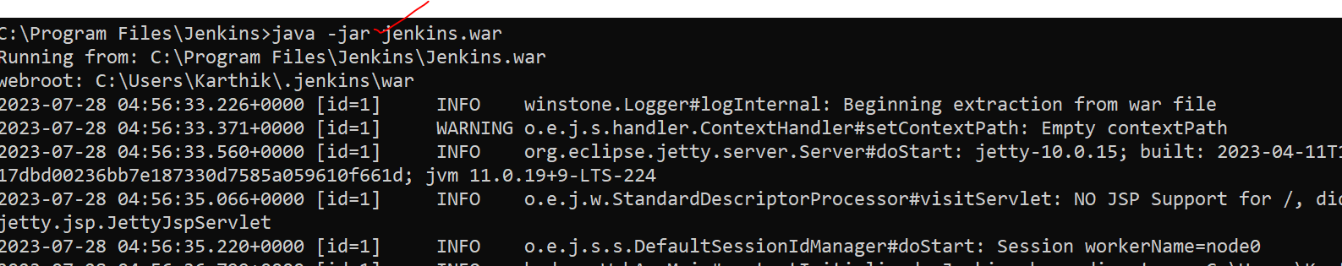

After login ->Manage jenkins

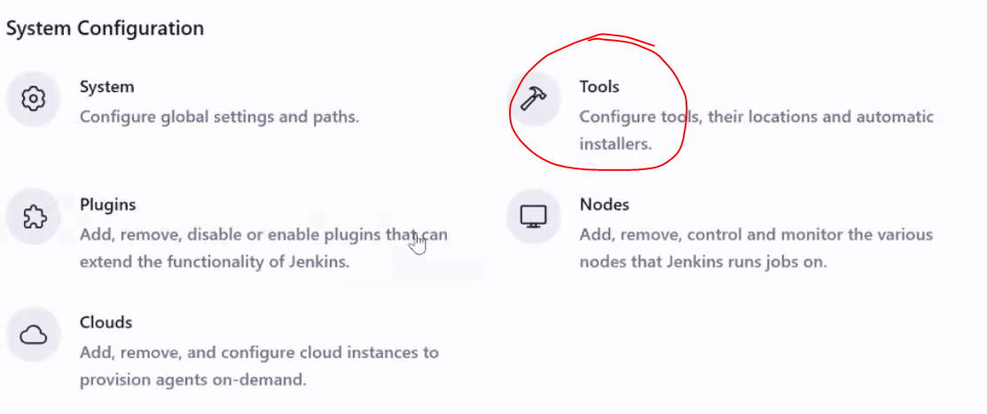

Java

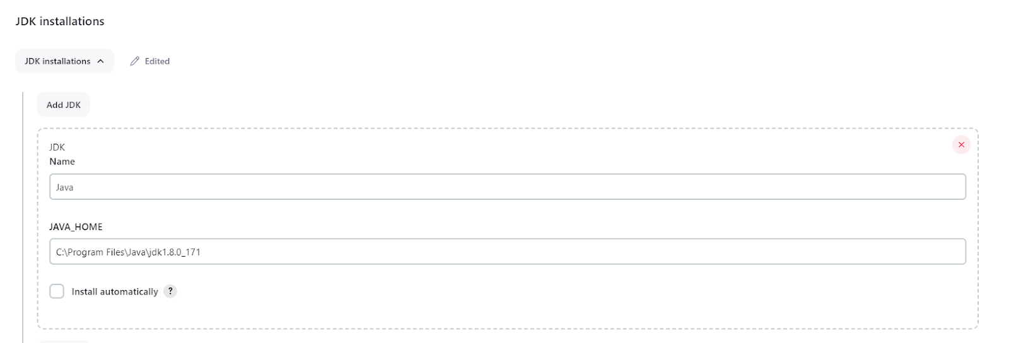

Git

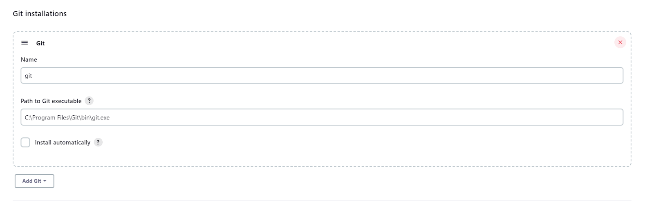

Maven :

<https://dlcdn.apache.org/maven/maven-3/3.9.3/binaries/apache-maven-3.9.3-bin.zip>

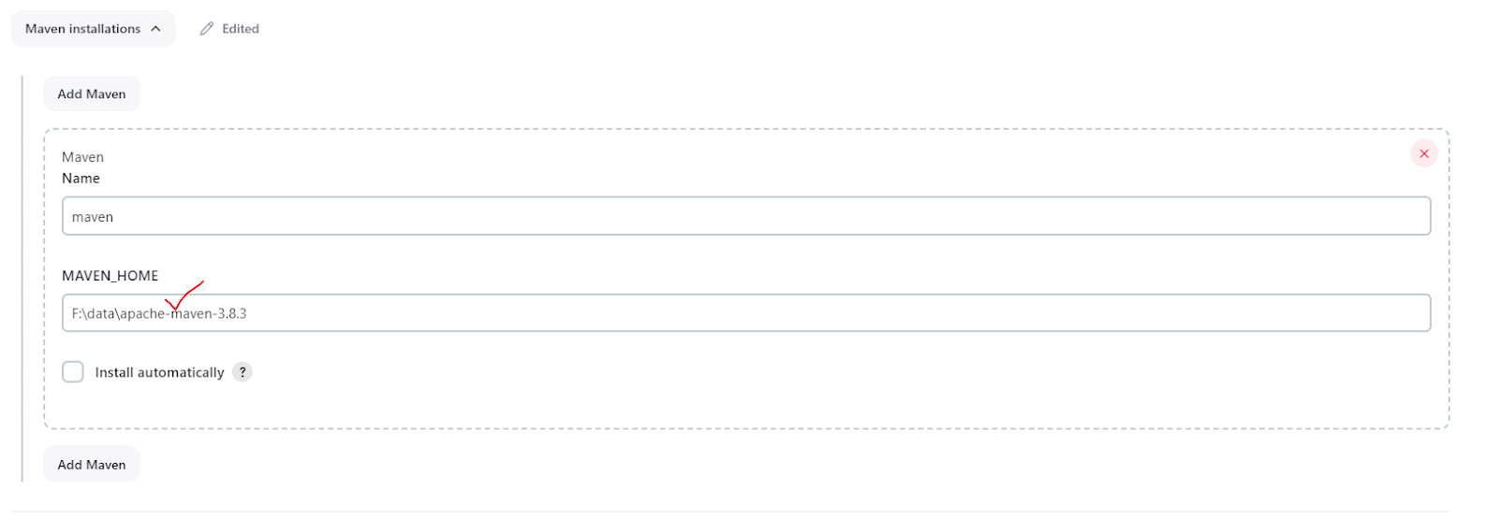

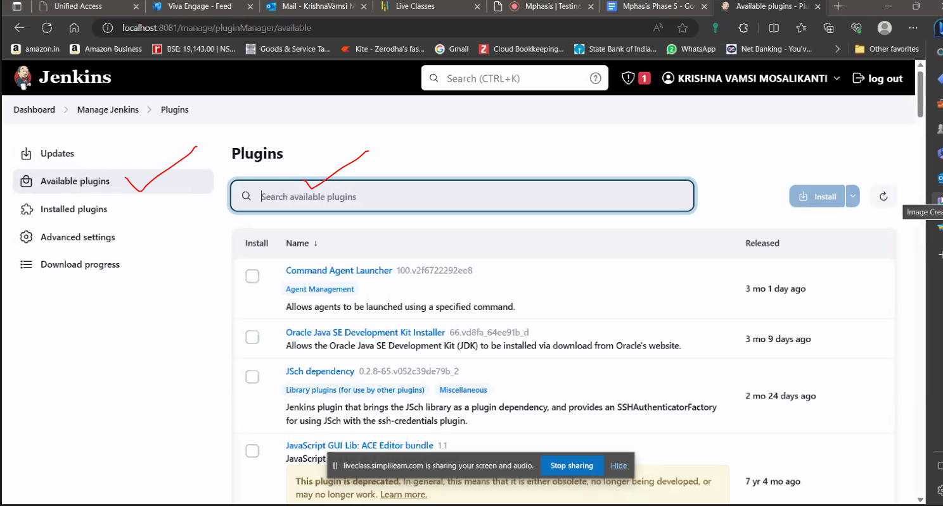

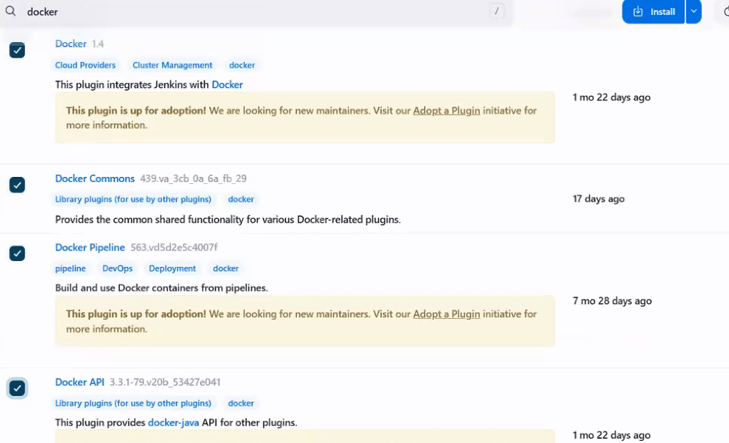

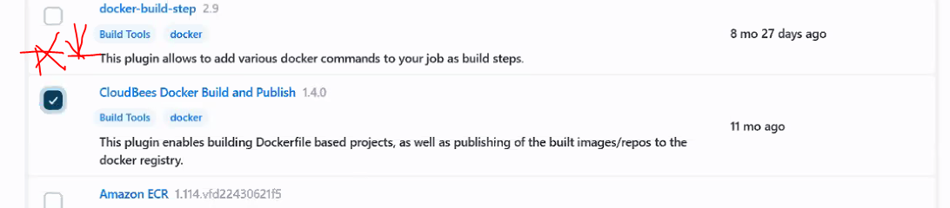

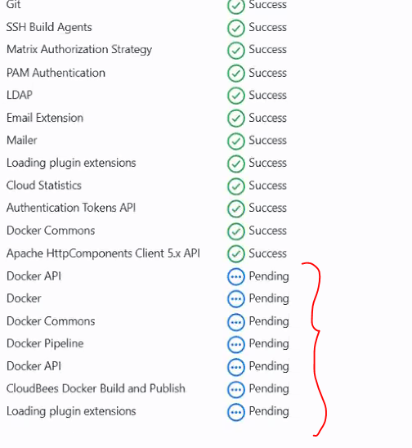

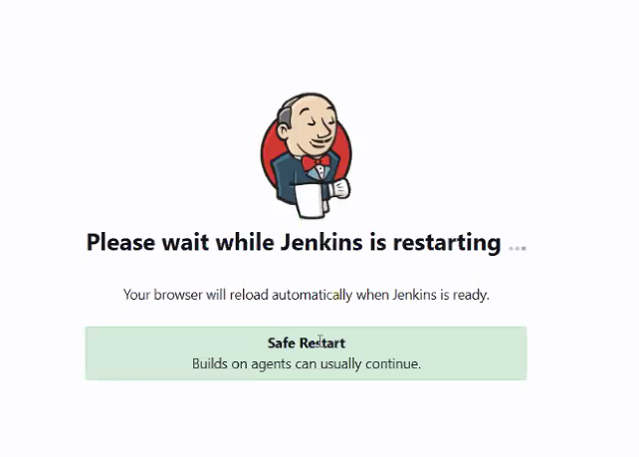

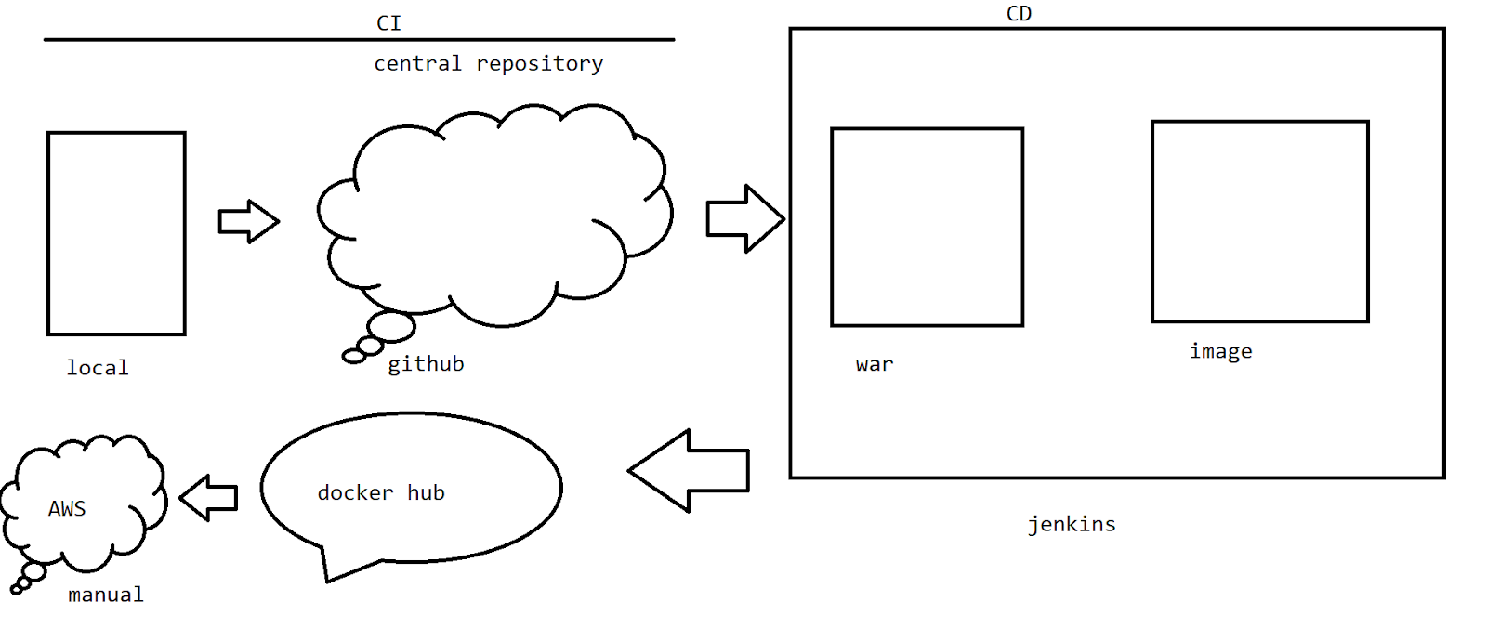

1. Creating SCM process
2. Creating a pipeline

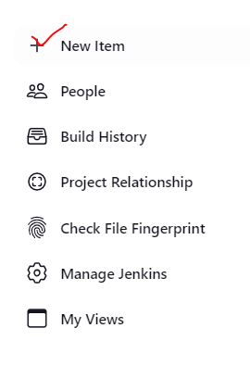

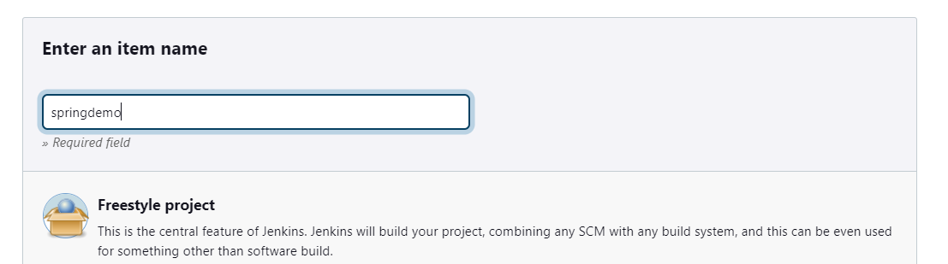

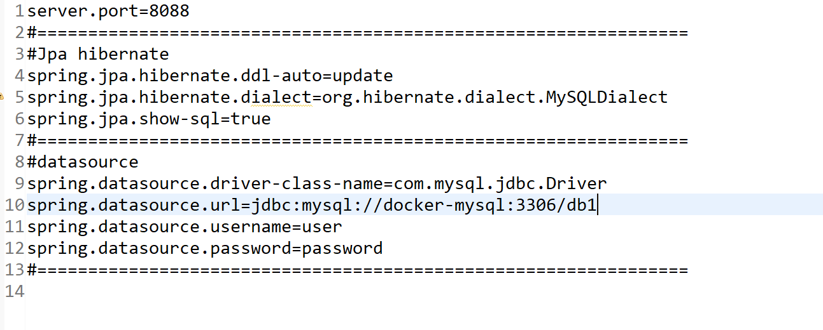

Via git push the code into the github

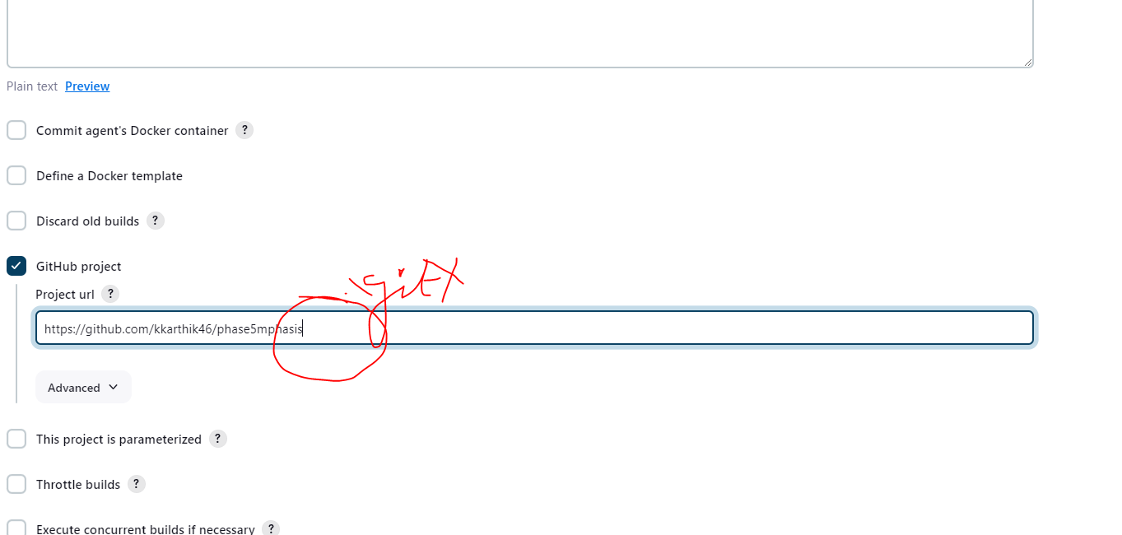

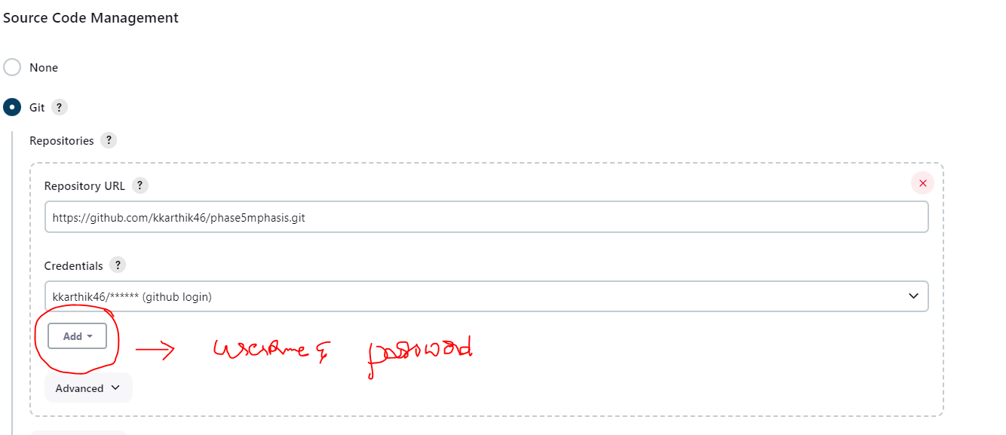

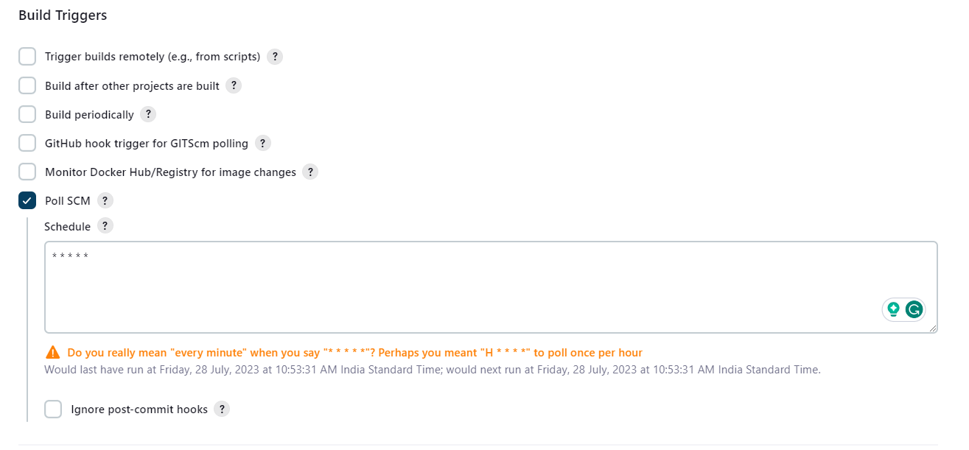

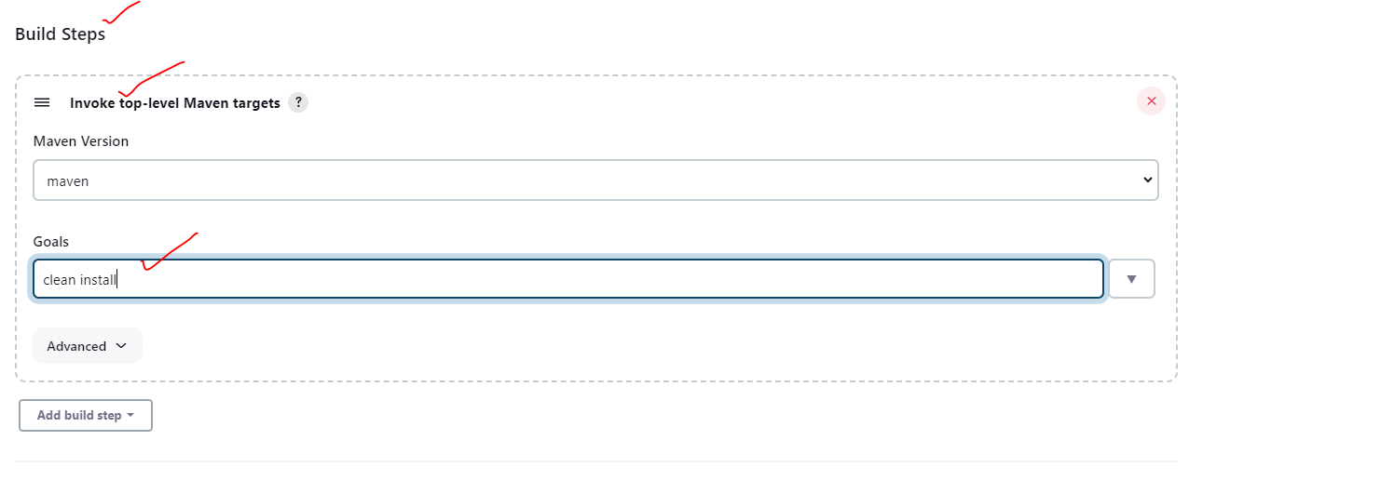

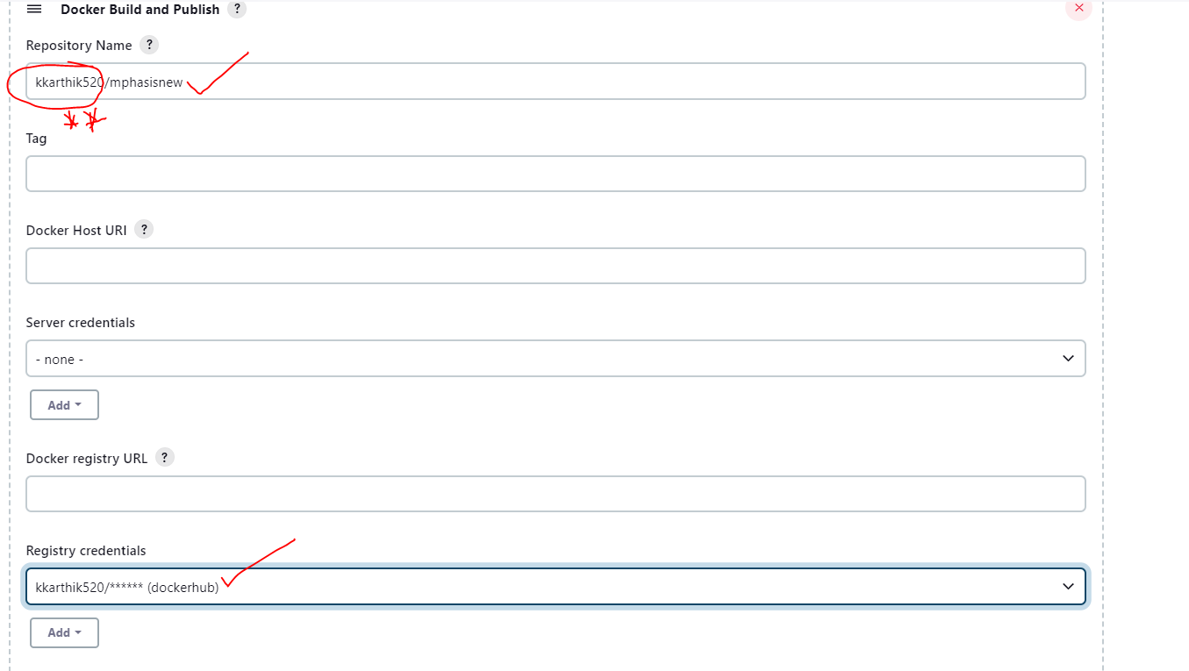

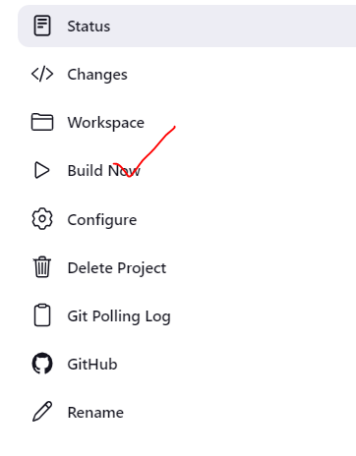

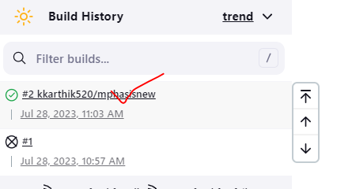

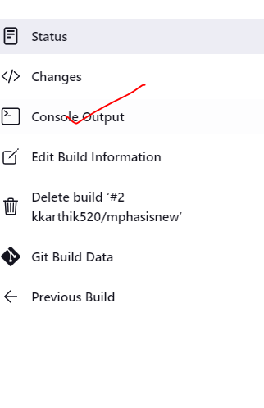

//Jenkins pipe line

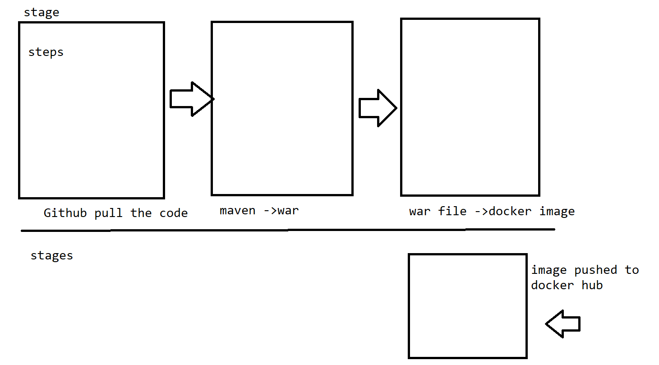

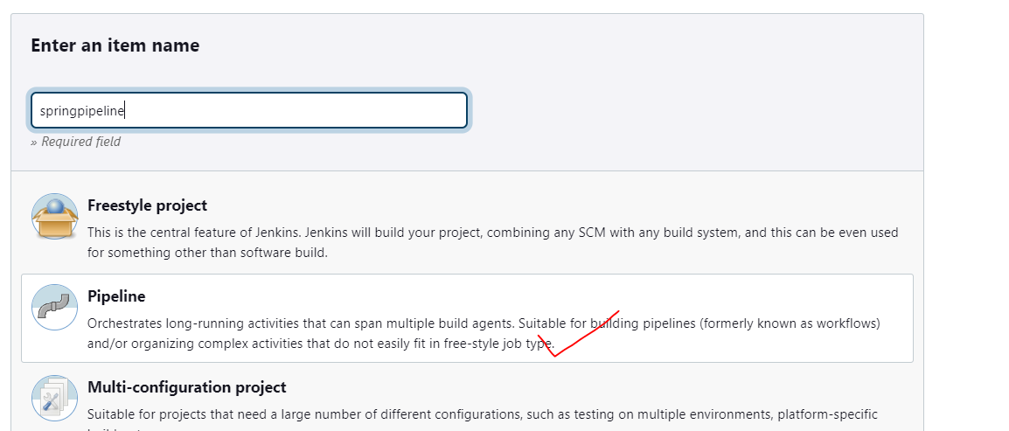

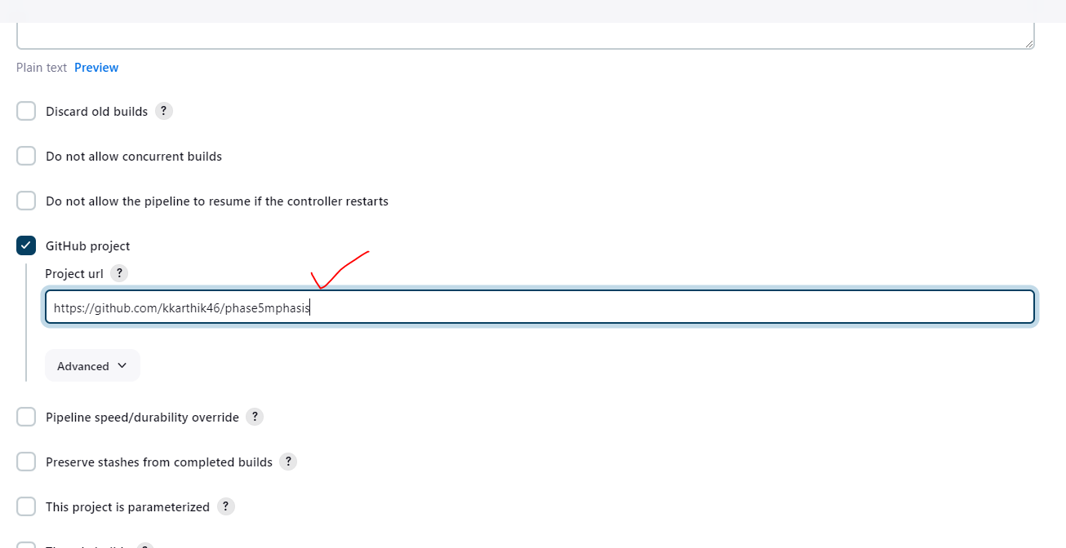

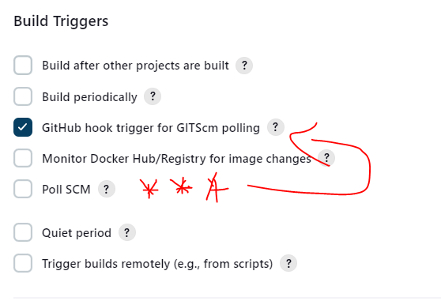

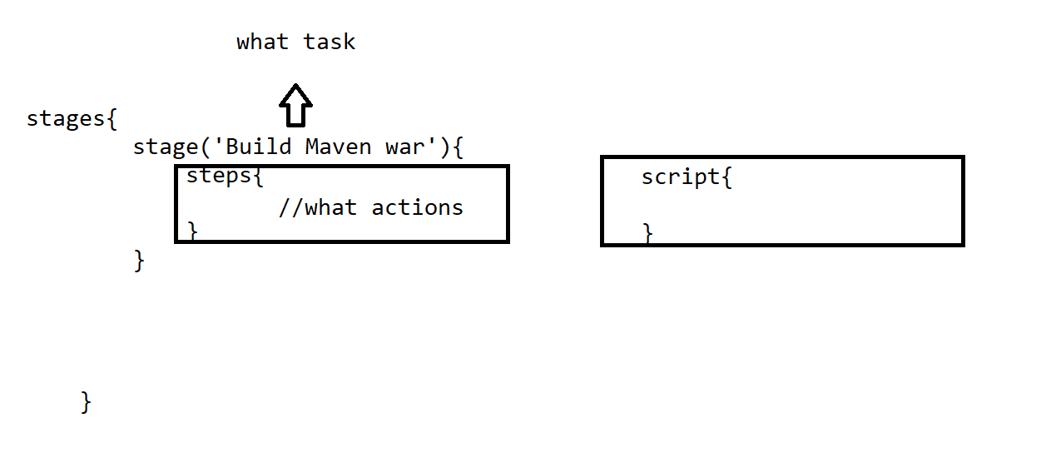

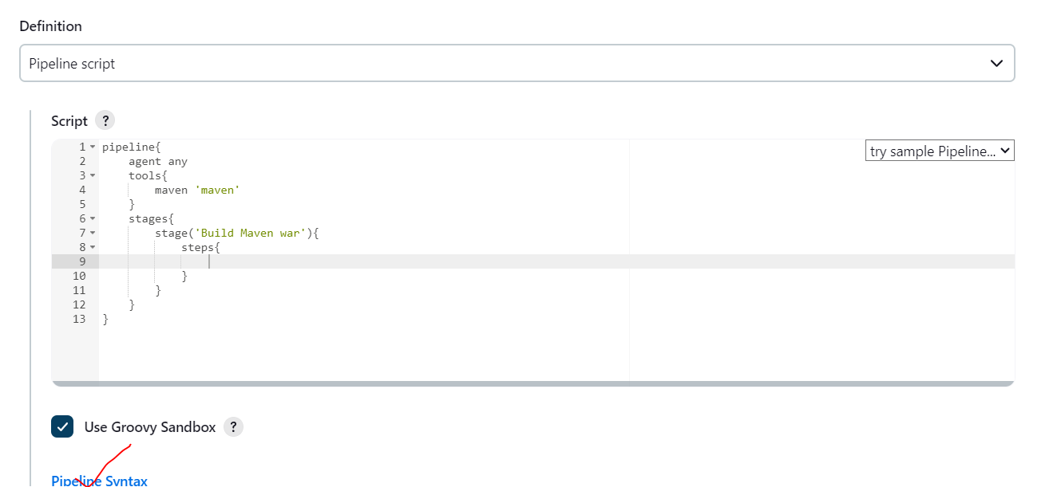

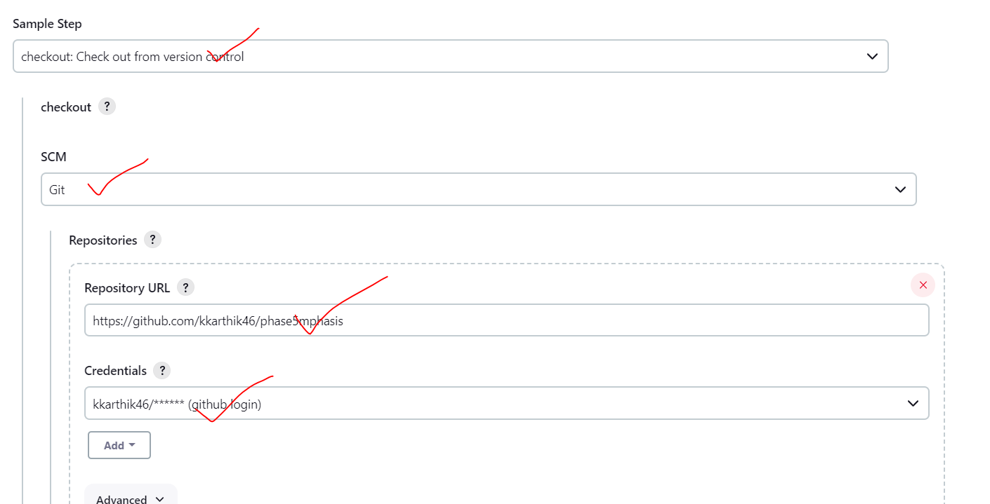

With docker

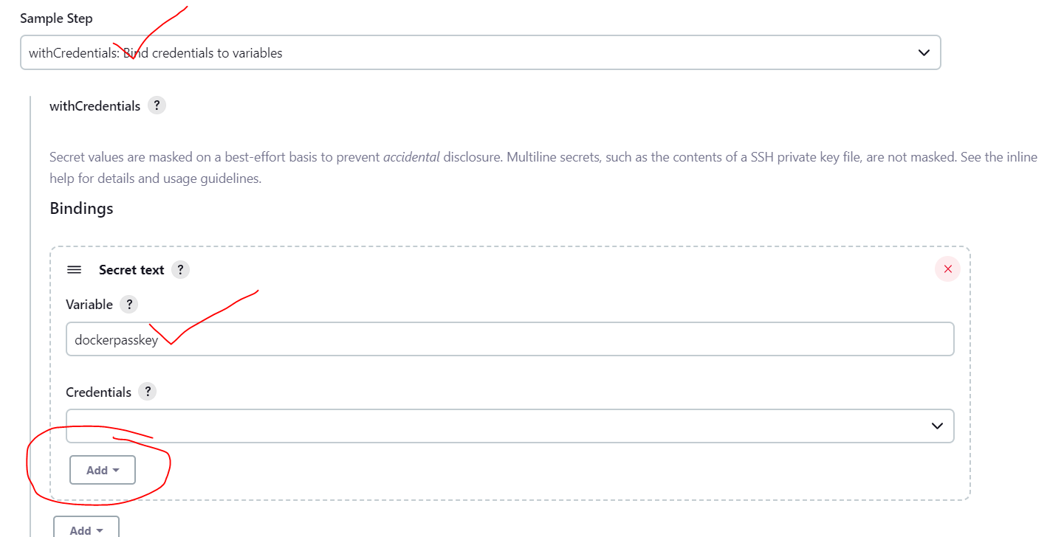

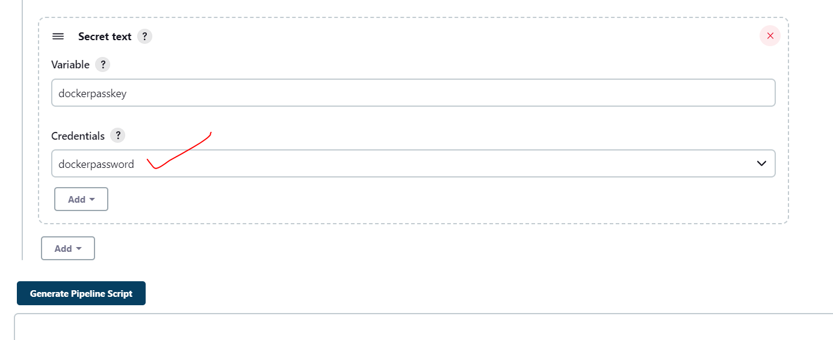

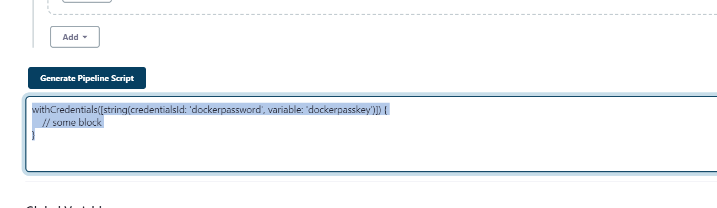

pipeline{

    agent any

    tools{

        maven 'maven'

    }

    stages{

        stage('Build Maven war'){

            steps{

               checkout scmGit(branches: [[name: '*/master']], extensions: [], userRemoteConfigs: [[credentialsId: '86896008-36a1-4054-8aa9-04c12f4fd6af', url: 'https://github.com/kkarthik46/phase5mphasis']])

                bat 'mvn clean install'

            }

        }

        stage('Build Docker Image'){

            steps{

            script{

              bat 'docker build -t kkarthik520/jenkinsmph .'

            }

            }

        }

        stage('Push Docker Image'){

            steps{

            script{

             withCredentials([string(credentialsId: 'dockerpassword', variable: 'dockerpasskey')]) {

           bat 'docker login -u kkarthik520 -p %dockerpasskey%'

            }

            bat 'docker push kkarthik520/jenkinsmph'

            }

            }

        }

    }

}

=================================================================  
Forget Jenkins password

1. Do a login with admin as username and password in the file intialAdminPassword

.jenkins/secret/

2. Go to config.xml and make the

<useSecurity>false</useSecurity>

Restart your jenkins

=====================================================================

Clean docker images with volume

docker system prune -a --volumes

====================================================================

Docker swarm

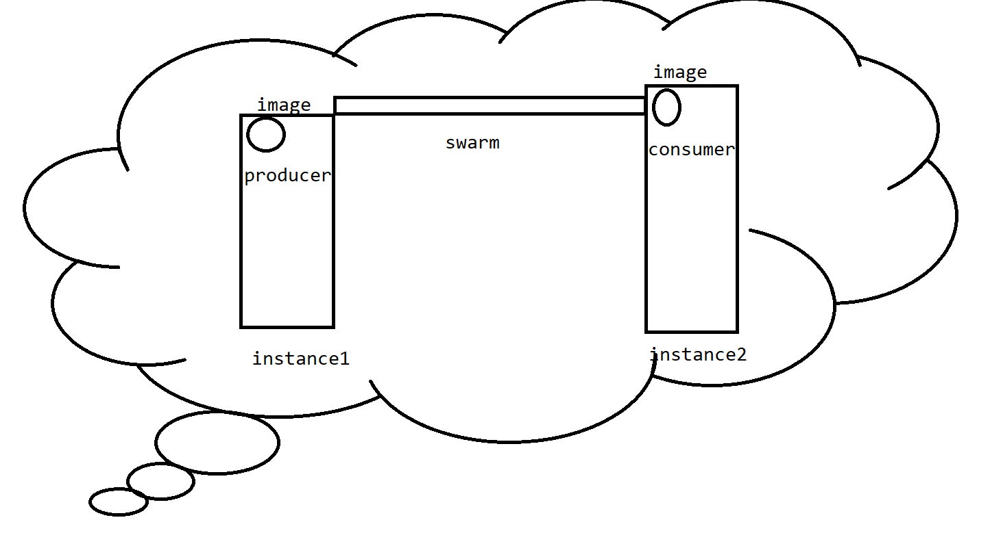

1. On local swarm -> we can upscale our images

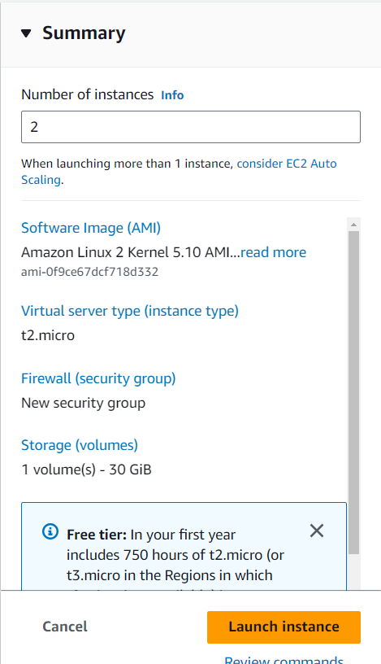

kkarthik520/producer

kkarthik/consumer

On the aws producer instance

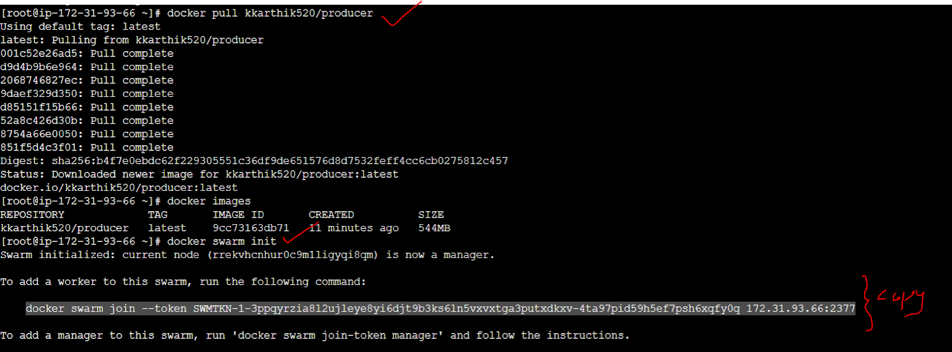

On the aws consumer instance



//producer end we need to establish network

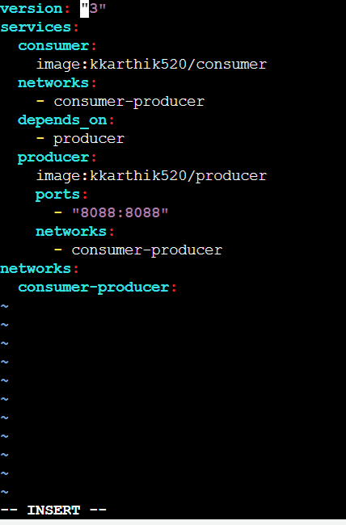

dockerconfig.yaml

version: "3"

services:

  consumer:

    image: kkarthik520/consumer

    networks:

      - consumer-producer

    depends_on:

      - producer

  producer:

    image: kkarthik520/producer

    ports:

      - "8088:8088"

    networks:

      - consumer-producer

networks:

  consumer-producer:

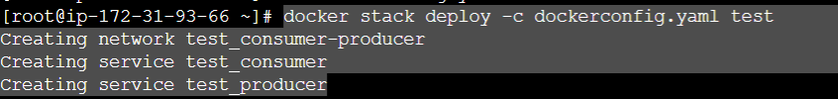

//producer

package com.example.demo;

import lombok.Data;

@Data

public class Employee {

private int eid;

private String ename;

private double salary;

}

//controller

package com.example.demo;

import org.springframework.stereotype.Controller;

import org.springframework.web.bind.annotation.RequestMapping;

@Controller

public class TestController {

@RequestMapping("/employee")

public Employee data() {

Employee  e=new Employee();

e.setEid(1);

e.setEname("karthik");

e.setSalary(1000);

return e;

}

}

//consumer

package com.example.demo;

import org.springframework.http.HttpEntity;

import org.springframework.http.HttpHeaders;

import org.springframework.http.HttpMethod;

import org.springframework.http.MediaType;

import org.springframework.http.ResponseEntity;

import org.springframework.stereotype.Controller;

import org.springframework.web.client.RestTemplate;

@Controller

public class ConsumerController {

public void getEmployee() {

String url="http://producer:8088/employee";

RestTemplate rest=new RestTemplate();

ResponseEntity<String> response=null;

response=rest.exchange(url,HttpMethod.GET,getheader(),String.class);

System.out.println(response.getBody());

}

//respreseting in json format

private static HttpEntity<?> getheader(){

HttpHeaders headers=new HttpHeaders();

headers.set("Accept",MediaType.APPLICATION_JSON_VALUE);

return new HttpEntity<>(headers);

}

}

//Kubernetes

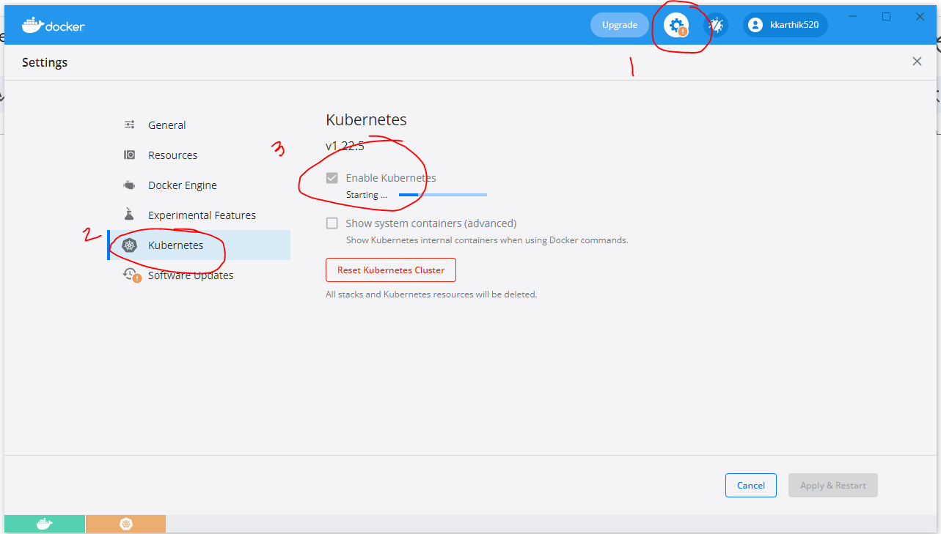

K8s=>shot name

Kubectl to verify k8s is up ot not

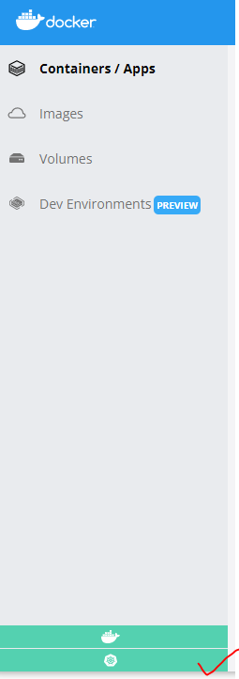

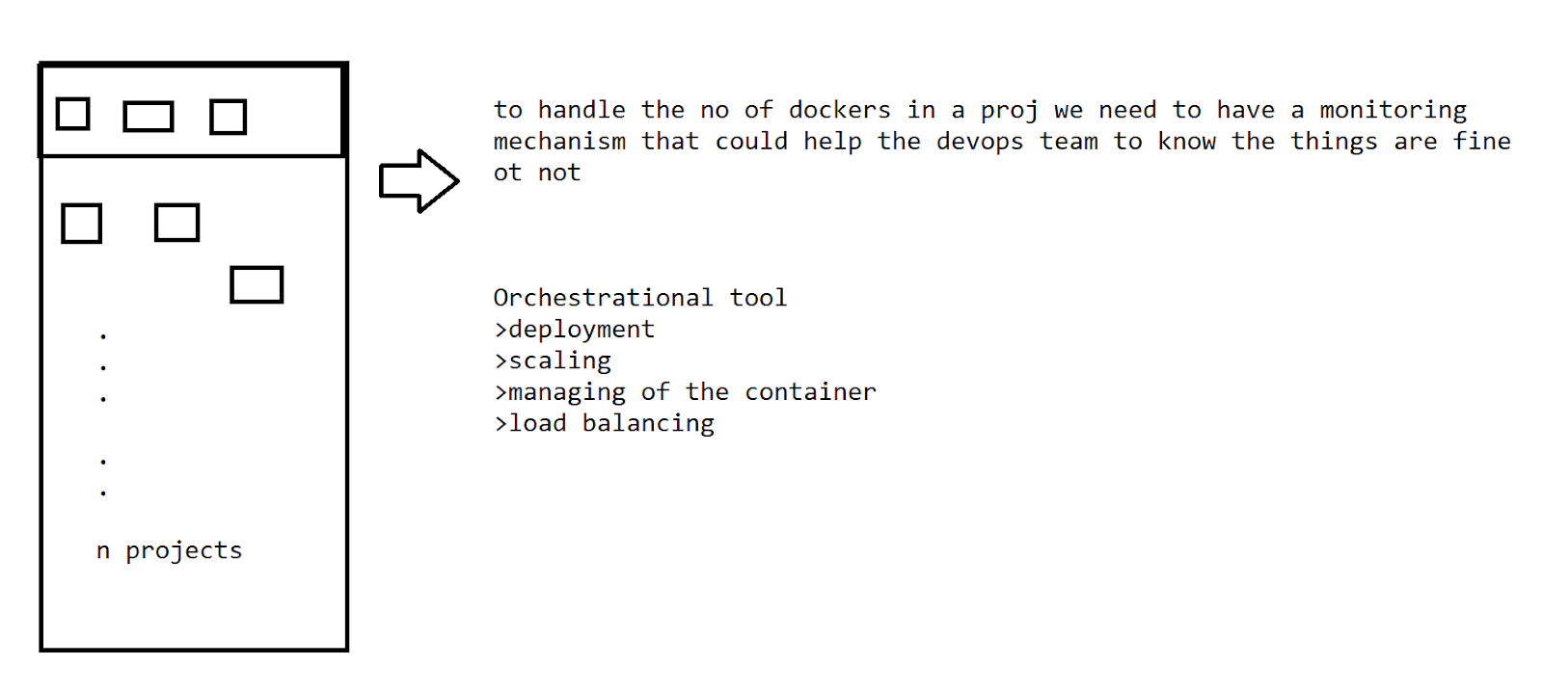

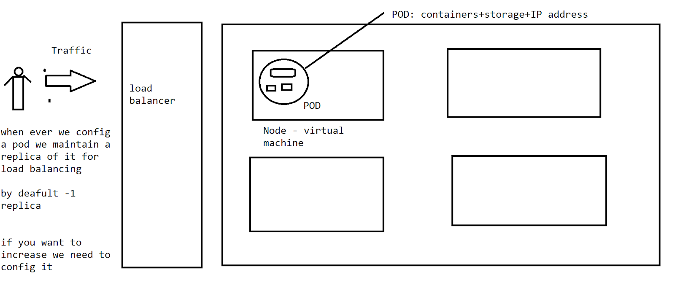

K8 works on the mechanism of master and slave model

It is similar processing docker swarm . K8s is the replacement for the swarm

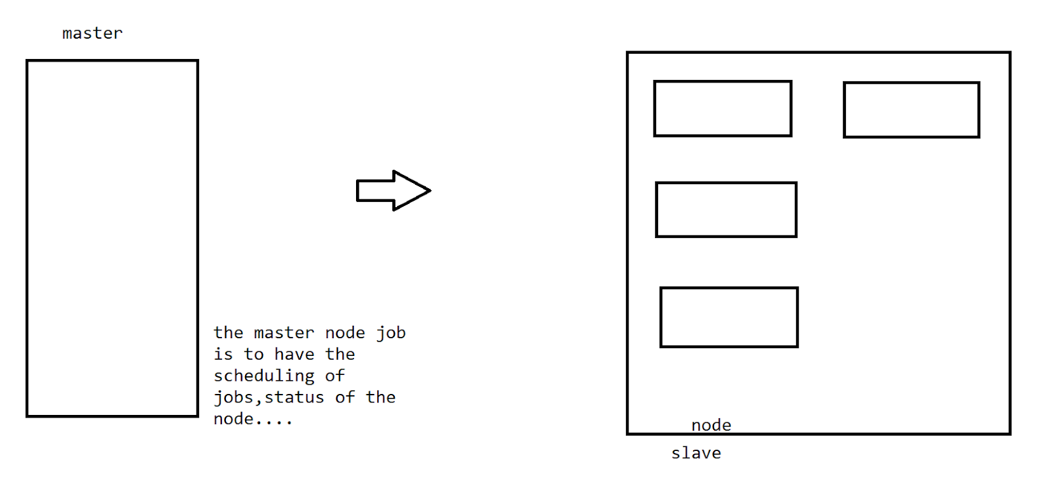

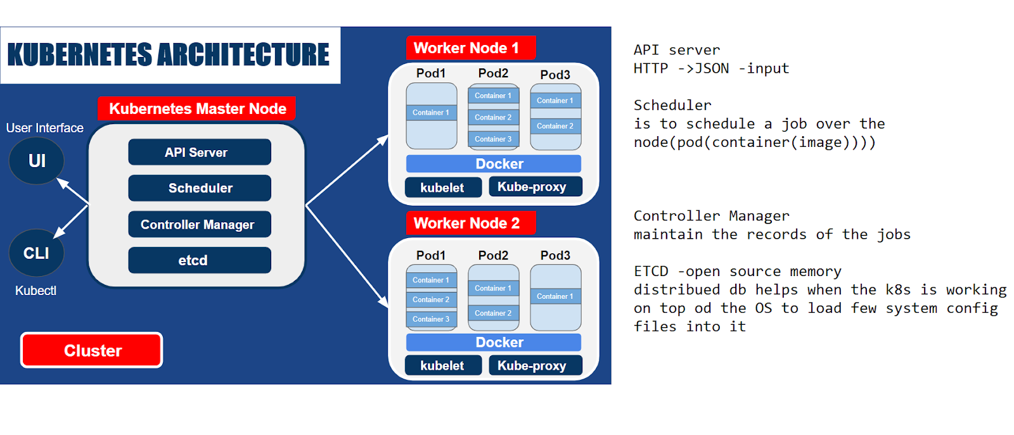

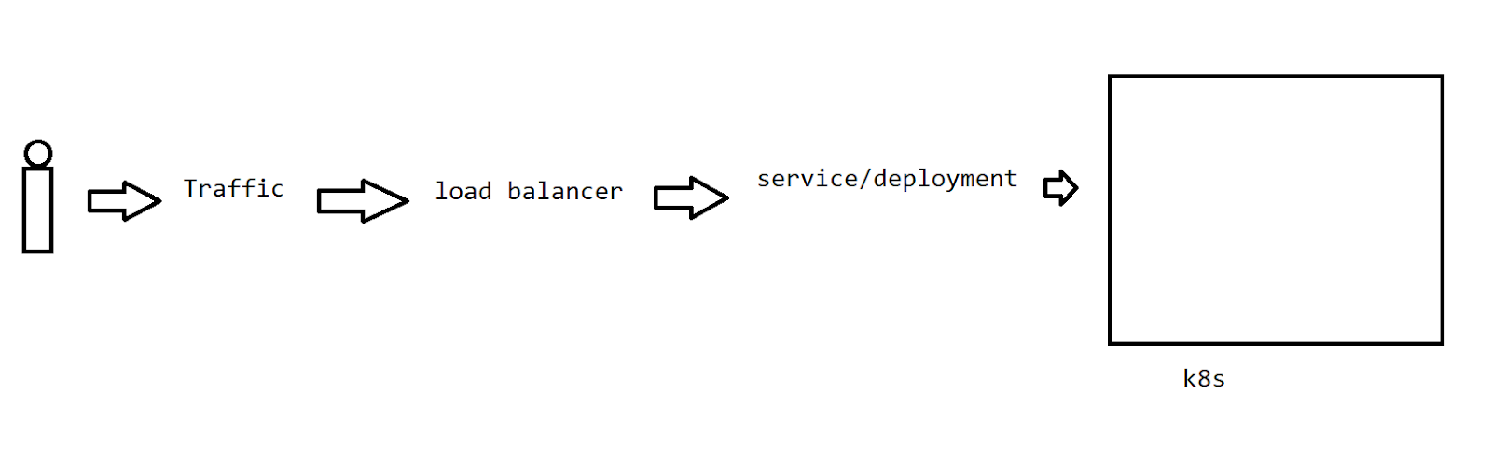

K8s has the self-healing capacity

If the container fails?

-restart the container auto

If the node fails ?

-replace the affected node with the new node and starts the containers over it .

If the node responding ?

Kills the node and the container

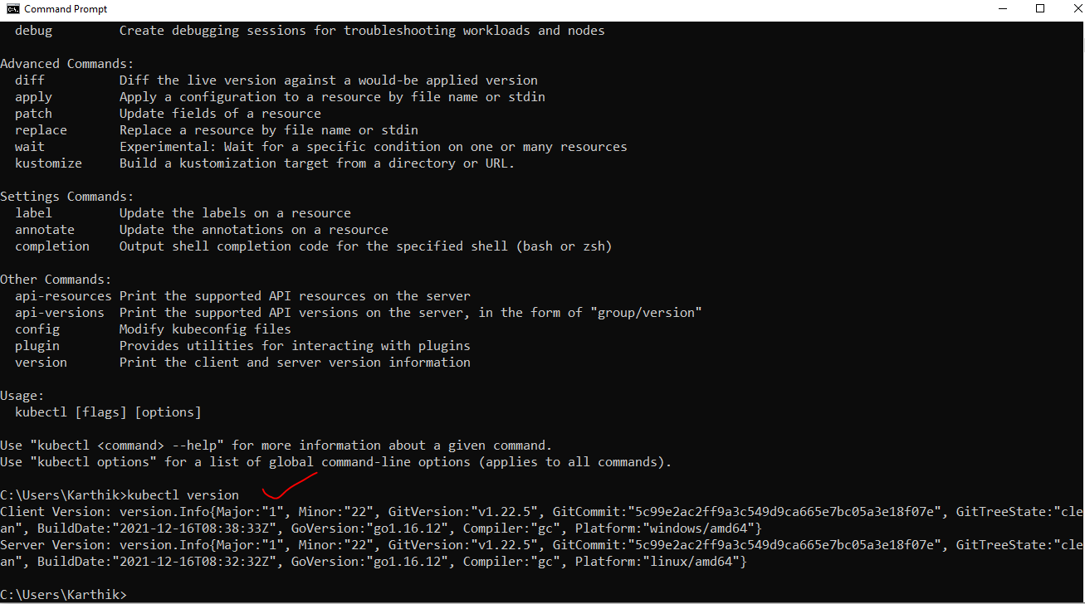

* In k8s when ever we are config we require

1. Deployment
2. Service

1. Create a pod



1. List of pods

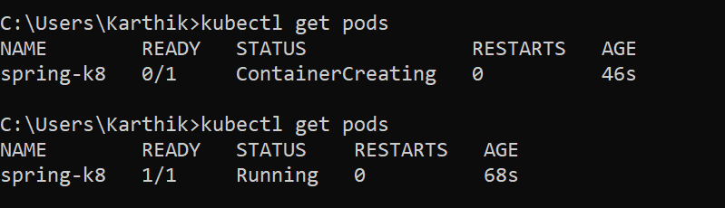

1. Create a deployment

This command ensures that all the pods are running or not.

If not running it makes the image active on the container

If any pod gets failed then this command replaces the pod with the image again



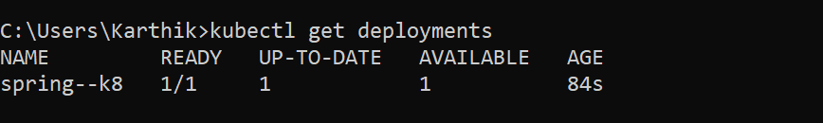

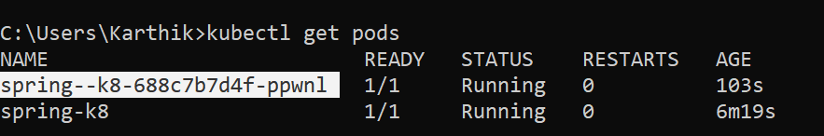

Create a service:

The deployment is given to the load balancer with the image of port 8088 which runs over the pod container of the same port



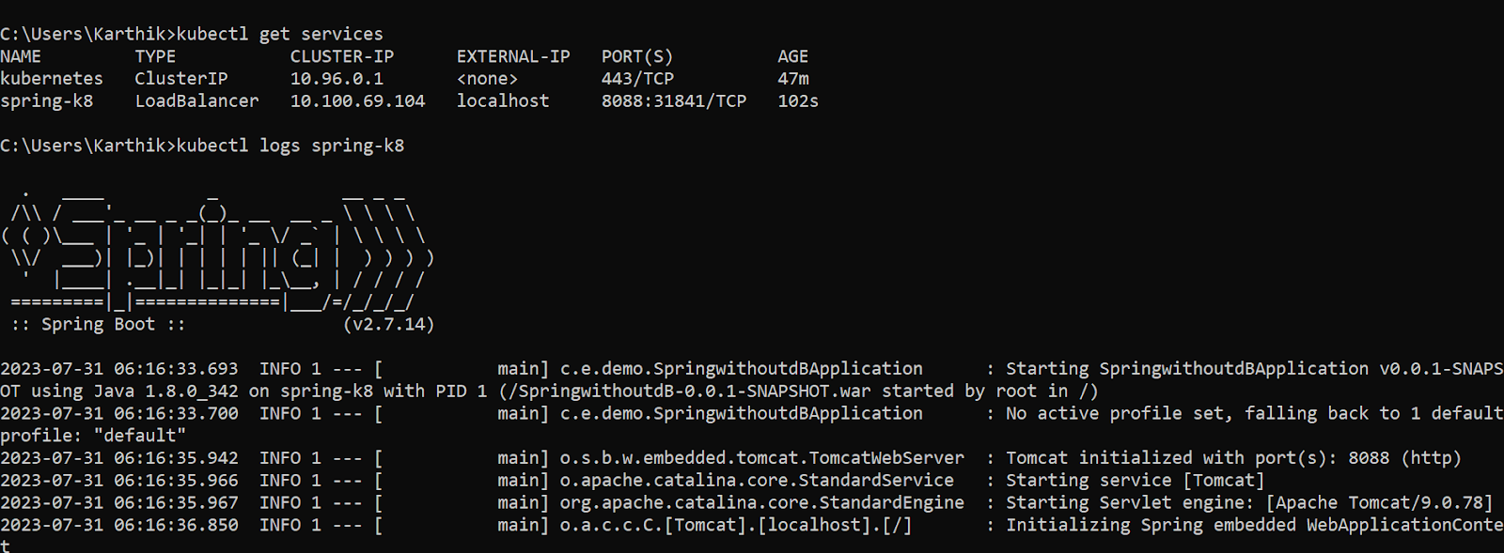

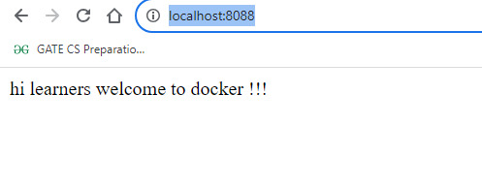

To create the replicas

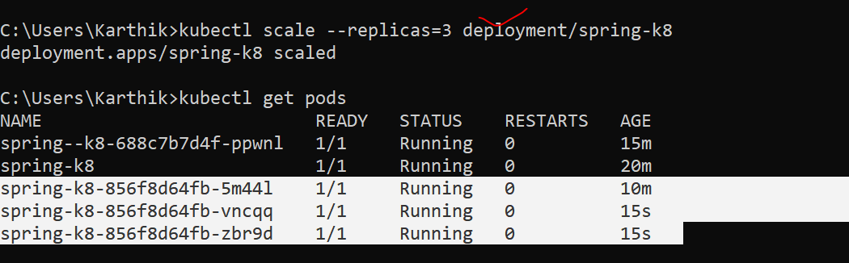

Get complete details of a pod

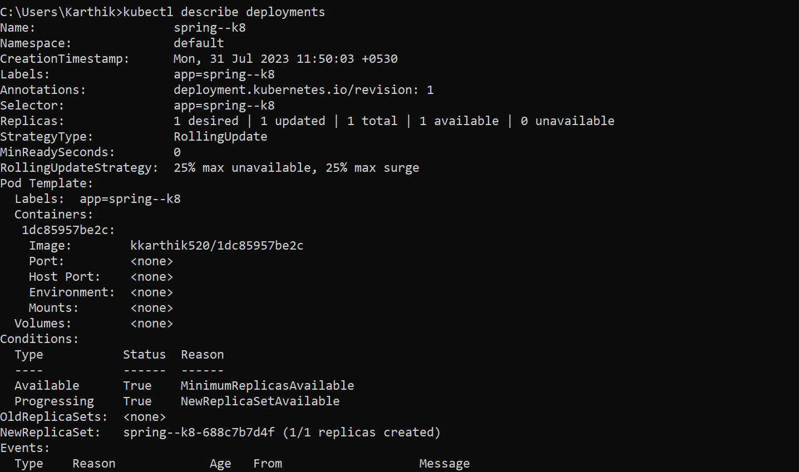

Know about the replicas

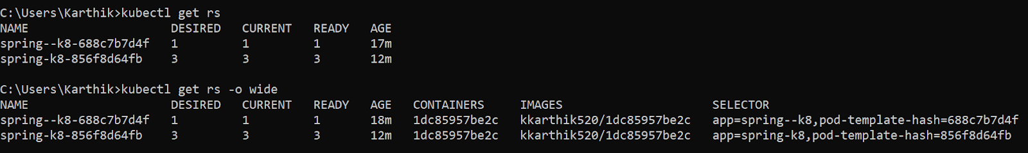

Autoscaling on the utilization



//reference of angular image

<https://www.indellient.com/blog/how-to-dockerize-an-angular-application-with-nginx/>